1 When the system of equations and is graphed on a set of axes, what is the total number of points of intersection?
1) | 1
2) | 2
3) | 3
4) | 0

2 Given: 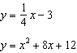
In which quadrant will the graphs of the given equations intersect?
1) | I
2) | II
3) | III
4) | IV

3 Given the system of equations: 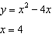
The number of points of intersection is
1) | 1
2) | 2
3) | 3
4) | 0

4 The solution of the system of equations and is
1) | and
2) | and
3) | and
4) | and

5 When solved graphically, what is the solution to the following system of equations?
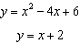
1)
2)
3) | and
4) | and

6 What is the solution of the system of equations and ?
1) | and
2) | and
3) | and
4) | and

7 Given the equations: 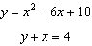
What is the solution to the given system of equations?
1)
2)
3)
4)

8 The equations and are graphed on the same set of axes. The coordinates of a point in the solution of this system of equations are
1)
2)
3)
4)

9 When the system of equations and is solved graphically, the solution is
1) | and
2) | and
3) | and
4) | and

10 What is the solution of the following system of equations?
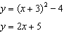
1)
2)
3)
4)

11 What is the solution of the system of equations graphed below?
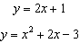

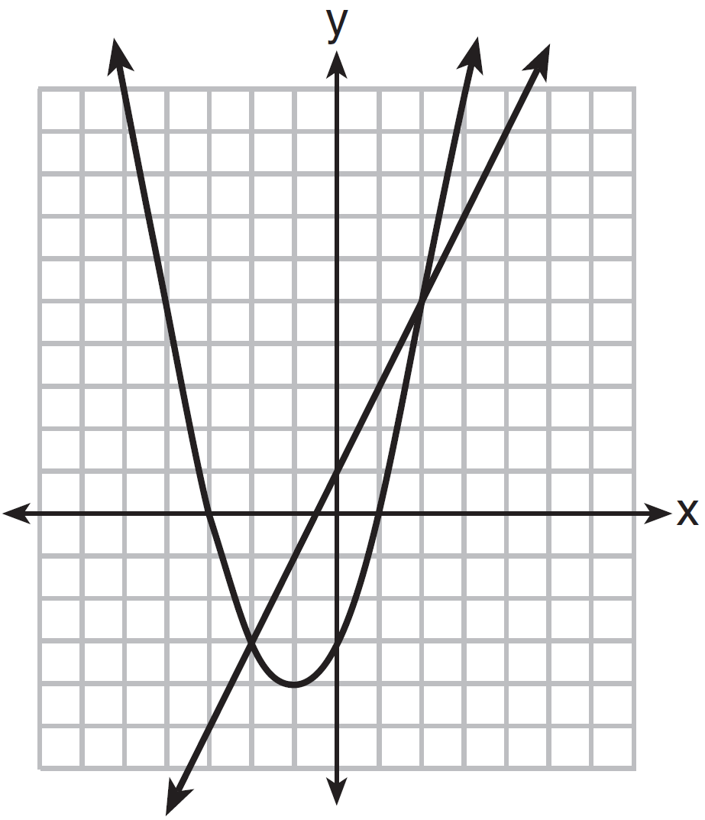
1)
2)
3) | and
4) | and

12 Which graph could be used to find the solution to the following system of equations?
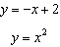
1) | 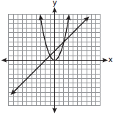
2) | 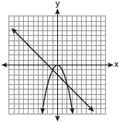
3) | 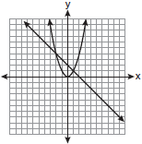
4) | 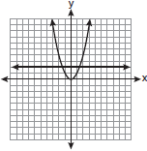

13 Which graph could be used to find the solution to the following system of equations?
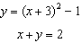
1) | 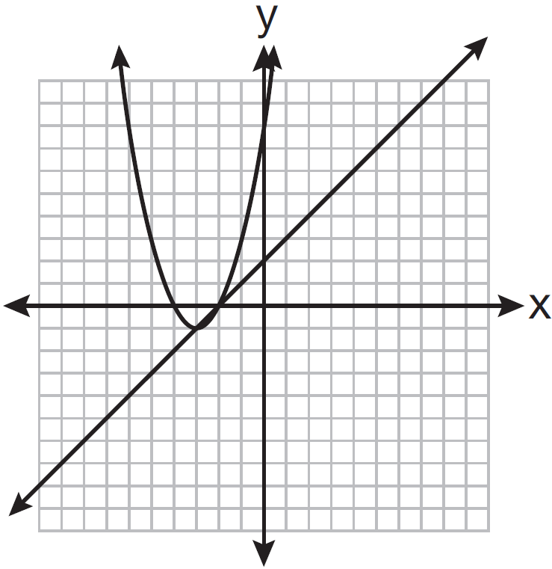
2) | 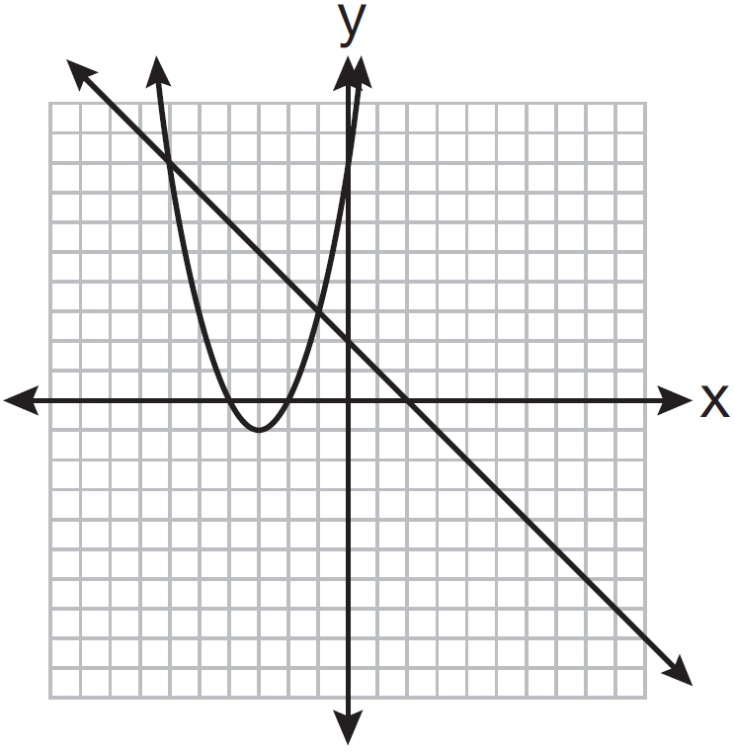
3) | 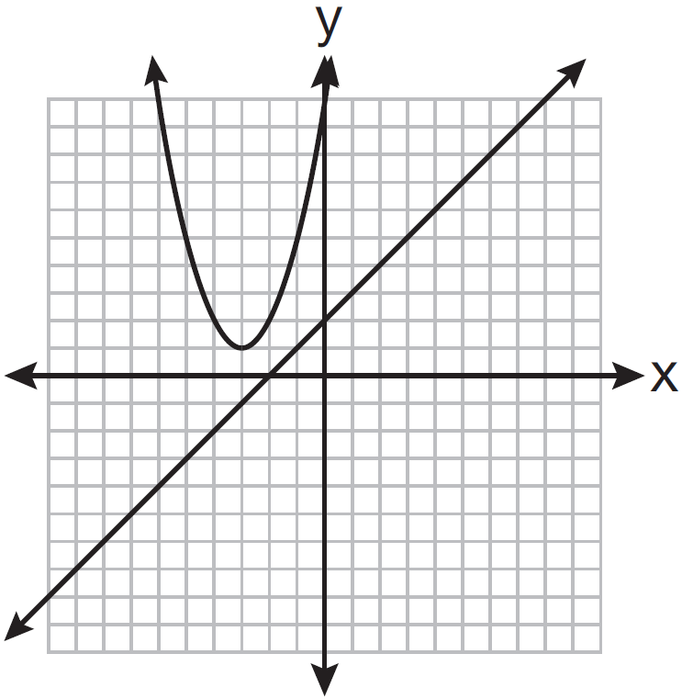
4) | 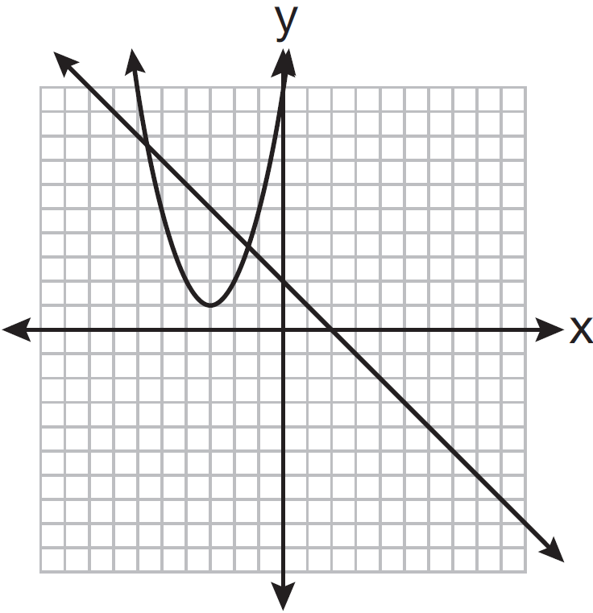

14 On the set of axes below, solve the following system of equations graphically and state the coordinates of all points in the solution.
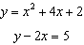

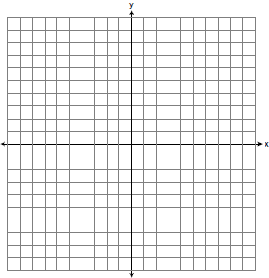

15 Solve the following system of equations graphically. State the coordinates of all points in the solution.
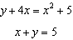

16 Solve the following system of equations graphically. 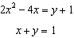

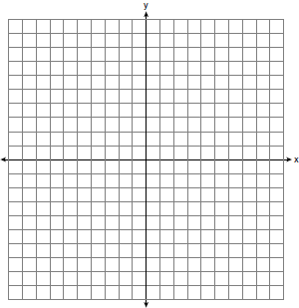

17 On the set of axes below, solve the system of equations graphically and state the coordinates of all points in the solution.
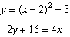

18 On the set of axes below, solve the following system of equations graphically for all values of x and y.
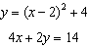

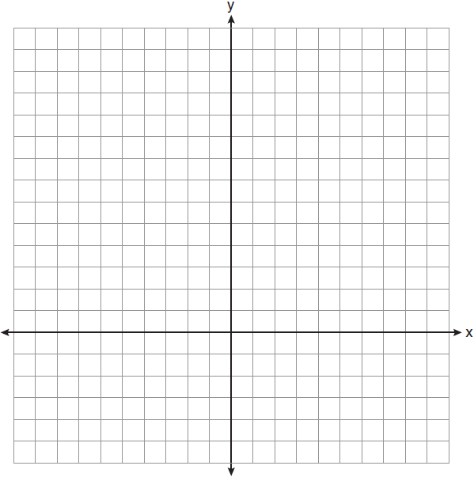

1 ANS: 2
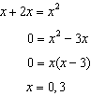

REF: 061406ge

2 ANS: 3
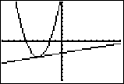

REF: 061011ge

3 ANS: 1
. is the only intersection. 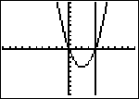

REF: 060923ge

4 ANS: 2
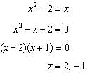

REF: 011409ge

5 ANS: 3
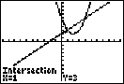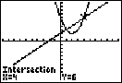

REF: 081118ge

6 ANS: 1
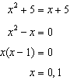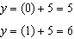

REF: 081406ge

7 ANS: 4
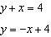. 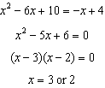. 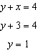. 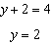 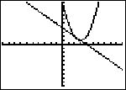

REF: 080912ge

8 ANS: 4
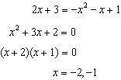

REF: 081516ge

9 ANS: 2
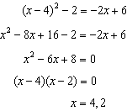. 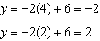

REF: 081319ge

10 ANS: 3
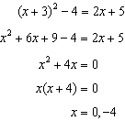

REF: 081004ge

11 ANS: 4 REF: 011501ge

12 ANS: 3
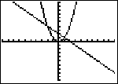

REF: fall0805ge

13 ANS: 2 REF: 061313ge

14 ANS:
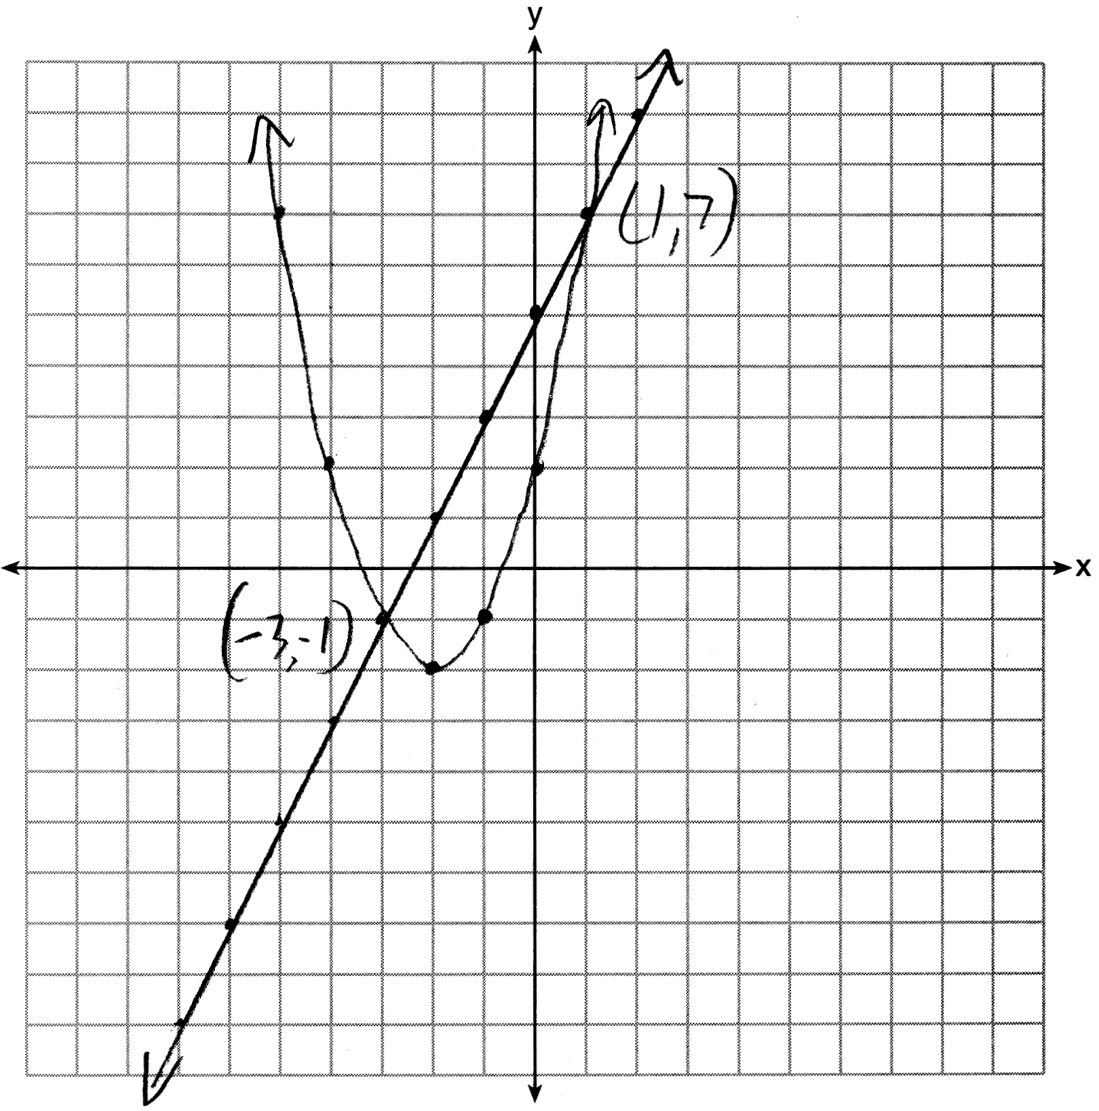

REF: 011636ge

15 ANS:
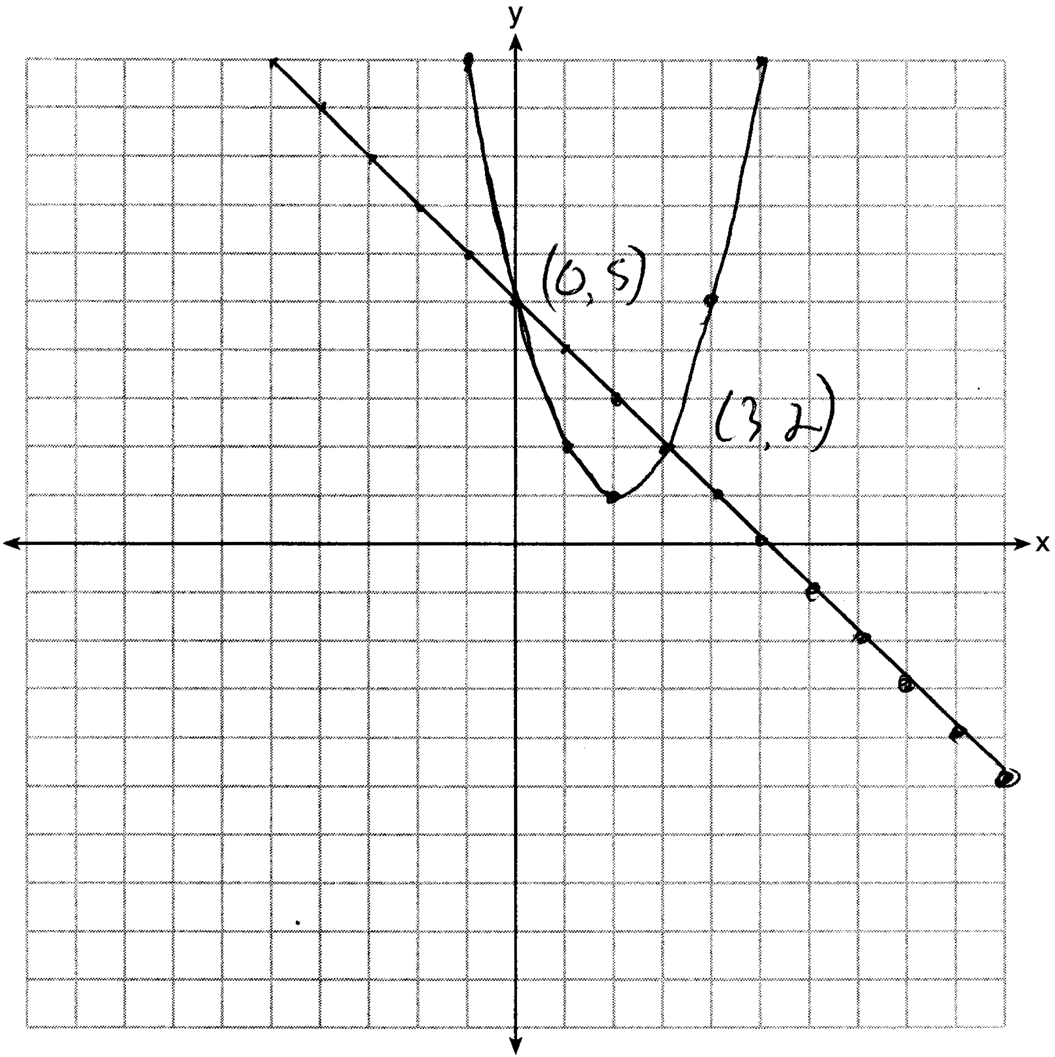

REF: 061535ge

16 ANS:
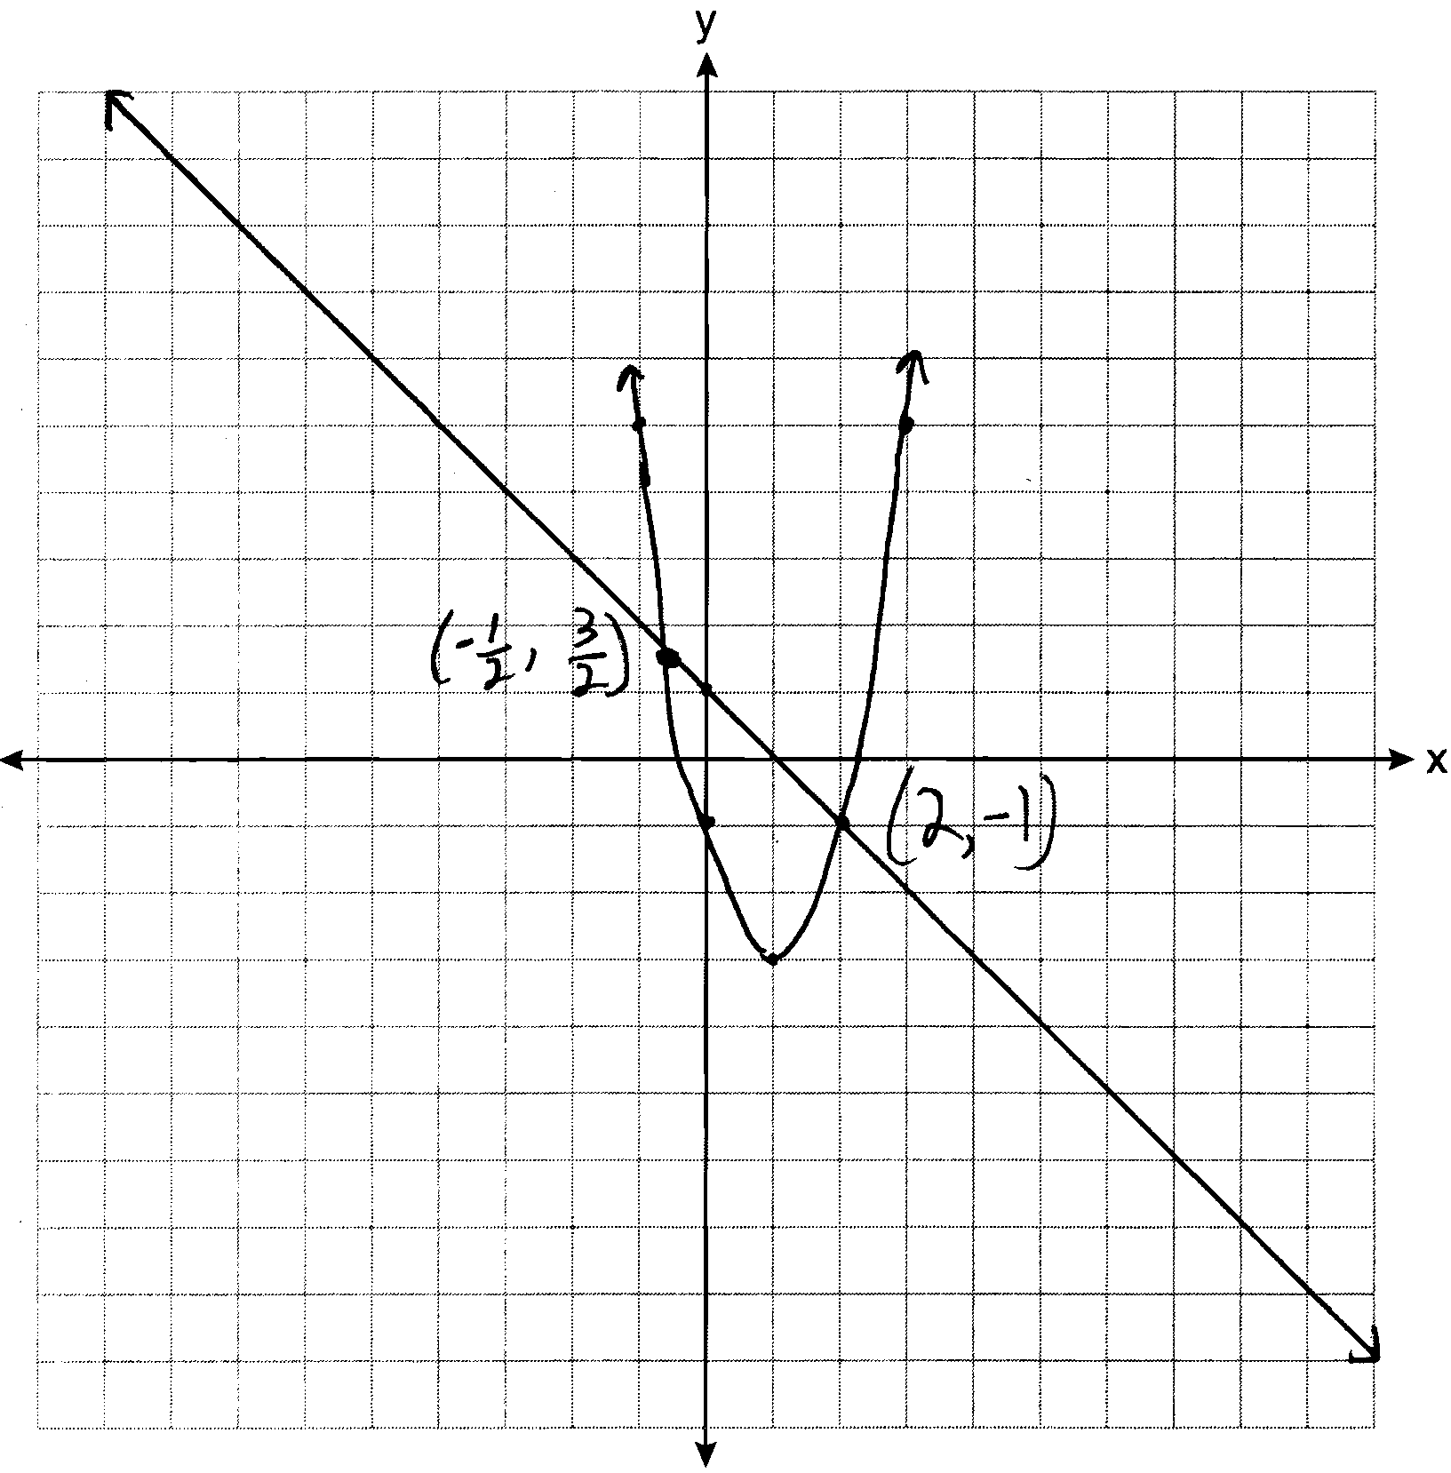

REF: 061137ge

17 ANS:
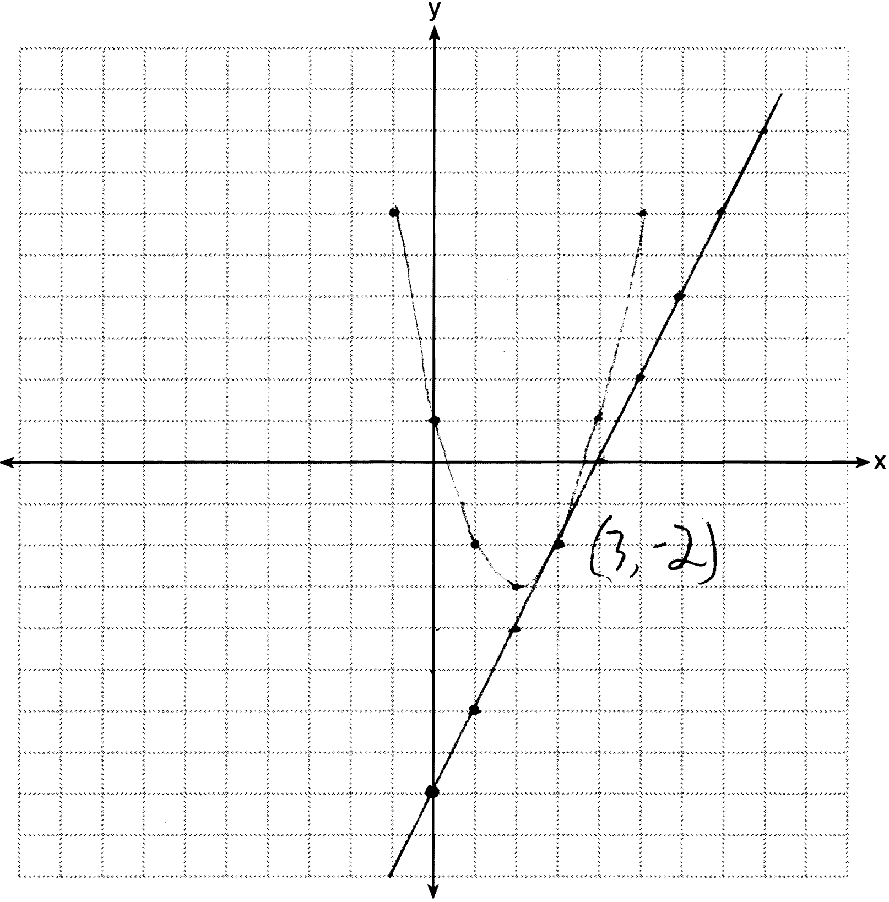

REF: 061238ge

18 ANS:
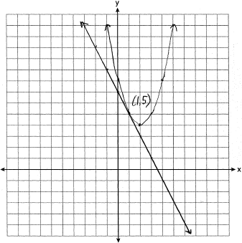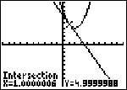

REF: 011038ge

