1 Which ordered pair is a solution to the system of equations and ?
1)
2)
3)
4)

2 How many solutions are there for the following system of equations?
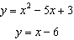
1) | 1
2) | 2
3) | 3
4) | 0

3 The graphs of the equations and are drawn on the same set of axes. At which point do the graphs intersect?
1)
2)
3)
4)

4 Which ordered pair is in the solution set of the system of equations and ?
1)
2)
3)
4)

5 What is the solution set of the system of equations and ?
1)
2)
3)
4)

6 Which values of x are in the solution set of the following system of equations?
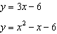
1)
2)
3)
4)

7 Which ordered pair is a solution of the system of equations and ?
1)
2)
3)
4)

8 Solve the following system of equations algebraically for all values of x and y.
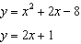

9 The accompanying diagram shows the graphs of a linear equation and a quadratic equation.

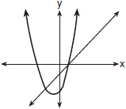

How many solutions are there to this system of equations?
1) | 1
2) | 2
3) | 3
4) | 0

10 Solve the following system of equations algebraically: 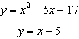

11 Solve the following system of equations algebraically.
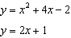

12 Solve the following system of equations algebraically: 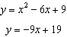

13 Which ordered pair is a solution of the system of equations shown in the graph below?

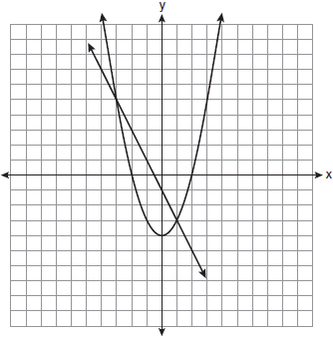
1)
2)
3)
4)

14 Two equations were graphed on the set of axes below.

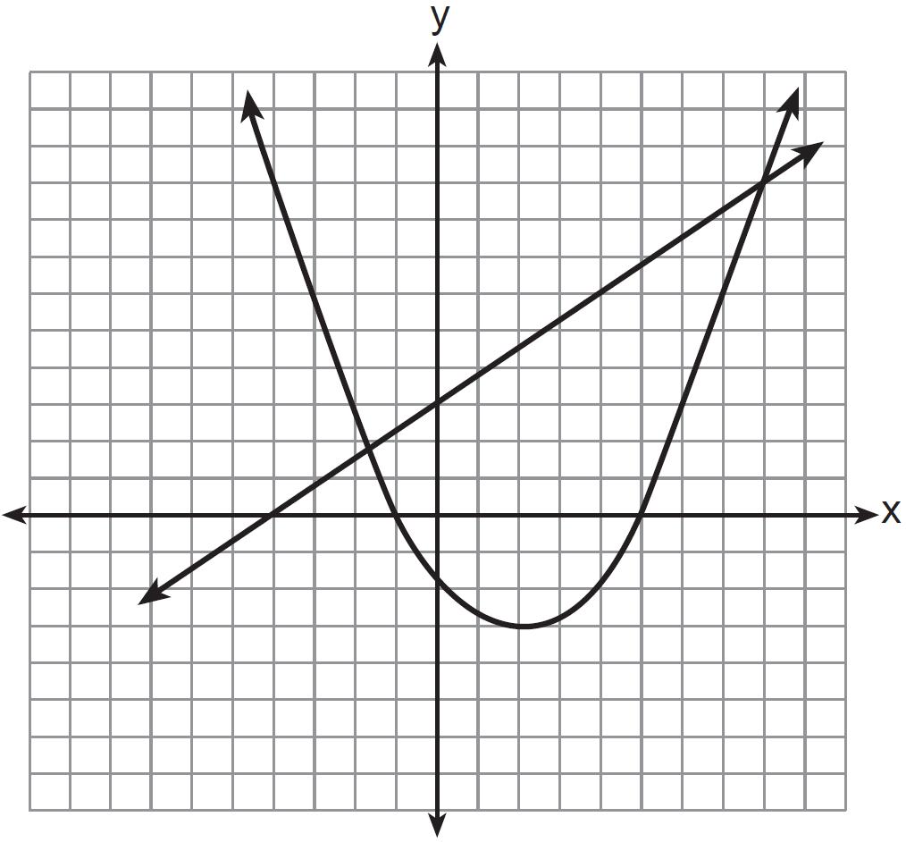

Which point is a solution of the system of equations shown on the graph?
1)
2)
3)
4)

15 Which graph could be used to find the solution of the system of equations and ?
1) | 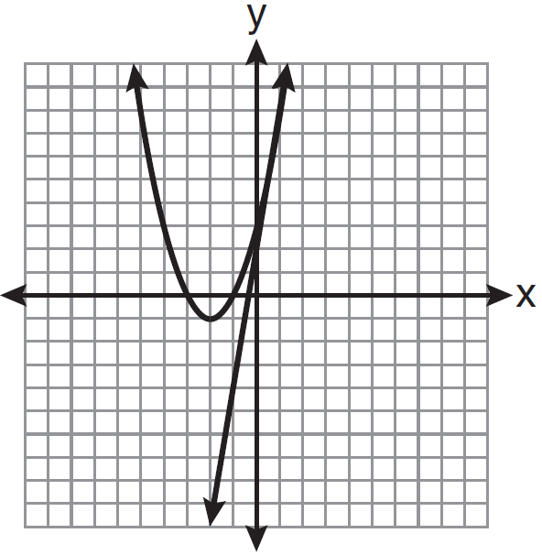
2) | 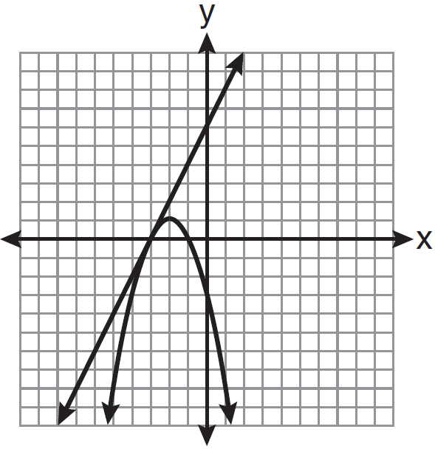
3) | 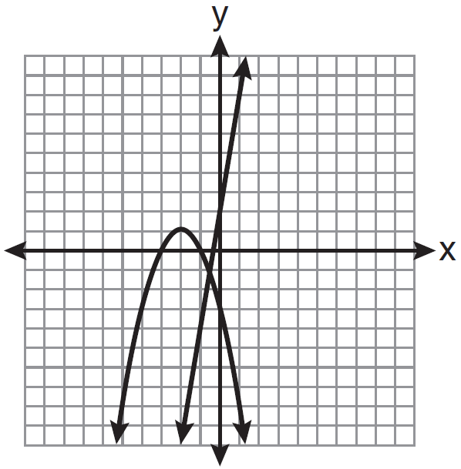
4) | 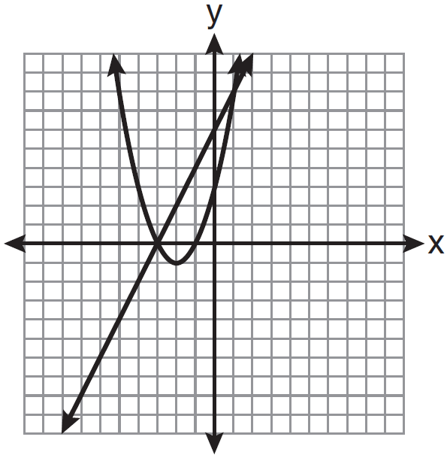

16 Which graph can be used to find the solution of the following system of equations?
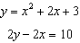
1) | 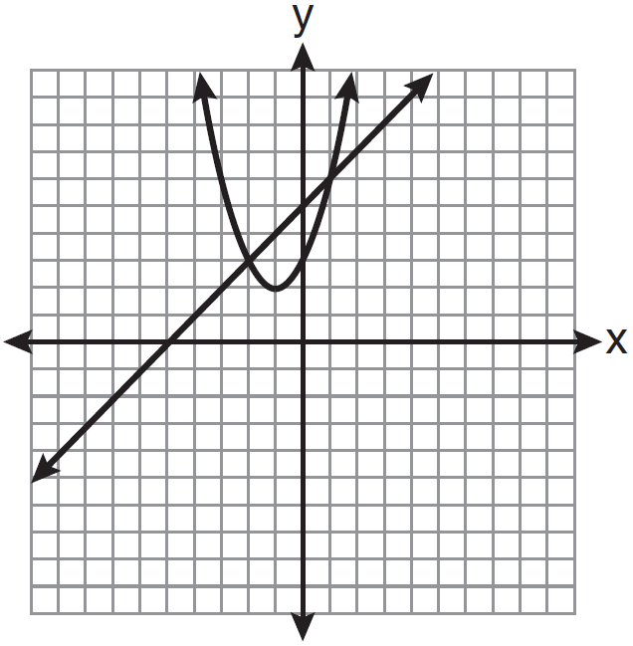
2) | 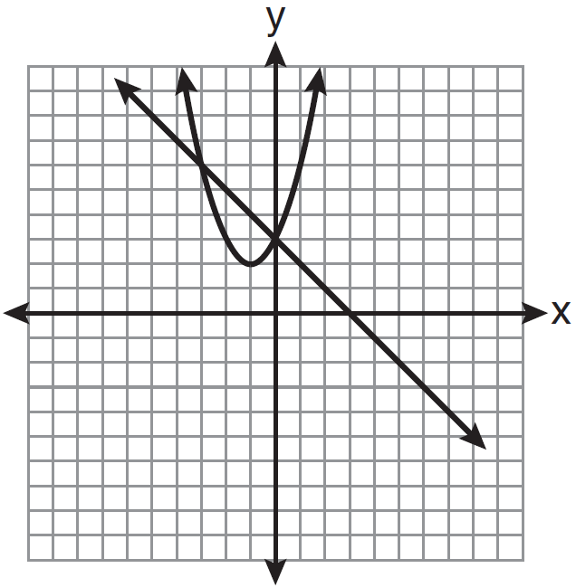
3) | 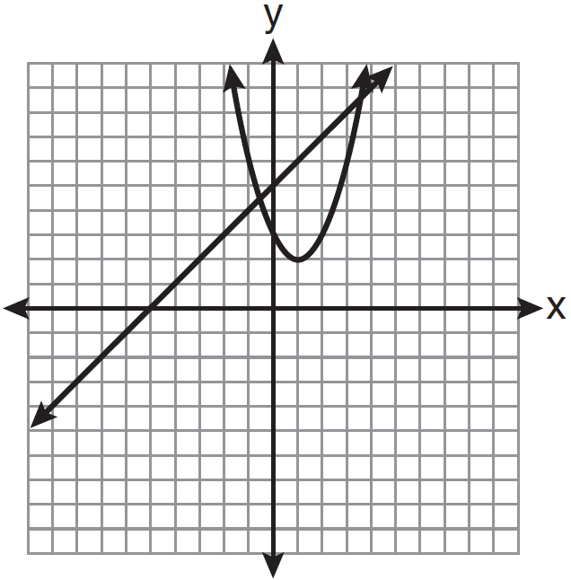
4) | 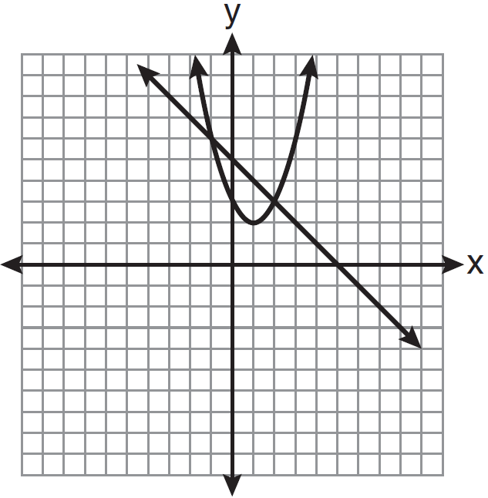

17 On the set of axes below, solve the following system of equations graphically and state the coordinates of all points in the solution set.
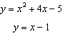

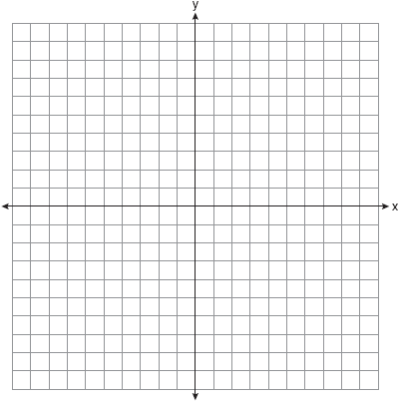

18 Solve the following system of equations algebraically or graphically for x and y:
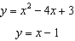



19 On the set of axes below, solve the following system of equations graphically for all values of x and y. State the coordinates of all solutions.
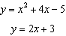

20 Solve the following system of equations algebraically or graphically for x and y:
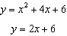

21 Solve the following system of equations:
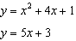
[The use of the grid is optional.]



22 Solve the following system of equations algebraically or graphically for x and y:
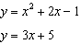



23 On the set of axes below, solve the following system of equations graphically for all values of x and y.
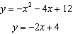

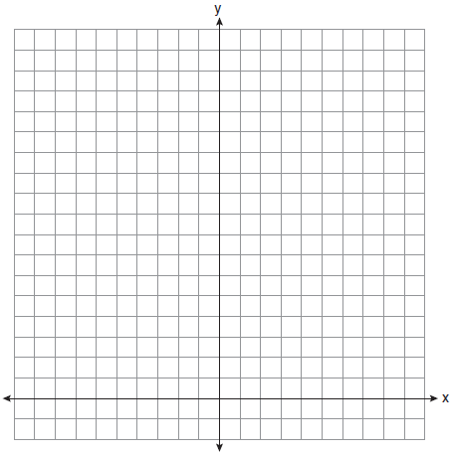

24 On the set of axes below, solve the following system of equations graphically and state the coordinates of all points in the solution set.
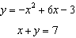

25 On the set of axes below, solve the following system of equations graphically for all values of x and y. State the coordinates of all solutions.
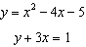

3

26 On the set of axes below, graph the following system of equations. Using the graph, determine and state all solutions of the system of equations.
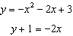

27 Solve the following systems of equations graphically, on the set of axes below, and state the coordinates of the point(s) in the solution set.
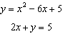

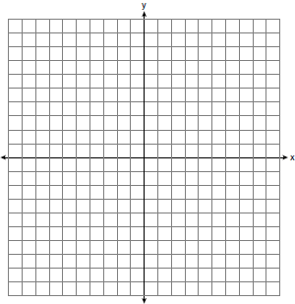

28 On the set of axes below, solve the following system of equations graphically for all values of x and y.
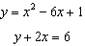

29 On the set of axes below, graph the following system of equations.
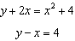
Using the graph, determine and state the coordinates of all points in the solution set for the system of equations.

30 A rocket is launched from the ground and follows a parabolic path represented by the equation . At the same time, a flare is launched from a height of 10 feet and follows a straight path represented by the equation . Using the accompanying set of axes, graph the equations that represent the paths of the rocket and the flare, and find the coordinates of the point or points where the paths intersect.



1 ANS: 2
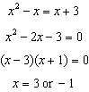. Since , the solutions are and . 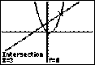

REF: 061118ia

2 ANS: 1
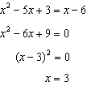

REF: 061330ia

3 ANS: 4
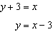. 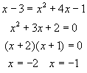. 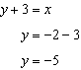.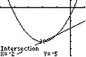. 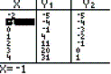

REF: 060018a

4 ANS: 2
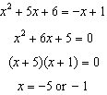. 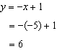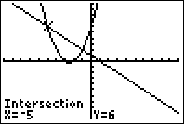

REF: 080812ia

5 ANS: 2
. 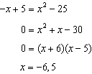. 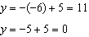. 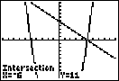

REF: 061213ia

6 ANS: 2
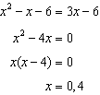

REF: 081015a2

7 ANS: 2
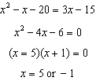. 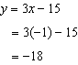. 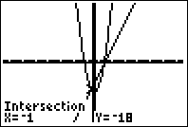

REF: 010922ia

8 ANS:
. 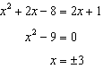. 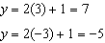

REF: 081236ia

9 ANS: 2 REF: 060507a

10 ANS:
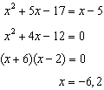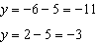

REF: 011538ia

11 ANS:
. 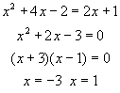. 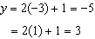. 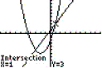. 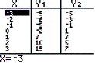

REF: 080135a

12 ANS:
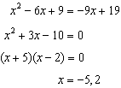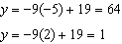

REF: 081439ia

13 ANS: 2 REF: 011012ia

14 ANS: 1 REF: 011207ia

15 ANS: 4 REF: 011102ia

16 ANS: 1
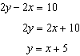 axis of symmetry: 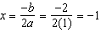

REF: 081010ia

17 ANS:
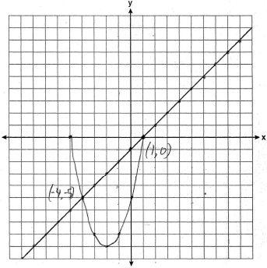. 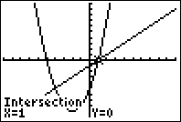

REF: 080839ia

18 ANS:
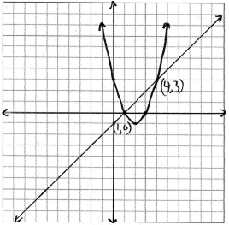. 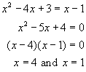. 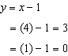. 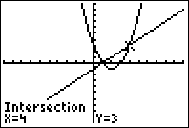

REF: 060839a

19 ANS:
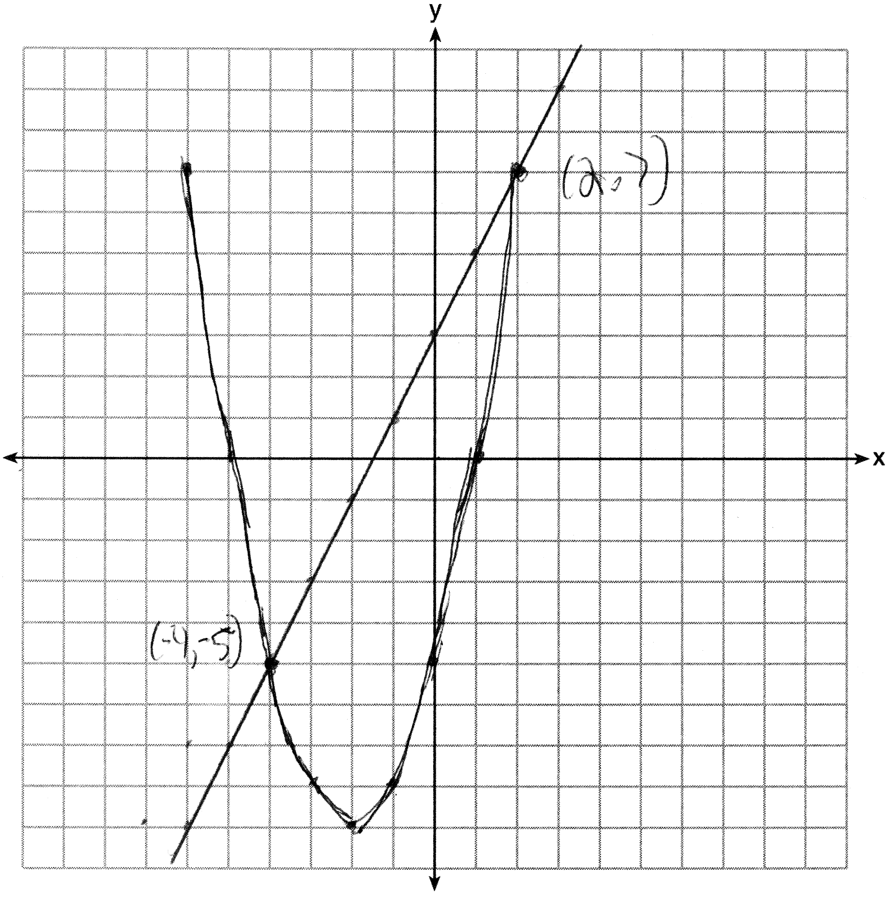

REF: 011437ia

20 ANS:
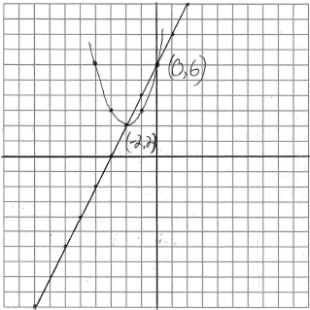. 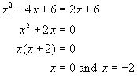. 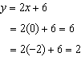. 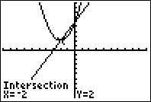

REF: 080839a

21 ANS:
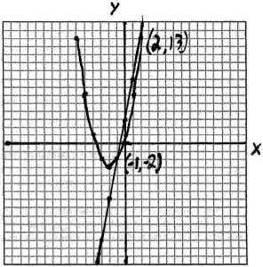. 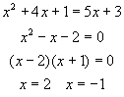. 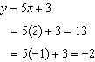. 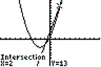. 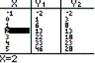

REF: 080538a

22 ANS:
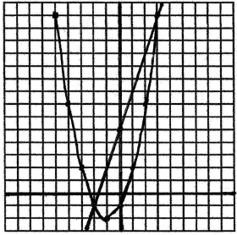 and . 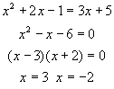. 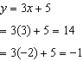. 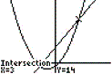. 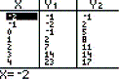

REF: 069935a

23 ANS:
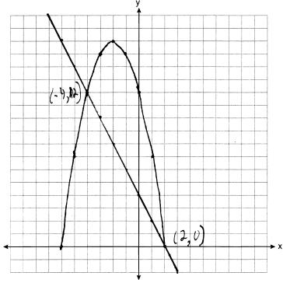

REF: 061039ia

24 ANS:
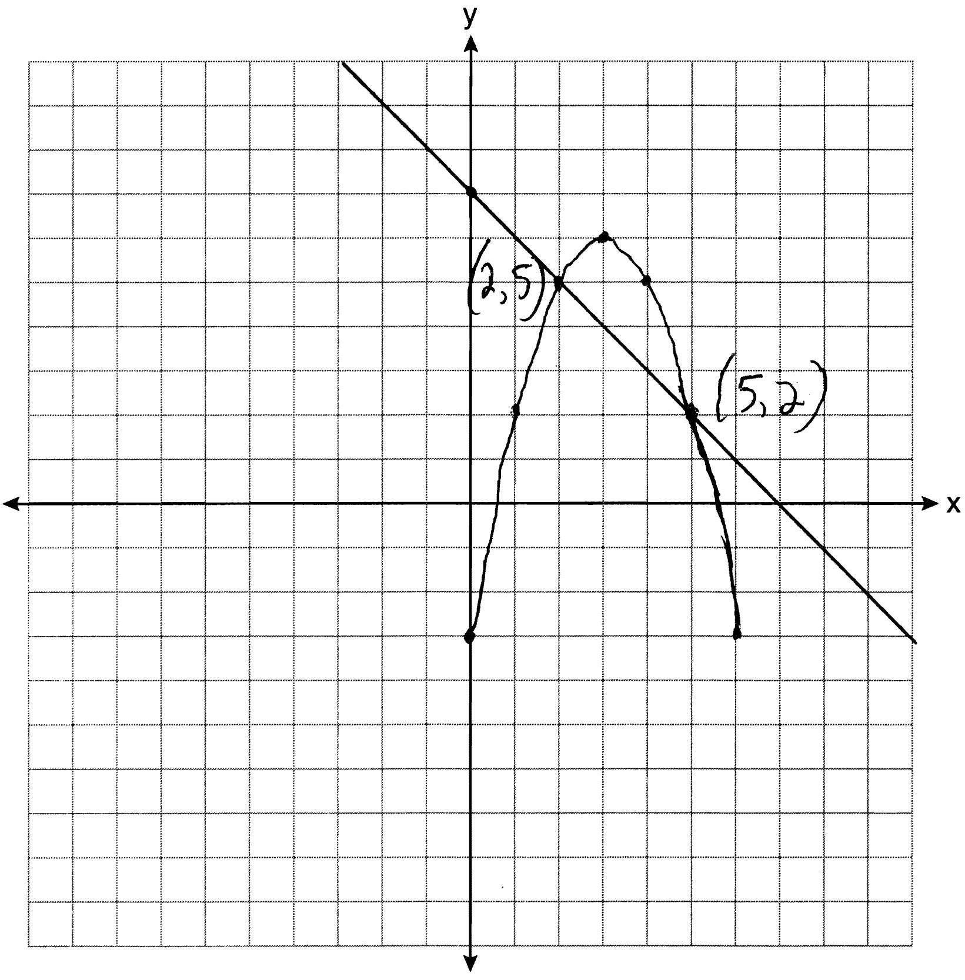

REF: 081138ia

25 ANS:
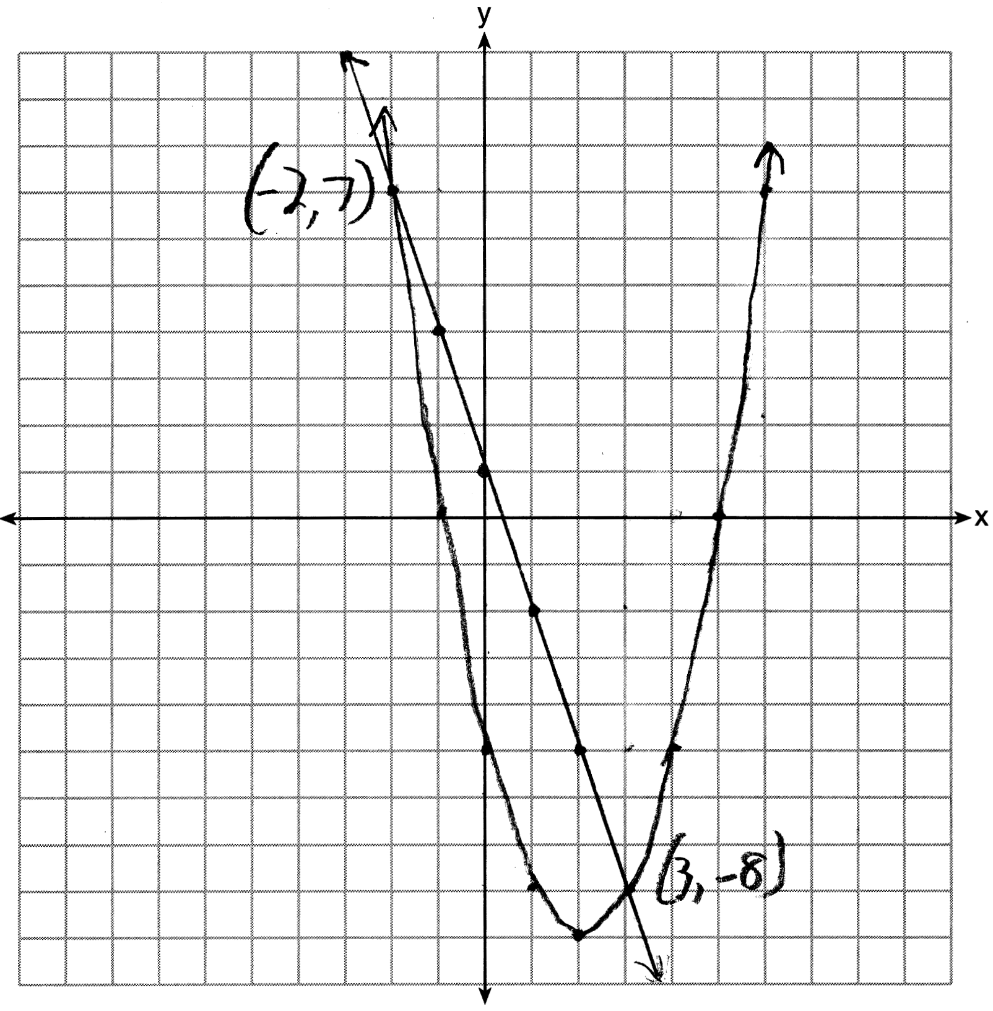. 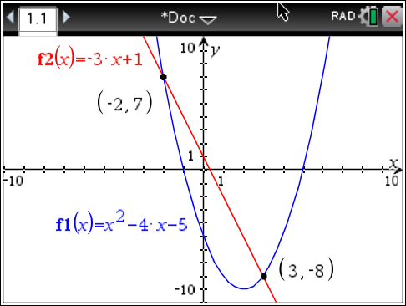

REF: 061637ia

26 ANS:
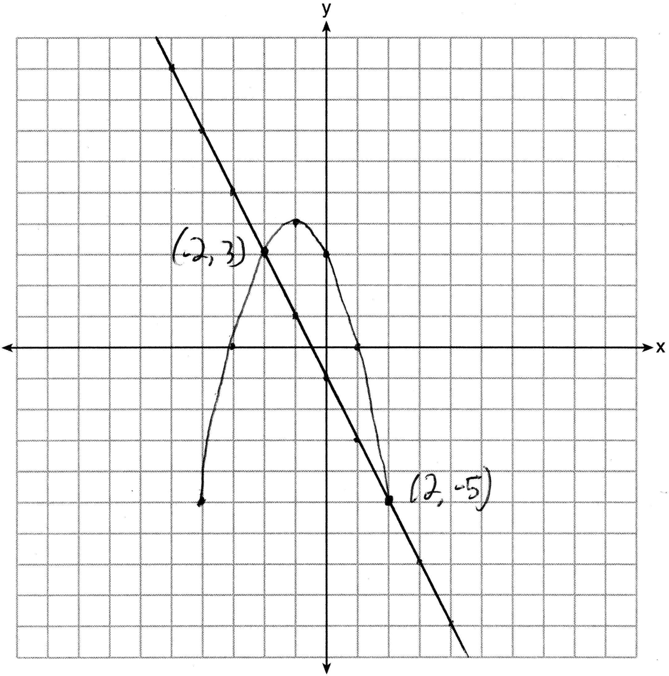

REF: 081337ia

27 ANS:
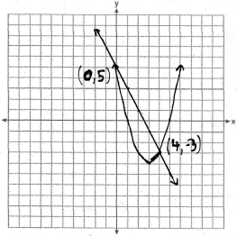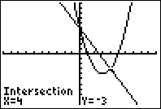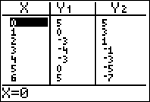

REF: fall0738ia

28 ANS:
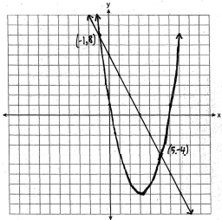

REF: 060939ia

29 ANS:
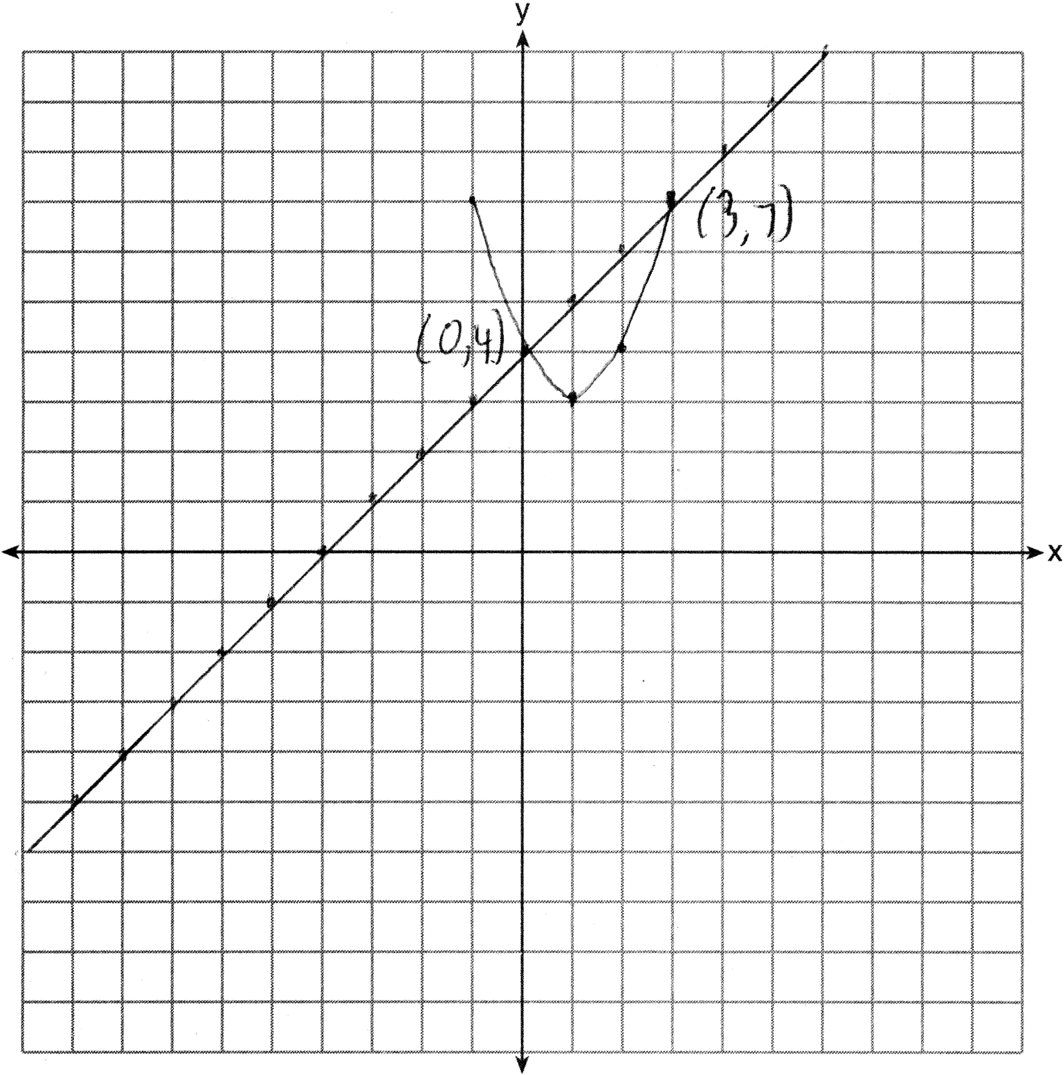

REF: 011339ia

30 ANS:
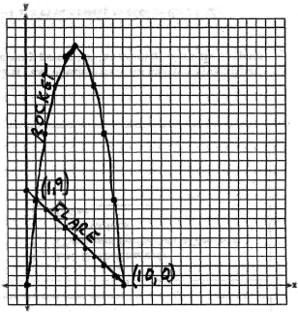. 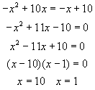. 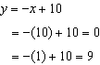. 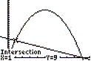. 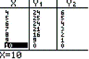

REF: 060235a

