1 When solved graphically, which system of equations will have exactly one point of intersection?
1) 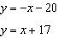 2) 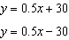 3) 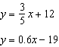 4) 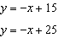

2 Using the substitution method, Ken solves the following system of equations algebraically.
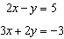
Which equivalent equation could Ken use?
1) 2) 3) 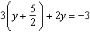 4) 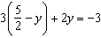

3 If and , what is the value of x?
1) 2) 6 3) 4) 4

4 What is the value of x in the solution of the system of equations and ?
1) 8 2) 2 3) 3 4) 4

5 What is the value of the y-coordinate of the solution to the system of equations and ?
1) 6 2) 2 3) 3 4) 5

6 What is the value of the y-coordinate of the solution to the system of equations and ?
1) 1 2) 3) 3 4) 4

7 What is the value of the y-coordinate of the solution to the system of equations and ?
1) 2) 2 3) 3 4)

8 What is the value of y in the following system of equations?
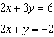
1) 1 2) 2 3) 4) 4

9 What is the value of A in the following system of equations?
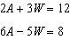
1) 1 2) 2 3) 3 4) 9

10 If and , the value of b is
1) 1 2) 7 3) 4.5 4) 4

11 What is the solution of the system of equations and ?
1) 2) 3) 4)

12 What is the solution of the system of equations and ?
1) 2) 3) 4)

13 What is the solution of the system of equations below?
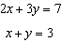
1) 2) 3) 4)

14 What is the solution of the following system of equations? 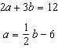
1) and 2) and 3) and 4) and

15 Which ordered pair is the solution of the following system of equations?
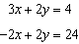
1) 2) 3) 4)

16 What point is the intersection of the graphs of the lines and ?
1) 2) 3) 4)

17 Which ordered pair satisfies the system of equations below?
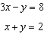
1) 2) 3) 4)

18 The equations and represent the money collected from school concert ticket sales during two class periods. If x represents the cost for each adult ticket and y represents the cost for each student ticket, what is the cost for each adult ticket?
1) $20 2) $10 3) $8 4) $4

19 The equations and represent the money collected from selling gift baskets in a school fundraising event. If x represents the cost for each snack gift basket and y represents the cost for each chocolate gift basket, what is the cost for each chocolate gift basket?
1) $20 2) $25 3) $30 4) $54

20 Solve the following system of equations algebraically for y:
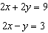

21 Solve the following system of equations algebraically:
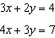
[Only an algebraic solution can receive full credit.]
1 ANS: 1
In (2) – (4), the equations in each system have equal slope, and therefore do not intersect.

REF: 080529a

2 ANS: 1 REF: 081315ia

3 ANS: 3
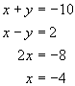

REF: 060824a

4 ANS: 2
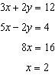

REF: 061409ia

5 ANS: 2
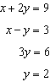

REF: 060925ia

6 ANS: 1
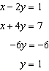

REF: 080920ia

7 ANS: 2
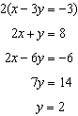

REF: 081021ia

8 ANS: 4
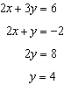

REF: 080013a

9 ANS: 3
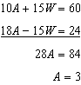

REF: 061609ia

10 ANS: 4
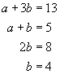

REF: 080706a

11 ANS: 3
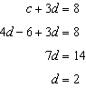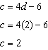

REF: 061012ia

12 ANS: 3
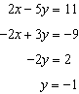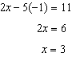

REF: 081109ia

13 ANS: 2
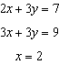

REF: 011410ia

14 ANS: 3
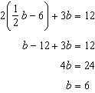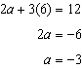

REF: 061511ia

15 ANS: 3
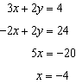. 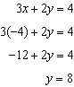

REF: 060007a

16 ANS: 1
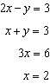. 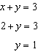

REF: 080429a

17 ANS: 2
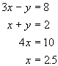. 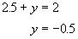

REF: 060716a

18 ANS: 3
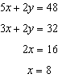

REF: fall0708ia

19 ANS: 3
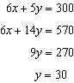

REF: 011519ia

20 ANS:
2. Subtracting the equations: 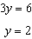

REF: 061231ia

21 ANS:
. 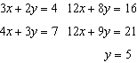. 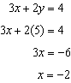

REF: 010937ia

