1 A system of equations is shown below.
Equation A:
Equation B:
Which method eliminates one of the variables?
1) | Multiply equation A by and add the result to equation B. | 3) | Multiply equation A by 2 and equation B by and add the results together.
2) | Multiply equation B by 3 and add the result to equation A. | 4) | Multiply equation B by 5 and equation A by 4 and add the results together.

2 Using the substitution method, Vito is solving the following system of equations algebraically:
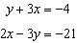
Which equivalent equation could Vito use?
1) |  | 3)
2) |  | 4)

3 Which system of equations will yield the same solution as the system below?
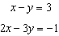
1) | 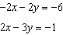 | 3) | 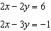
2) | 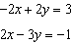 | 4) | 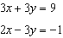

4 Which system of linear equations has the same solution as the one shown below?
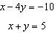
1) | 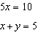 | 3) | 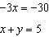
2) | 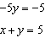 | 4) | 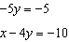

5 Which system of equations has the same solution as the system below?
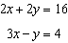
1) | 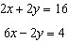 | 3) | 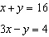
2) | 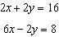 | 4) | 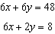

6 Which system of equations has the same solutions as the system below?
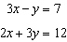
1) | 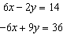 | 3) | 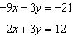
2) | 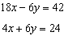 | 4) | 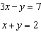

7 Which system has the same solution as the system below?
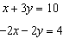
1) | 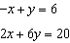 | 3) | 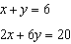
2) | 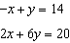 | 4) | 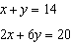

8 A system of equations is given below.
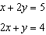
Which system of equations does not have the same solution?
1) | 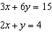 | 3) | 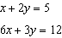
2) | 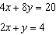 | 4) | 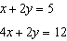

9 Which pair of equations could not be used to solve the following equations for x and y?
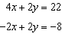
1) | 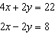 | 3) | 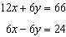
2) | 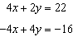 | 4) | 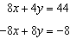

10 Which system of equations does not have the same solution as the system below?
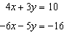
1) | 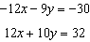 | 3) | 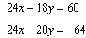
2) | 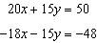 | 4) | 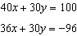

11 What is the solution to the system of equations below?
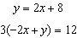
1) | no solution | 3)
2) | infinite solutions | 4) | 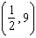

12 The line represented by the equation shares a solution point with the line represented by the table below.

x | y
 | 3.2
 | 3.8
2 | 4.6
4 | 5
11 | 6.4

The solution for this system is
1) |  | 3)
2) |  | 4)

13 Albert says that the two systems of equations shown below have the same solutions.

First System | Second System
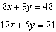 | 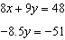

Determine and state whether you agree with Albert. Justify your answer.

14 In attempting to solve the system of equations and , John graphed the two equations on his graphing calculator. Because he saw only one line, John wrote that the answer to the system is the empty set. Is he correct? Explain your answer.

15 Guy and Jim work at a furniture store. Guy is paid $185 per week plus 3% of his total sales in dollars, x, which can be represented by . Jim is paid $275 per week plus 2.5% of his total sales in dollars, x, which can be represented by . Determine the value of x, in dollars, that will make their weekly pay the same.
1 ANS: 2 REF: 011815ai

2 ANS: 3

REF: 011922ai

3 ANS: 3
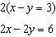

REF: 081822ai

4 ANS: 1
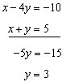 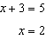 (1) 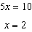 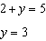

REF: 081922ai

5 ANS: 2
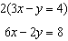

REF: 061414ai

6 ANS: 2
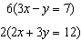

REF: 012020ai

7 ANS: 2
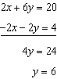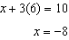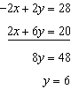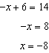

REF: 062120ai

8 ANS: 4 REF: 081622ai

9 ANS: 4 REF: 011621ai

10 ANS: 4

REF: 081724ai

11 ANS: 1
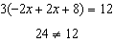

REF: 061708ai

12 ANS: 4
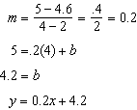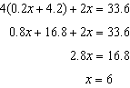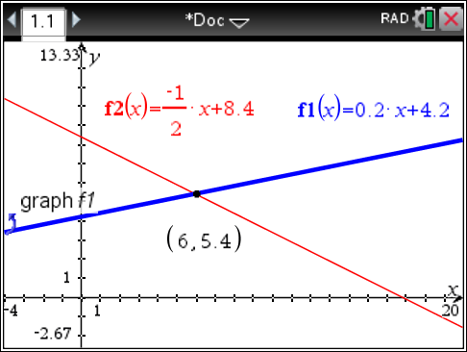

REF: 061618ai

13 ANS:
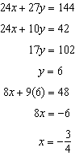 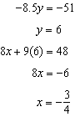 Agree, as both systems have the same solution.

REF: 061533ai

14 ANS:
No. There are infinite solutions.

REF: 011725ai

15 ANS:
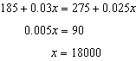

REF: 081427ai

