1 Which equation has imaginary roots?
1)
2)
3)
4)

2 Which equation has imaginary roots?
1)
2)
3)
4)

3 Which equation has imaginary roots?
1)
2)
3)
4)

4 In the equation , imaginary roots will be generated if
1)
2)
3)
4)

5 The equation has imaginary roots when n is equal to
1) | 10
2) | 8
3) | 6
4) | 4

6 For which positive value of m will the equation have roots that are real, equal, and rational?
1) | 12
2) | 9
3) | 3
4) | 4

7 For which value of k will the roots of be real?
1) | 1
2) | 2
3) | 3
4) | 0

8 For which value of c will the roots of the equation be real numbers?
1) | 1
2) | 2
3) | 3
4) | 4

9 Which value of c would make the roots of the equation real, rational, and equal?
1) | 9
2)
3) | 18
4)

10 The roots of the equation are real and equal if k is equal to
1)
2) | 2
3)
4) | 4

11 The roots of the equation are real if the value of k is
1) | 0
2) | 2
3) | 3
4) | 4

12 Which value of c will make the roots of the equation real and equal?
1)
2)
3) | 0
4) | 16

13 The roots of the equation are real, rational, and equal when a has a value of
1) | 1
2) | 2
3) | 3
4) | 4

14 For which value of k will the roots of the equation be real and rational numbers?
1) | 1
2)
3) | 0
4) | 4

15 What is the greatest value of c for which the roots of the equation are real?

16 Use the discriminant to determine all values of k that would result in the equation having equal roots.

17 Find all values of k such that the equation has imaginary roots.

18 For what value of k are the roots of equal?

19 Find the value of k if the roots of the equation are equal.

20 What is one value of k for which has real roots?

1 ANS: 3

REF: 080211b

2 ANS: 3 REF: 068833siii

3 ANS: 3
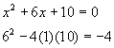

REF: 060518b

4 ANS: 4
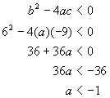

REF: 080320b

5 ANS: 1
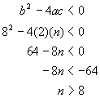

REF: 080411b

6 ANS: 1
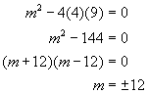

REF: 080516b

7 ANS: 3 REF: 019031siii

8 ANS: 1 REF: 089632siii

9 ANS: 1 REF: 089918siii

10 ANS: 2 REF: 060032siii

11 ANS: 4 REF: 080019siii

12 ANS: 4 REF: 010123siii

13 ANS: 2
. 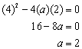

REF: 060307b

14 ANS: 3

REF: 061423a2

15 ANS:
4

REF: 080214siii

16 ANS:
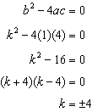

REF: 061028a2

17 ANS:
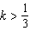. 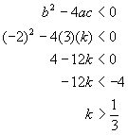

REF: 060423b

18 ANS:
8
REF: 018418siii

19 ANS:
9
REF: 068512siii

20 ANS:
REF: 019440siii

