1 Which graph represents a quadratic function with a negative discriminant?
1) | 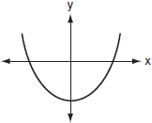
2) | 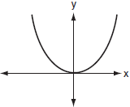
3) | 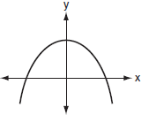
4) | 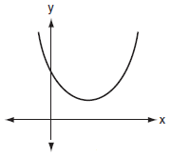

2 If zero is the value of the discriminant of the equation , which graph best represents ?
1) | 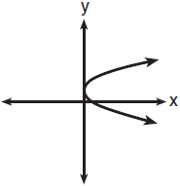
2) | 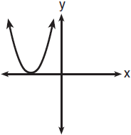
3) | 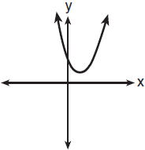
4) | 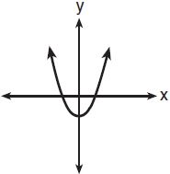

3 If the roots of are real, rational, and equal, what is true about the graph of the function ?
1) | It intersects the x-axis in two distinct points.
2) | It lies entirely below the x-axis.
3) | It lies entirely above the x-axis.
4) | It is tangent to the x-axis.

4 Which statement must be true if a parabola represented by the equation does not intersect the x-axis?
1)
2)
3) | , and is a perfect square.
4) | , and is not a perfect square.

5 Which is a true statement about the graph of the equation ?
1) | It is tangent to the x-axis.
2) | It does not intersect the x-axis.
3) | It intersects the x-axis in two distinct points that have irrational coordinates.
4) | It intersects the x-axis in two distinct points that have rational coordinates.

6 Jacob is solving a quadratic equation. He executes a program on his graphing calculator and sees that the roots are real, rational, and unequal. This information indicates to Jacob that the discriminant is
1) | zero
2) | negative
3) | a perfect square
4) | not a perfect square

7 If the roots of a quadratic equation are real, irrational, and unequal, the discriminant could have a value of
1) | 1
2) | 0
3) | 8
4)

8 The roots of a quadratic equation are real, rational, and equal when the discriminant is
1)
2) | 2
3) | 0
4) | 4

9 Which number is the discriminant of a quadratic equation whose roots are real, unequal, and irrational?
1) | 0
2)
3) | 7
4) | 4

10 Which equation has real, rational, and unequal roots?
1)
2)
3)
4)

11 Which equation has roots that are real, rational, and unequal?
1)
2)
3)
4)

12 Which equation has rational roots?
1)
2)
3)
4)

13 How many real-number solutions does have?
1) | one
2) | two
3) | zero
4) | infinitely many

14 How many real solutions does the equation have? Justify your answer.

15 Is the solution to the quadratic equation written below rational or irrational? Justify your answer.

16 Given the function , such that the entire graph of the function lies above the x-axis. Explain why the equation has no real solutions.

1 ANS: 4 REF: 080620b

2 ANS: 2 REF: 011020b

3 ANS: 4
If the roots of the quadratic are equal, the graph of the function intersects the x-axis only once.

REF: 010313b

4 ANS: 2
If a parabola does not intersect the x-axis, the roots are imaginary, and the discriminant is less than 0.

REF: 010416b

5 ANS: 4

REF: 010713b

6 ANS: 3 REF: 060103b

7 ANS: 3 REF: 061623a2

8 ANS: 3 REF: 010201b

9 ANS: 3 REF: 060717b

10 ANS: 2

REF: 011506a2

11 ANS: 3

REF: 010817b

12 ANS: 4 REF: 089828siii

13 ANS: 3

REF: 061822ai

14 ANS:
None

REF: 081529ai

15 ANS:
Irrational, as 89 is not a perfect square.

REF: 081828ai

16 ANS:
Since the graph lies entirely above the x-axis, there is no point on the graph where y = 0.

REF: 080525b

