1 The roots of are
1) | 1 and 4
2) | 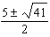
3) | and
4) | 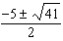

2 The roots of the equation are
1) | and
2) | and 3
3) | 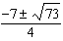
4) | 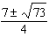

3 If the quadratic formula is used to find the roots of the equation , the correct roots are
1)
2)
3)
4)

4 A cliff diver on a Caribbean island jumps from a height of 105 feet, with an initial upward velocity of 5 feet per second. An equation that models the height, , above the water, in feet, of the diver in time elapsed, t, in seconds, is . How many seconds, to the nearest hundredth, does it take the diver to fall 45 feet below his starting point?
1) | 1.45
2) | 1.84
3) | 2.10
4) | 2.72

5 Solve for x to the nearest tenth: .

6 Use the quadratic formula to solve for x. Round the solutions to the nearest hundredth.

7 Solve algebraically for all values of x. Round your answer to the nearest hundredth.

8 Using the quadratic formula, solve for all values of x. Round your answers to the nearest hundredth.

9 Solve algebraically for all values of x, rounding to the nearest tenth.

10 Solve algebraically for all values of d, rounding to the nearest tenth.

11 Solve algebraically for w, to the nearest hundredth.

12 Use the quadratic formula to determine the exact roots of the equation .

13 Use the quadratic formula to solve the equation . Express the answer in simplest radical form.

14 Solve the equation and express the answer in simplest radical form.

15 Fred's teacher gave the class the quadratic function .
a) State two different methods Fred could use to solve the equation .
b) Using one of the methods stated in part a, solve for x, to the nearest tenth.

16 A rocket is shot vertically into the air. Its height, h, at any time, t, in seconds, can be modeled by the equation . Determine algebraically, the number of seconds it will take the rocket to reach a height of 529 feet.

17 Barb pulled the plug in her bathtub and it started to drain. The amount of water in the bathtub as it drains is represented by the equation , where L represents the number of liters of water in the bathtub and t represents the amount of time, in minutes, since the plug was pulled. How many liters of water were in the bathtub when Barb pulled the plug? Show your reasoning. Determine, to the nearest tenth of a minute, the amount of time it takes for all the water in the bathtub to drain.
1 ANS: 2
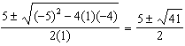

REF: 061921ai

2 ANS: 3
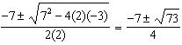

REF: 081009a2

3 ANS: 1
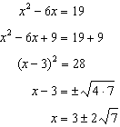

REF: fall1302ai

4 ANS: 2
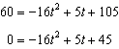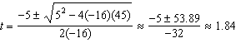

REF: 061424a2

5 ANS:
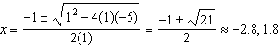

REF: 061827ai

6 ANS:
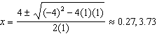

REF: 012330ai

7 ANS:
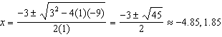

REF: 082332ai

8 ANS:
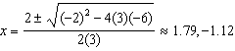

REF: 012429ai

9 ANS:
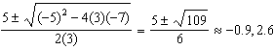

REF: 082231ai

10 ANS:
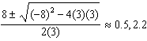

REF: 062332ai

11 ANS:
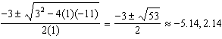

REF: 062132ai

12 ANS:
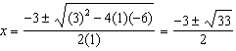

REF: 082429ai

13 ANS:
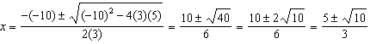

REF: 062433ai

14 ANS:
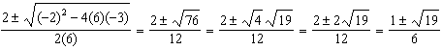

REF: 011332a2

15 ANS:
Two of the following: quadratic formula, complete the square, factor by grouping or graphically.
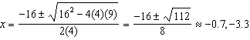

REF: 011634ai

16 ANS:
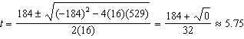

REF: 011738a2

17 ANS:
120, 4.2. Barb pulled the plug at t = 0, so there were 120 liters in the tub. 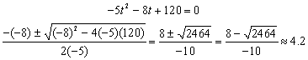

REF: 080634b

