1 The quadratic equation is rewritten in the form , where q is a constant. What is the value of p?
1)
2)
3)
4) | 9

2 Which equation has the same solution as ?
1)
2)
3)
4)

3 Which equation is equivalent to ?
1)
2)
3)
4)

4 When solving the equation by completing the square, which equation is a step in the process?
1)
2)
3)
4)

5 When solving by completing the square, which equation is a step in the process?
1)
2)
3)
4)

6 Which step can be used when solving by completing the square?
1)
2)
3)
4)

7 Which equation has the same solutions as ?
1)
2)
3)
4)

8 Which equation has the same solutions as ?
1)
2)
3)
4)

9 Which equation has the same solution as ?
1)
2)
3)
4)

10 When using the method of completing the square, which equation is equivalent to ?
1)
2)
3)
4)

11 When completing the square for , which equation is a correct step in this process?
1)
2)
3)
4)

12 If is solved by completing the square, one of the steps in the process is
1)
2)
3)
4)

13 If is solved by completing the square, an intermediate step would be
1)
2)
3)
4)

14 The method of completing the square was used to solve the equation . Which equation is a correct step when using this method?
1)
2)
3)
4)

15 What are the roots of the equation ?
1)
2)
3)
4)

16 What are the solutions to the equation ?
1)
2)
3)
4)

17 What are the solutions to the equation ?
1)
2)
3)
4)

18 Which value of k will make 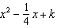 a perfect square trinomial?
1)
2)
3)
4)

19 Brian correctly used a method of completing the square to solve the equation . Brian’s first step was to rewrite the equation as . He then added a number to both sides of the equation. Which number did he add?
1)
2)
3)
4) | 49

20 When directed to solve a quadratic equation by completing the square, Sam arrived at the equation 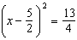. Which equation could have been the original equation given to Sam?
1)
2)
3)
4)

21 Express the equation in the form .

22 Solve the following equation by completing the square:

23 Solve the equation by completing the square.

24 Determine the exact values of x for by completing the square.

25 Use the method of completing the square to determine the exact values of x for the equation .

26 Find the exact roots of by completing the square.

27 Use the method of completing the square to determine the exact values of x for the equation .

28 Use the method of completing the square to determine the exact values of x for the equation . Express your answer in simplest radical form.

29 Solve by completing the square, expressing the result in simplest radical form.

30 A student was given the equation to solve by completing the square. The first step that was written is shown below.
The next step in the student’s process was . State the value of c that creates a perfect square trinomial. Explain how the value of c is determined.
1 ANS: 3
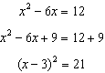

REF: 061812ai

2 ANS: 2

REF: 061408ai

3 ANS: 2
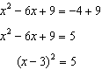

REF: 082320ai

4 ANS: 2
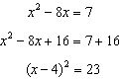

REF: 011614ai

5 ANS: 1
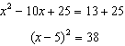

REF: 082215ai

6 ANS: 1 REF: 061408a2

7 ANS: 4
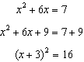

REF: 011517ai

8 ANS: 2
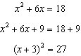

REF: 082408ai

9 ANS: 1
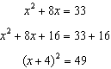

REF: 011915ai

10 ANS: 4
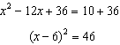

REF: 012319ai

11 ANS: 1
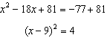

REF: 062306ai

12 ANS: 3
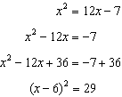

REF: 061505a2

13 ANS: 2
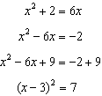

REF: 011116a2

14 ANS: 1
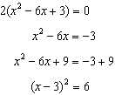

REF: 011722ai

15 ANS: 2
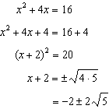

REF: 061410ai

16 ANS: 2
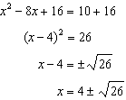

REF: 061722ai

17 ANS: 1
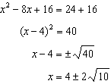

REF: 061523ai

18 ANS: 1
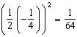

REF: 081527a2

19 ANS: 2 REF: 061122a2

20 ANS: 4
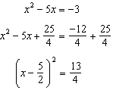

REF: 061518ai

21 ANS:
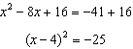

REF: 012431ai

22 ANS:
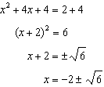

REF: 081830ai

23 ANS:
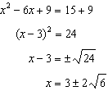

REF: 081732ai

24 ANS:
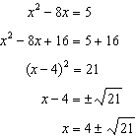

REF: 062232ai

25 ANS:
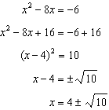

REF: 012031ai

26 ANS:
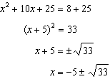

REF: 011636a2

27 ANS:
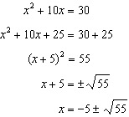

REF: 062429ai

28 ANS:
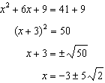

REF: fall2304ai

29 ANS:
. 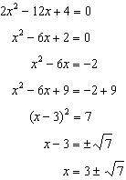

REF: fall0936a2

30 ANS:
Since , p is half the coefficient of x, and the constant term is equal to . 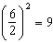

REF: 081432ai

