1 The larger root of the equation is
1)
2)
3) | 3
4) | 4

2 The roots of the equation are
1) | and 2
2) | and 2
3) | 0 and
4) | 0 and 4

3 The roots of the equation are
1) | 0 and 9
2) | 0 and
3) | 0 and 3
4) | 0 and

4 One of the roots of the equation is 3. What is the other root?
1) | 15
2) | 6
3)
4)

5 What are the roots of the equation ?
1) | 1 and 21
2)
3) | 3 and 7
4)

6 What are the roots of the equation ?
1) | 1 and 7
2) | and 7
3) | and
4) | 1 and 6

7 What are the roots of the equation ?
1) | 1 and
2) | 2 and 3
3) | and 6
4) | and

8 The roots of the equation are
1) | and
2) | and 8
3) | 6 and
4) | 6 and 8

9 One root of the equation is
1)
2)
3) | 3
4)

10 Find the roots of the equation algebraically.

11 Find the roots of the equation algebraically.

12 If the roots of a quadratic equation are and 3, the equation can be written as
1)
2)
3)
4)

13 If the roots of a quadratic equation are and 2, the equation is equivalent to
1)
2)
3)
4)

14 Which equation has roots of and 5?
1)
2)
3)
4)

15 Form the quadratic equation whose roots are and .

16 The two roots of an equation are and . Form the equation.

17 Write a quadratic equation in standard form that has roots of and 2.

18 Form an equation whose roots are 2 and .

19 Form the equation whose roots are and .
1 ANS: 3
The two roots are and 3. The larger root is 3.

REF: 069909a

2 ANS: 4
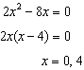

REF: 011427ia

3 ANS: 1
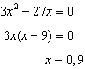

REF: 011223ia

4 ANS: 3
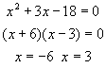

REF: 080622a

5 ANS: 3
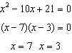

REF: 010914ia

6 ANS: 4
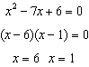

REF: 060902ia

7 ANS: 2
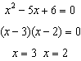

REF: 081120ia

8 ANS: 4
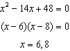

REF: 011320ia

9 ANS: 3
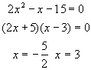

REF: 060104a

10 ANS:
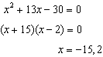

REF: 081036ia

11 ANS:
. 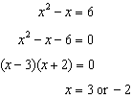

REF: 011034ia

12 ANS: 2 REF: 061326ia

13 ANS: 1 REF: 081420ia

14 ANS: 2
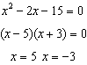

REF: 011128ia

15 ANS:

REF: 019012al

16 ANS:

REF: 119207al

17 ANS:
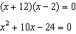

REF: 061533ia

18 ANS:

REF: 039112al

19 ANS:

REF: 019311al

