1 Solve for x:

2 Solve for x:

3 Solve for x:

4 Solve algebraically for all values of x.

5 Solve algebraically. Explain the first step you used to solve the given equation.

6 In the equation , b is an integer. Find algebraically all possible values of b.

7 Solve:

8 Solve the equation for y:

9 Write an equation that defines as a trinomial where . Solve for x when .

10 Solve:

11 Solve:

12 Solve the equation algebraically for x.

13 Solve:

14 Solve:

15 Solve:

16 Solve:

17 Solve algebraically for the exact values of x.

18 Solve for m by factoring.

19 Amy solved the equation . She stated that the solutions to the equation were and . Do you agree with Amy's solutions? Explain why or why not.

20 Janice is asked to solve . She begins the problem by writing the following steps:
Line 1
Line 2
Line 3
Use Janice's procedure to solve the equation for x. Explain the method Janice used to solve the quadratic equation.
1 ANS:
and 5. 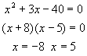

REF: 089926a

2 ANS:
. 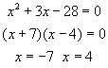

REF: 060229a

3 ANS:
. 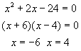

REF: 010637a

4 ANS:
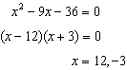

REF: 082329ai

5 ANS:
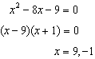 I factored the quadratic.

REF: 011927ai

6 ANS:
6 and 4

REF: 081425ai

7 ANS:
1, 5

REF: 069109al

8 ANS:
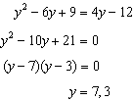

REF: 011627ai

9 ANS:
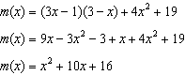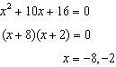

REF: 061433ai

10 ANS:
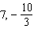

REF: 019805al

11 ANS:
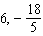

REF: 069805al

12 ANS:
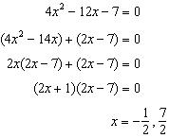

REF: 011529ai

13 ANS:
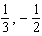

REF: 019607al

14 ANS:
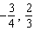

REF: 099805al

15 ANS:
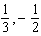

REF: 030005al

16 ANS:
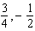

REF: 060005al

17 ANS:
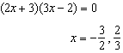

REF: 062230ai

18 ANS:
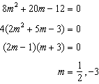

REF: fall1305ai

19 ANS:
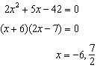 Agree, as shown by solving the equation by factoring.

REF: 061628ai

20 ANS:
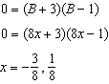 Janice substituted B for , resulting in a simpler quadratic. Once factored, Janice substituted for B.

REF: 081636ai

