1 What is the solution set of the equation ?
1)
2)
3)
4)

2 The solution to the equation is
1) | 0, only
2) | 6, only
3) | 0 and 6
4)

3 What is the solution set of the equation ?
1) | and a
2) | and
3) | 2 and a
4) | 2 and

4 The solution set for the equation is
1)
2)
3)
4)

5 What is the solution set of ?
1)
2)
3)
4)

6 What is the solution set of the equation ?
1)
2)
3)
4)

7 What is the solution set for the equation ?
1)
2)
3)
4)

8 What is the solution set of the equation ?
1)
2)
3)
4)

9 The solution set of the equation is
1)
2)
3)
4)

10 The solution set for the equation is
1)
2)
3)
4)

11 The solutions of are
1) | and
2) | 2 and 14
3) | and
4) | 4 and 7

12 If is a factor of , then the value of w is
1) | 12
2)
3) | 3
4)

13 Which equation has the solution set ?
1)
2)
3)
4)

14 For which equation is the solution set ?
1)
2)
3)
4)

15 Which equation has the same solutions as
1)
2)
3)
4)

16 What is the solution set of the equation ?
1)
2) | 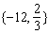
3) | 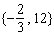
4)

17 What are the solutions to the equation ?
1) | and
2) | and 4
3) | and
4) | and 2

1 ANS: 2
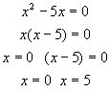

REF: 010727a

2 ANS: 3
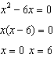

REF: 080921ia

3 ANS: 3 REF: 011702ai

4 ANS: 2
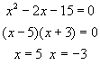

REF: 080012a

5 ANS: 1
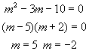

REF: 080118a

6 ANS: 1
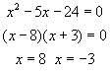

REF: 060313a

7 ANS: 4
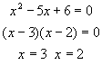

REF: 010520a

8 ANS: 2
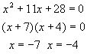

REF: 060514a

9 ANS: 3
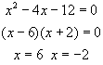

REF: 060725a

10 ANS: 3
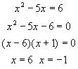

REF: 080525a

11 ANS: 2
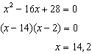

REF: 061311ia

12 ANS: 1
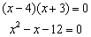

REF: 060430a

13 ANS: 1
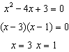

REF: 010913a

14 ANS: 1
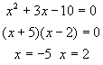

REF: 080825a

15 ANS: 4 REF: 011503ai

16 ANS: 3
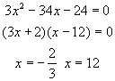

REF: 010419a

17 ANS: 1
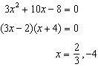

REF: 081619ai

