1 If the domain is the set of real numbers, what is the solution set for the equation ?
1)
2)
3)
4)

2 The solution to is
1)
2)
3)
4)

3 What is the solution set of the equation ?
1)
2) | {2,8}
3)
4)

4 A solution of the equation 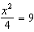 is
1) | 12
2) | 6
3) | 3
4)

5 If , the roots of the equation are
1) | and 25
2) | , only
3) | and 5
4) | , only

6 Solve algebraically.

7 What is the positive solution of the equation ?

8 Solve for the exact values of x.

9 Solve the quadratic equation below for the exact values of x.

10 Which value of x is a solution to the equation ?
1)
2)
3)
4)

11 The solutions to are
1)
2)
3) | and
4) | 1 and 7

12 The solution of the equation is
1)
2)
3)
4)

13 A student is asked to solve the equation . The student's solution to the problem starts as 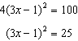
A correct next step in the solution of the problem is
1)
2)
3)
4)

14 What is the solution of the equation ?
1) | 6, only
2) | 2, only
3) | 2 and
4) | 6 and

15 What are the solutions to the equation ?
1) | 1 and 7
2) | and
3)
4)

16 Ryker is given the graph of the function 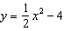. He wants to find the zeros of the function, but is unable to read them exactly from the graph.
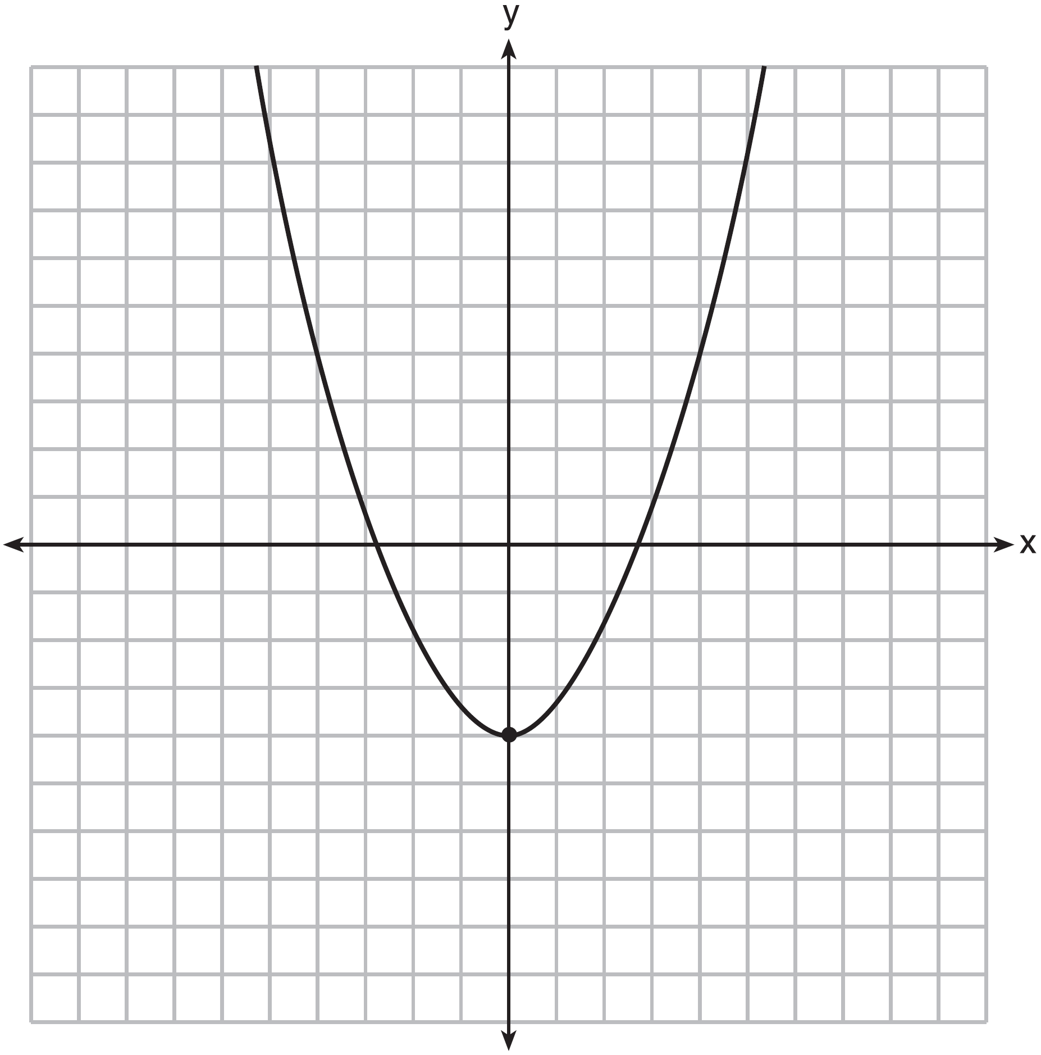

Find the zeros in simplest radical form.
1 ANS: 4 REF: 010324siii

2 ANS: 4
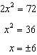

REF: 062318ai

3 ANS: 3
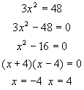

REF: 010215a

4 ANS: 2
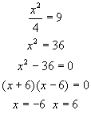

REF: 010808a

5 ANS: 3 REF: 081403ai

6 ANS:
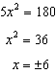

REF: 061928ai

7 ANS:
3. 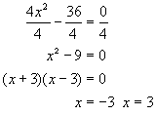

REF: 080733a

8 ANS:
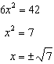

REF: 081931ai

9 ANS:
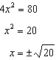

REF: 011932ai

10 ANS: 4
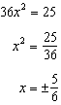

REF: 011715ai

11 ANS: 3
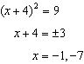

REF: 012015ai

12 ANS: 3 REF: 081523ai

13 ANS: 1 REF: 061521ai

14 ANS: 3
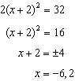

REF: 061619ai

15 ANS: 1
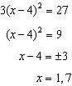

REF: 011814ai

16 ANS:
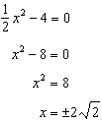

REF: fall1306ai

