1 The solutions of the equation are
1) | 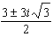
2) | 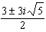
3) | 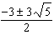
4) | 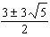

2 The roots of the equation are
1) | 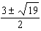
2) | 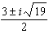
3) | 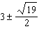
4) | 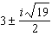

3 The roots of the equation are
1) | 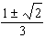
2) | 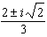
3) | 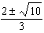
4) | 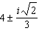

4 Solve the equation for x and express the roots in simplest form:

5 Solve for x and express the roots of the equation in simplest form.

6 Solve the equation and express the roots in simplest form.

7 Solve the equation for x and express the roots in simplest form:

8 Solve for x and express the roots in terms of i:

9 Solve for x and express the roots in terms of i:

10 Express the roots of the equation in simplest form.

11 Express the roots of the equation in form.

12 Express the roots of the equation in form.

13 Express the roots of the equation in simplest form.
1 ANS: 4
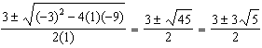

REF: 061009a2

2 ANS: 2 REF: 068526siii

3 ANS: 2 REF: 088526siii

4 ANS:
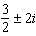

REF: 089838siii

5 ANS:
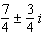

REF: 069937siii

6 ANS:
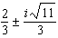. . 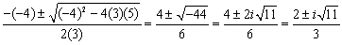

REF: 080931b

7 ANS:
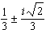

REF: 010438siii

8 ANS:
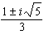

REF: 019542siii

9 ANS:

REF: 089541siii

10 ANS:
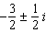

REF: 080238siii

11 ANS:
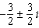

REF: 068636siii

12 ANS:
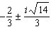

REF: 089037siii

13 ANS:
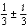

REF: 060138siii

