1 Max solves a quadratic equation by completing the square. He shows a correct step:
What are the solutions to his equation?
1)
2)
3)
4)

2 The roots of the equation are
1)
2)
3)
4)

3 Solve for x in simplest form:

4 In physics class, Taras discovers that the behavior of electrical power, x, in a particular circuit can be represented by the function . If , solve the equation and express your answer in simplest form.

5 Solve the equation and express the roots in simplest form.

6 Express, in simplest form, the roots of the equation .

7 Find the roots of the equation and express your answer in simplest form.

8 Solve the equation and express the roots in the form .

9 Express the roots of the equation in form.

10 Solve the equation and express your answers in the form .

11 Solve the equation and express the roots in terms of i.

12 Solve the equation and express the roots in simplest form.

13 Solve for x and express the roots in simplest form:

14 Solve for x and express your answer in simplest form:

15 Solve for x and express your answer in simplest form:

16 Solve the equation , and express the roots in the form .

17 Express the roots of the equation in form.

18 Express the roots of the equation in form.

19 Express the roots of the equation in simplest form.

20 Solve for x and express in simplest form:

21 Solve for x and express your answer in simplest form: 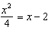
1 ANS: 2
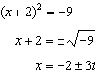

REF: 011408a2

2 ANS: 1 REF: 088422siii

3 ANS:
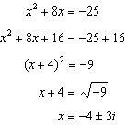

REF: 010222b

4 ANS:
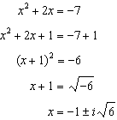

REF: 010627b

5 ANS:
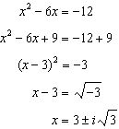. .

REF: fall9928b

6 ANS:
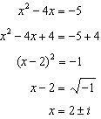

REF: 080328b

7 ANS:
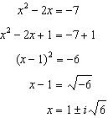

REF: 010931b

8 ANS:

REF: 068038siii

9 ANS:

REF: 088537siii

10 ANS:

REF: 088637siii

11 ANS:

REF: 088738siii

12 ANS:

REF: 088937siii

13 ANS:

REF: 019736siii

14 ANS:

REF: 010339siii

15 ANS:

REF: 060042siii

16 ANS:

REF: 018737siii

17 ANS:

REF: 019638siii

18 ANS:

REF: 018942siii

19 ANS:
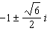

REF: 089939siii

20 ANS:
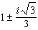

REF: 019440siii

21 ANS:

REF: 010242siii

