1 The graphs below represent functions defined by polynomials. For which function are the zeros of the polynomials 2 and ?
1) | 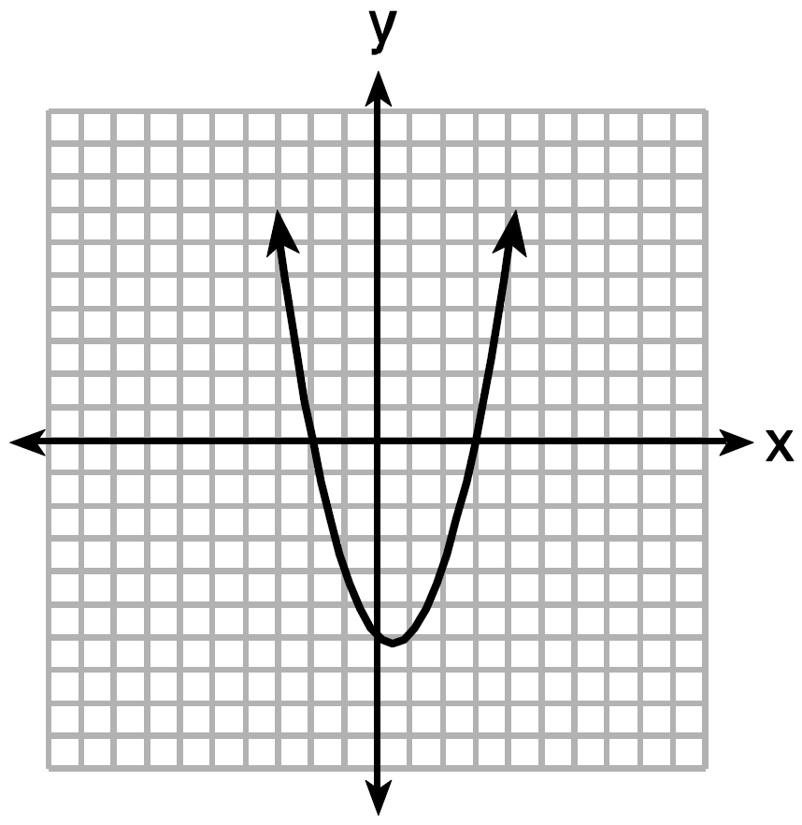
2) | 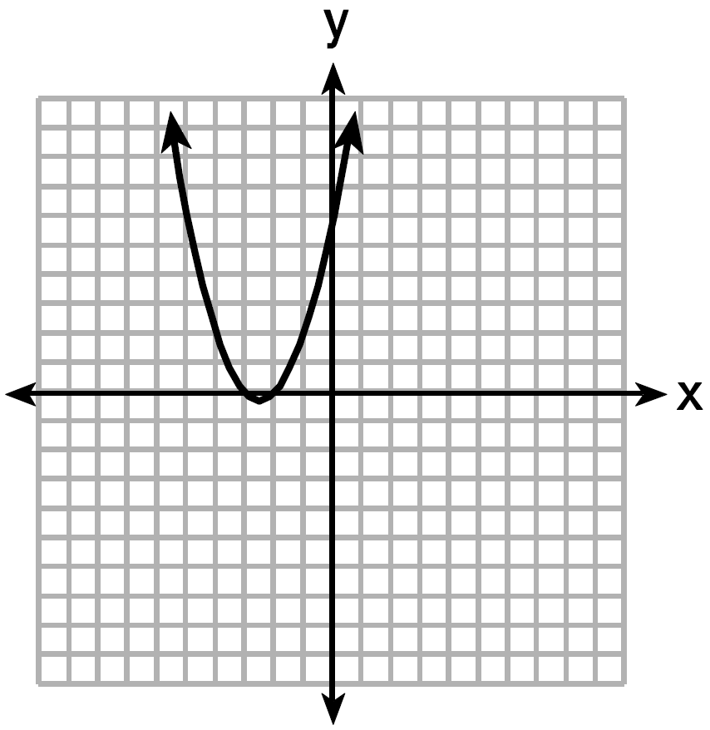
3) | 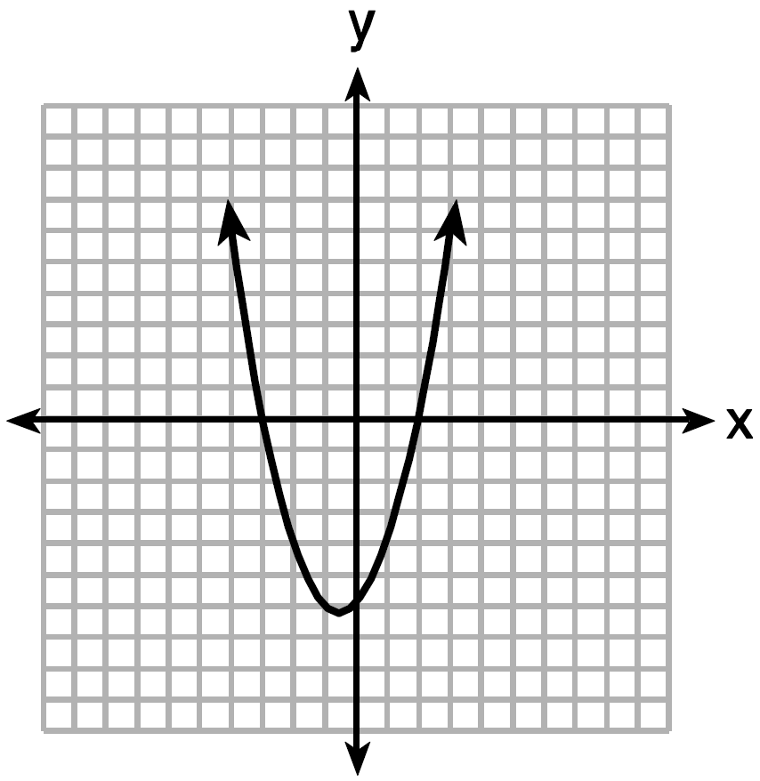
4) | 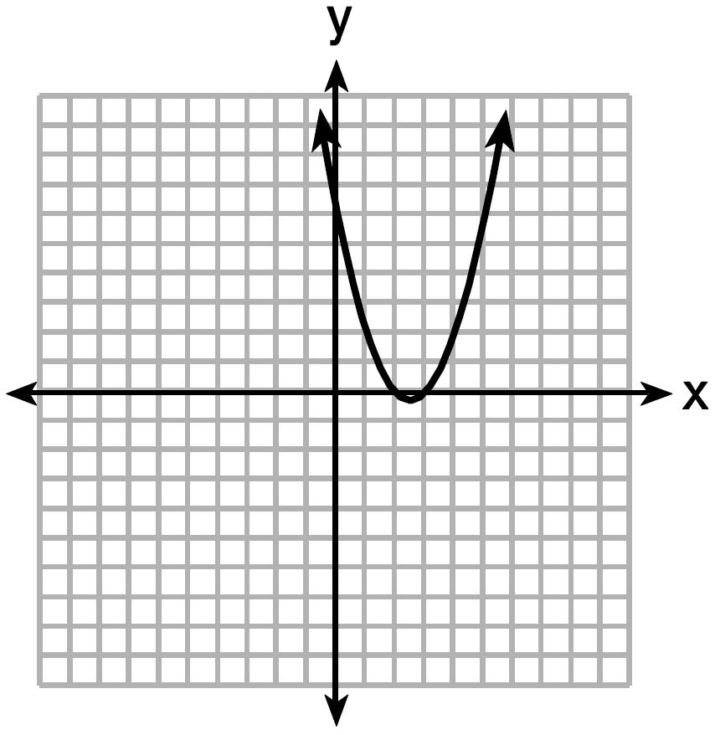

2 Which function has zeros of -4 and 2?
1)
2) | 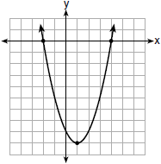
3)
4) | 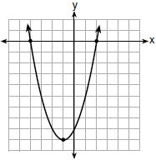

3 The graph of 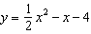 is shown below. The points , , and lie on this graph.
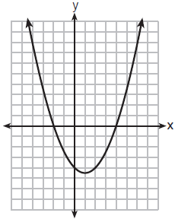
Which of these points can determine the zeros of the equation ?
1) | A, only
2) | B, only
3) | A and C, only
4) | A, B, and C

1 ANS: 3 REF: spr1302ai

2 ANS: 4 REF: 011706ai

3 ANS: 3 REF: 011909ai

