1 If the equation has as one root, what is the value of k?
1) | 9
2)
3) | 3
4)

2 If 2 and 3 are roots of the equation , what is the value of k?
1) | 1
2) | 6
3) | 5
4)

3 If and 7 are the roots of the quadratic equation , then k must be
1)
2)
3) | 6
4) | 8

4 If one root of the equation is , what is the other root?
1)
2) | 2
3) | 3
4) | 5

5 In the equation , one value of x is 2.5. Find c. Find the other value of x.

6 For which equation is the sum of the roots equal to the product of the roots?
1)
2)
3)
4)

7 If the sum of the roots of the equation is equal to the product of the roots, the value of k is
1)
2)
3) | 3
4) | 6

8 What is the product of the roots of if one of the roots is 7?
1) | 21
2)
3)
4)

9 Which quadratic equation has the roots and ?
1)
2)
3)
4)

10 Which equation has roots of and ?
1)
2)
3)
4)

1 ANS: 1
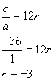. 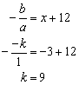

REF: 060606b

2 ANS: 4 REF: 018728siii

3 ANS: 2 REF: 019923siii

4 ANS: 4 REF: 060325siii

5 ANS:
1.25, 0.5

REF: 069940siii

6 ANS: 4
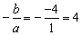. 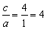

REF: 080612b

7 ANS: 3 REF: 018633siii

8 ANS: 3
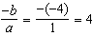. If the sum is 4, the roots must be 7 and .

REF: 011418a2

9 ANS: 3
The sum of the roots is 4 and the product of the roots is 1. 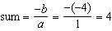. 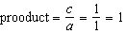.

REF: 061017b

10 ANS: 2 REF: 089628siii

