1 Which equation has roots whose sum is 3 and whose product is ?
1)
2)
3)
4)

2 Juan has been told to write a quadratic equation where the sum of the roots is equal to and the product of the roots is equal to . Which equation meets these requirements?
1)
2)
3)
4)

3 For which equation does the sum of the roots equal and the product of the roots equal 2?
1)
2)
3)
4)

4 For which equation does the sum of the roots equal 3 and the product of the roots equal 4.5?
1)
2)
3)
4)

5 For which equation does the sum of the roots equal and the product of the roots equal ?
1)
2)
3)
4)

6 Which equation has roots with the sum equal to and the product equal to ?
1)
2)
3)
4)

7 Which quadratic equation has roots whose sum is and product is ?
1)
2)
3)
4)

8 Which quadratic equation has roots with a sum of and a product of ?
1)
2)
3)
4)

9 Write a quadratic equation such that the sum of its roots is and the product of its roots is 6. What are the roots of this equation?

10 Write a quadratic equation such that the sum of its roots is 6 and the product of its roots is .
1 ANS: 2
sum of the roots, 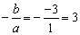. product of the roots, 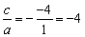

REF: 060820b

2 ANS: 3
sum of the roots, 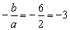. product of the roots, 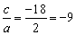

REF: 010919b

3 ANS: 3
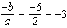. 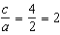

REF: 011121a2

4 ANS: 4 REF: 069931siii

5 ANS: 3
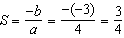. 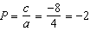

REF: fall0912a2

6 ANS: 3
sum of the roots, 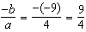. product of the roots, 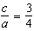

REF: 061208a2

7 ANS: 4
sum of the roots, 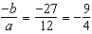. product of the roots, 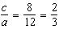

REF: 061627a2

8 ANS: 3
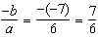. 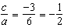

REF: 011718a2

9 ANS:
, . 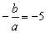. 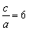. If then and 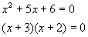
REF: 010830b

10 ANS:
, 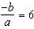. 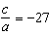. If then and
REF: 061130a2

