1 Given the equation . What is the product of the roots?
1) | 9
2)
3) | 3
4)

2 What is the product of the roots of the equation ?
1)
2)
3)
4) | 4

3 What is the product of the roots of the equation ?
1)
2)
3) | 3
4)

4 What is the product of the roots of the equation ?
1) | 1
2) | 2
3)
4)

5 What is the product of the roots of ?
1)
2)
3)
4)

6 What is the product of the roots of the quadratic equation ?
1) | 5
2)
3)
4)

7 What is the sum of the roots of the equation ?
1)
2) | 2
3)
4)

8 What is the sum of the roots of the equation ?
1)
2)
3)
4)

9 What is the sum of the roots of the equation ?
1)
2)
3) | 3
4)

10 What is the sum of the roots of the equation ?
1)
2)
3)
4)

11 What is the sum of the roots of the equation ?
1)
2)
3)
4)

12 What is the sum of the roots of the equation ?
1)
2) | 2
3)
4)

13 Find the sum of the roots of the equation .

14 What are the sum and product of the roots of the equation ?
1) | 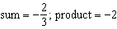
2) | 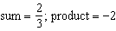
3) | 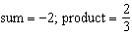
4) | 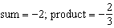

15 What are the sum (S) and product (P) of the roots of the equation ?
1) | 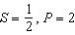
2) | 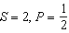
3) | 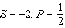
4)

16 What are the sum (S) and product (P) of the roots of the equation ?
1)
2) | 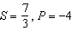
3) | 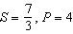
4) | 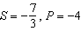

17 Which statement about the equation is true?
1) | The product of the roots is .
2) | The product of the roots is .
3) | The sum of the roots is 3.
4) | The sum of the roots is .

18 Find the sum and product of the roots of the equation .

19 Determine the sum and the product of the roots of the equation .

20 Determine the sum and the product of the roots of .

21 Given the equation , state the sum and product of the roots.

22 If the sum of the roots of is added to the product of its roots, the result is
1) | 15
2)
3)
4)

23 If the sum of the roots of the equation is added to the product of the roots, the result is
1) | 1
2)
3)
4) | 4

24 In the equation , the sum of the roots exceeds the product of the roots by
1) | 9
2) | 5
3)
4)

25 What is the product of the roots of the quadratic equation ?
1)
2) | 2
3)
4) | 4

1 ANS: 2 REF: 088730siii

2 ANS: 2 REF: 068733siii

3 ANS: 3 REF: 019523siii

4 ANS: 3 REF: 019726siii

5 ANS: 3
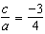

REF: 011517a2

6 ANS: 4
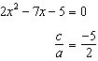

REF: 061414a2

7 ANS: 1 REF: 019424siii

8 ANS: 2 REF: 010429siii

9 ANS: 2 REF: 069635siii

10 ANS: 2 REF: 080129siii

11 ANS: 3 REF: 089418siii

12 ANS: 2
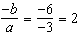

REF: 011613a2

13 ANS:

REF: 080210siii

14 ANS: 2
sum: 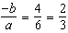. product: 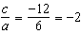

REF: 011209a2

15 ANS: 2 REF: 069833siii

16 ANS: 3 REF: 060133siii

17 ANS: 2
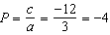

REF: 081506a2

18 ANS:
Sum 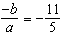. Product 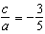

REF: 061030a2

19 ANS:
Sum 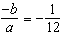. Product 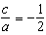

REF: 061328a2

20 ANS:
. Sum 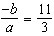. Product 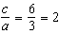

REF: 011329a2

21 ANS:
Sum 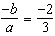. Product 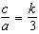

REF: 061534a2

22 ANS: 4
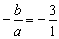. 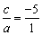.

REF: 080217b

23 ANS: 1 REF: 069034siii

24 ANS: 2 REF: 060030siii

25 ANS: 3
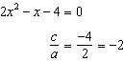

REF: 081605a2

