1 Which equation has roots of and ?
1)
2)
3)
4)

2 Which quadratic equation has the roots and ?
1)
2)
3)
4)

3 Which quadratic equation has the roots and ?
1)
2)
3)
4)

4 Which equation has as a solution?
1)
2)
3)
4)

5 Which equation has the complex number as a root?
1)
2)
3)
4)

6 If and are the roots of the equation , what is the value of c?
1)
2) | 5
3)
4) | 4

7 Write a quadratic equation whose roots are and .

8 If the solution set of is , find the value of p.

9 The roots of a quadratic equation are and . Find the sum of the roots and . Find the product of the roots and . Write a quadratic equation that has roots and .

10 If is one root of a quadratic equation with real coefficients, what is the sum of the roots of the equation?
1 ANS: 1
The product of the roots equals 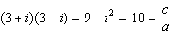. OR
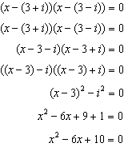
REF: 082208aii

2 ANS: 3 REF: 089325siii

3 ANS: 2 REF: 088620siii

4 ANS: 4
If is one solution, the other is . 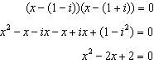
REF: 081601aii

5 ANS: 4
If is one root, the other is . The sum of the roots is 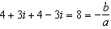
REF: 080718b

6 ANS: 2
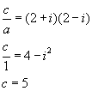
REF: 060719b

7 ANS:
REF: 089442siii

8 ANS:
REF: 018411siii

9 ANS:
6, 13,
REF: 080041siii

10 ANS:
REF: 010522b

