1 What is the solution to

2 What is the solution of ?

3 What is the solution of the inequality ?

4 When is solved for x, the solution is

5 What is the solution of ?

6 The solution to is

7 The inequality 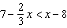 is equivalent to

8 The inequality 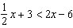 is equivalent to

9 What is the solution to the inequality 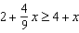?

10 Which inequality is shown on the accompanying graph?

11 Which inequality is represented in the graph below?

12 Which inequality is represented in the accompanying graph?

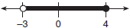

13 Which graph best represents the solution set for the inequality ?

14 Which graph represents the solution set of ?

15 Which graph represents the solution set for and ?

16 In order to be admitted for a certain ride at an amusement park, a child must be greater than or equal to 36 inches tall and less than 48 inches tall. Which graph represents these conditions?

17 On June 17, the temperature in New York City ranged from 90° to 99°, while the temperature in Niagara Falls ranged from 60° to 69°. The difference in the temperatures in these two cities must be between

18 Solve the inequality algebraically for x.

19 Solve algebraically for y:

20 Solve the inequality below:

21 Solve algebraically for x:

22 Solve algebraically for x: 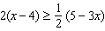

23 Solve 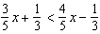 for x.

24 When is solved for a, the result is

25 Given that , solve for x in terms of a and b:

26 The manufacturer of Ron's car recommends that the tire pressure be at least 26 pounds per square inch and less than 35 pounds per square inch. On the accompanying number line, graph the inequality that represents the recommended tire pressure.

1 ANS:
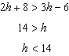

REF: 081607ai

2 ANS:
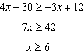

REF: 061406ia

3 ANS:
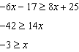

REF: 081121ia

4 ANS:
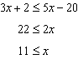

REF: 061609ai

5 ANS:
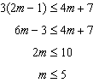

REF: 081002ia

6 ANS:
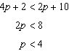

REF: 061801ai

7 ANS:
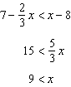

REF: 011507ai

8 ANS:
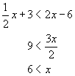

REF: 010425a

9 ANS:
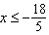
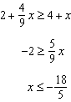

REF: 081711ai

10 ANS:
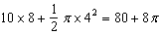

REF: 080815a

11 ANS:

REF: 060001a

12 ANS:

REF: 080411a

13 ANS:
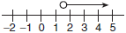

REF: 060616a

14 ANS:
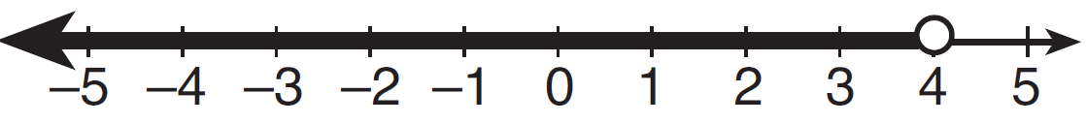

REF: 011418ia

15 ANS:
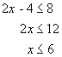. 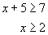

REF: 010312a

16 ANS:

REF: 010610a

17 ANS:
20° and 40°
The greatest difference occurs when NYC’s temperature is 99° and Niagara Falls’ temperature is 60°. The maximum difference is less than 40°. The least difference occurs when NYC’s temperature is 90° and Niagara Falls’ temperature is 69°. The minimum difference is greater than 20°.

REF: 089910a

18 ANS:
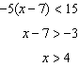

REF: 061331ia

19 ANS:
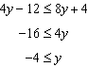

REF: 062125ai

20 ANS:
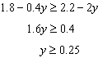

REF: 011727ai

21 ANS:
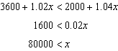

REF: 011925ai

22 ANS:
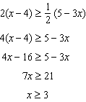

REF: 011234ia

23 ANS:
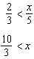

REF: 081929ai

24 ANS:
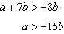

REF: 061913ai

25 ANS:
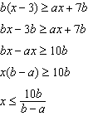

REF: 011631ai

26 ANS:
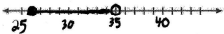

REF: 060532a

