1 When is solved for a, the result is
1)
2)
3)
4)

2 What is the solution to ?
1)
2) | 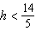
3)
4) | 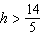

3 When is solved for x, the solution is
1)
2)
3)
4)

4 The solution to is
1)
2)
3)
4)

5 What is the solution to ?
1)
2)
3)
4)

6 What is the solution to the inequality ?
1)
2)
3)
4)

7 What is the solution to the inequality ?
1)
2)
3)
4)

8 What is the solution to 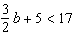?
1)
2)
3)
4)

9 The inequality 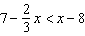 is equivalent to
1)
2) | 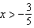
3)
4) | 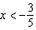

10 What is the solution to the inequality 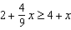?
1) | 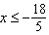
2) | 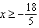
3) | 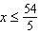
4) | 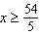

11 What is the solution to the inequality below?
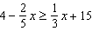
1)
2)
3)
4)

12 Solve algebraically.

13 Solve algebraically for y:

14 Solve the inequality 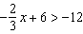 algebraically for x.

15 Solve the inequality below:

16 Solve algebraically for x:

17 Solve 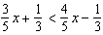 for x.

18 Given that , solve for x in terms of a and b:
1 ANS: 4
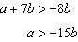

REF: 061913ai

2 ANS: 1
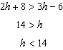

REF: 081607ai

3 ANS: 4
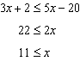

REF: 061609ai

4 ANS: 4
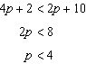

REF: 061801ai

5 ANS: 2
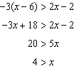

REF: 082310ai

6 ANS: 4
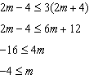

REF: 082413ai

7 ANS: 4
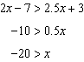

REF: 012418ai

8 ANS: 1
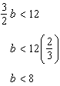

REF: 062207ai

9 ANS: 1
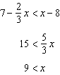

REF: 011507ai

10 ANS: 1
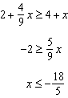

REF: 081711ai

11 ANS: 3
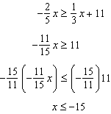

REF: 062322ai

12 ANS:
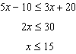

REF: 062425ai

13 ANS:
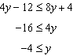

REF: 062125ai

14 ANS:
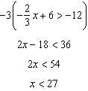

REF: 012327ai

15 ANS:
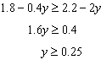

REF: 011727ai

16 ANS:
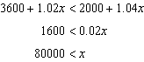

REF: 011925ai

17 ANS:
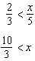

REF: 081929ai

18 ANS:
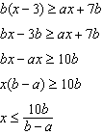
REF: 011631ai

