1 Solve for x: 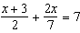

2 Solve for x: 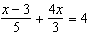

3 Solve: 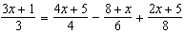

4 Solve: 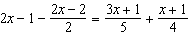

5 Solve: 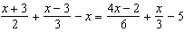
1 ANS:
7

REF: 069405siii

2 ANS:
3

REF: 069803siii

3 ANS:

REF: 019104al

4 ANS:
3

REF: 069805al

5 ANS:
5

REF: 089606al

