1 What is the value of x in the equation ?
1) 2) 3) 4) 4

2 What is the solution of the equation
1) 2) 2 3) 4.5 4) 13

3 The solution of the equation is
1) 1 2) 2 3) 4)

4 What is the value of n in the equation ?
1) 2) 3) 6 4) 10

5 What is the value of p in the equation ?
1) 1 2) 3) 3 4)

6 Which value of p is the solution of ?
1) 2) 3) 3 4) 7

7 What is the value of p in the equation ?
1) 1 2) 3) 3 4)

8 If , then x equals
1) 2) 3) 1.25 4) 2.5

9 Which value of x is the solution of the equation ?
1) 1 2) 2 3) 6 4) 0

10 Solve for x:
1) 1 2) 3) 3 4)

11 If , then x equals
1) 14 2) 7 3) 5 4) 4

12 If , the value of x is
1) 0 2) 5 3) 12 4) 20

13 What is the value of x in the equation ?
1) 6 2) 9 3) 10.5 4) 12

14 What is the value of x in the equation ?
1) 1 2) 0.6 3) 4)

15 What is the value of x in the equation ?
1) 2) 1.5 3) 3 4) 6

16 What is the value of m in the equation
1) 1 2) 3) 4) 0

17 What is the value of x in the equation ?
1) 1 2) 2 3) 3 4) 4

18 What is the value of x in the equation ?
1) 2) 2 3) 4)

19 If , the value of x is
1) 1 2) 3) 5 4) 4

20 If and , what is the product of x and m?
1) 2) 3) 3 4) 270

21 If and , the value of y is
1) 1 2) 0 3) 4) 10

22 What is the solution for the equation ?
1) 2) 3) all real numbers 4) There is no solution.

23 Debbie solved the linear equation as follows:

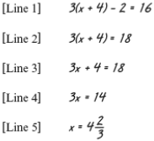

She made an error between lines
1) 1 and 2 2) 2 and 3 3) 3 and 4 4) 4 and 5

24 Solve for g:

25 Solve for x:

26 Solve algebraically for x:
1 ANS: 4
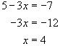

REF: 060810a

2 ANS: 1
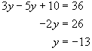

REF: 060214a

3 ANS: 4
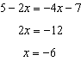

REF: 011305ia

4 ANS: 4
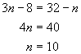

REF: 010705a

5 ANS: 4
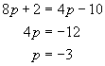

REF: 010807a

6 ANS: 4
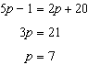

REF: 080801ia

7 ANS: 3
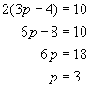

REF: 080602a

8 ANS: 4
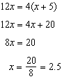

REF: spring9802a

9 ANS: 2
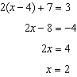

REF: 061425ia

10 ANS: 3
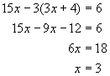

REF: 080015a

11 ANS: 4
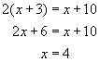

REF: 010401a

12 ANS: 3
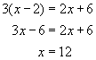

REF: 060404a

13 ANS: 4
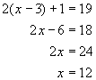

REF: 010904a

14 ANS: 3
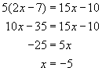

REF: 010601a

15 ANS: 3
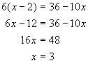

REF: 060702a

16 ANS: 1
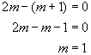

REF: 080812a

17 ANS: 3
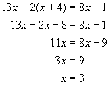
REF: 060602a

18 ANS: 1
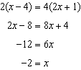
REF: 011106ia

19 ANS: 4
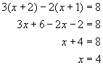
REF: 060813a

20 ANS: 4
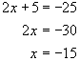. 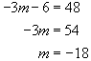. The product of x and m is 270.
REF: 080219a

21 ANS: 3
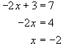. 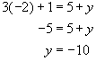.
REF: 060519a

22 ANS: 4
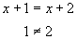
REF: 010908a

23 ANS: 2
Debbie failed to distribute the 3 properly.
REF: 011009ia

24 ANS:
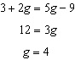
REF: fall0732ia

25 ANS:
10. 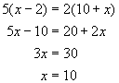.
REF: 080731a

26 ANS:
4. 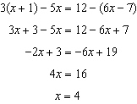
REF: 061238ia

