1 The statement is true when x is equal to
1)
2)
3) | 17
4) | 21

2 Which number is in the solution set of the inequality ?
1) | 5
2) | 6
3) | 7
4) | 8

3 Which value of x is in the solution set of the inequality ?
1)
2)
3)
4) | 12

4 Which value of x is in the solution set of the inequality ?
1)
2) | 2
3) | 3
4)

5 Which value of x is in the solution set of ?
1)
2)
3) | 0
4) | 3

6 Which value of x is a solution of the inequality ?
1) | 13
2) | 14
3) | 15
4) | 16

7 Which value of x is in the solution set of 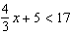?
1) | 8
2) | 9
3) | 12
4) | 16

8 Which value of x is in the solution set of the inequality ?
1) | 0
2) | 2
3) | 3
4) | 5

9 Which value of x is a solution of ?
1)
2)
3) | 3
4) | 0

10 In the set of positive integers, what is the solution set of the inequality ?
1)
2)
3)
4)

11 Find all the negative odd integers that satisfy the following inequality:

12 Given:
Determine all elements of set A that are in the solution of the inequality 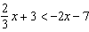.
1 ANS: 3 REF: 081317ia

2 ANS: 4
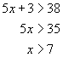

REF: 060311a

3 ANS: 1
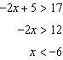

REF: fall0724ia

4 ANS: 4
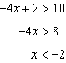

REF: 080805ia

5 ANS: 1
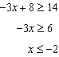

REF: 081309ia

6 ANS: 1
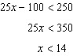

REF: 061517ia

7 ANS: 1
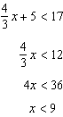

REF: 060914ia

8 ANS: 4
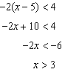

REF: 080913ia

9 ANS: 1
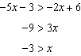

REF: 061622ia

10 ANS: 2
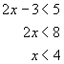

REF: 060118a

11 ANS:
. 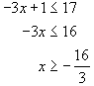

REF: 010536a

12 ANS:
. 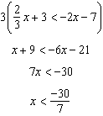

REF: 061034ia

