1 Given , which number is not in the solution set?
1) | 6
2) | 8
3) | 10
4) | 12

2 Which value would be a solution for x in the inequality ?
1)
2)
3) | 10
4) | 11

3 Given the set , what is the solution of ?
1)
2) | 1, 2
3)
4)

4 Determine the smallest integer that makes true.

5 Solve the inequality below to determine and state the smallest possible value for x in the solution set.

6 Given , determine the largest integer value of a when .

7 Solve for x algebraically:
If x is a number in the interval , state all integers that satisfy the given inequality. Explain how you determined these values.
1 ANS: 1
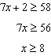
REF: 012003ai

2 ANS: 4
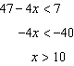
REF: 061713ai

3 ANS: 2
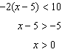
REF: 011817ai

4 ANS:
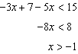 0 is the smallest integer.
REF: 061530ai

5 ANS:
6. 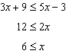
REF: 081430ai

6 ANS:
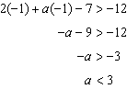
REF: 061427ai

7 ANS:
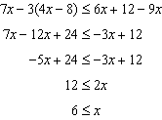 6, 7, 8 are the numbers greater than or equal to 6 in the interval.
REF: 081534ai

