1 An example of an algebraic expression is
1)
2)
3)
4)

2 An example of an algebraic expression is
1) | 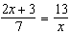
2)
3)
4)

3 An example of an algebraic expression is
1)
2)
3)
4)

4 An example of an algebraic expression is
1)
2)
3)
4)

5 Four students are playing a math game at home. One of the math game questions asked them to write an algebraic equation.
Brandon wrote:
William wrote:
Alice wrote:
Kayla wrote:
Which student wrote an algebraic equation?
1) | Brandon
2) | William
3) | Alice
4) | Kayla

6 Mr. Stanton asked his students to write an algebraic expression on a piece of paper. He chose four students to go to the board and write their expression.
Robert wrote:
Meredith wrote:
Steven wrote:
Cynthia wrote:
Which student wrote an algebraic expression?
1) | Robert
2) | Meredith
3) | Steven
4) | Cynthia

7 An example of an equation is
1)
2)
3)
4)

8 An example of an algebraic equation is
1)
2)
3)
4)

9 Chad complained to his friend that he had five equations to solve for homework. Are all of the homework problems equations? Justify your answer.

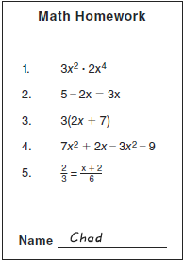
1 ANS: 4 REF: 061618ia

2 ANS: 2 REF: 011027ia

3 ANS: 1 REF: 081030ia

4 ANS: 2 REF: 061121ia

5 ANS: 4 REF: 011508ia

6 ANS: 2 REF: 011227ia

7 ANS: 4 REF: 011401ia

8 ANS: 3 REF: 061408ia

9 ANS:
Not all of the homework problems are equations. The first problem is an expression.

REF: 080931ia

