1 Which equation is equivalent to 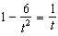?
1)
2)
3)
4)

2 Solve for y: 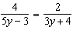

3 Solve: 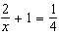

4 Solve for r: 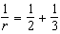

5 Solve for x: 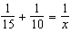

6 Solve for x: 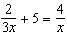

7 Solve for y: 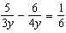

8 Solve for x: 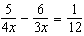

9 Solve for x: 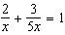

10 Solve for the positive value of x: 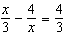

11 Solve for x: 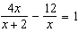

12 Solve for y: 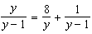

13 For all values of x for which the expression is defined, solve for x: 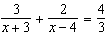

14 Solve for x: 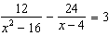

15 Solve for all values of x: 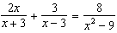

16 Solve for x: 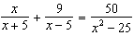

17 Solve for x: 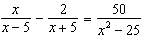

18 Solve the equation 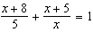 and express the roots in simplest form.

19 Solve the equation 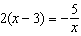 and express its roots in terms of i.

20 Solve the equation 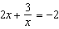 and express the roots in form.

21 Solve the equation 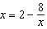 and express the roots in simplest form.

22 Express, in terms of i, the roots of 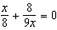.

23 Express the roots of the equation 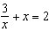 in simplest form.

24 Solve for x and express the roots in terms of i: 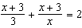

25 Solve for x and express the roots in simplest form: 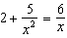

26 Express the roots of the equation 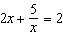 in simplest form.

27 Solve for y and express the roots of the equation in simplest form: 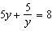

28 Solve for x and express your answer in simplest form: 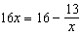

29 Solve for x and express the roots in simplest form: 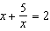

30 Solve for x and express the roots in simplest form: 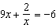

1 ANS: 1 REF: 060227siiii

2 ANS:

REF: 019705siii

3 ANS:

REF: 068714siii

4 ANS:

REF: 060213siii

5 ANS:
6

REF: 068015siii

6 ANS:

REF: 010410siii

7 ANS:
1

REF: 018909siii

8 ANS:

REF: 010204siii

9 ANS:

REF: 080308siii

10 ANS:
6

REF: 089809siii

11 ANS:
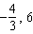

REF: 080041siii

12 ANS:
8

REF: 089637siii

13 ANS:
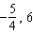

REF: 010042siii

14 ANS:

REF: 060138siii

15 ANS:

REF: 019840siii

16 ANS:
1

REF: 069841siii

17 ANS:

REF: 060342siii

18 ANS:

REF: 068537siii

19 ANS:

REF: 068738siii

20 ANS:
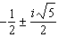

REF: 068837siii

21 ANS:

REF: 068936siii

22 ANS:

REF: 089339siii

23 ANS:

REF: 069441siii

24 ANS:

REF: 019736siii

25 ANS:
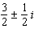

REF: 069740siii

26 ANS:
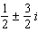

REF: 019838siii

27 ANS:
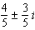

REF: 069841siii

28 ANS:
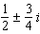

REF: 080142siii

29 ANS:

REF: 060237siii

30 ANS:
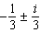

REF: 080341siii

