1 What is the value of x in the equation 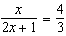?
1)
2)
3)
4)

2 If 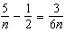, what is the value of n?
1)
2) | 2
3) | 9
4)

3 What is the solution set of the equation 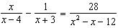?
1)
2)
3)
4)

4 One root of the equation 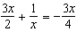 is
1)
2)
3)
4)

5 Solve for x: 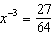

6 Solve algebraically for x: 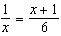

7 Solve for all values of x: 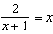

8 Solve for all values of x that satisfy the equation 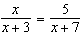.

9 Solve for all values of x: 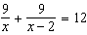

10 Solve for x and express your answer in simplest radical form: 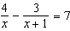

11 Solve for all values of x, to the nearest tenth: 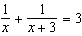

12 Solve: 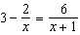

13 Solve: 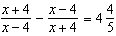

14 Solve: 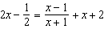

15 Working by herself, Mary requires 16 minutes more than Antoine to solve a mathematics problem. Working together, Mary and Antoine can solve the problem in 6 minutes. If this situation is represented by the equation 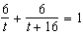, where t represents the number of minutes Antoine works alone to solve the problem, how many minutes will it take Antoine to solve the problem if he works by himself?

16 A rectangle is said to have a golden ratio when 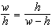, where w represents width and h represents height. When , between which two consecutive integers will h lie?

17 Electrical circuits can be connected in series, one after another, or in parallel circuits that branch off a main line. If circuits are hooked up in parallel, the reciprocal of the total resistance in the series is found by adding the reciprocals of each resistance, as shown in the accompanying diagram.

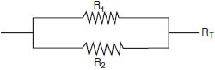

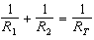

If , , and the total resistance, , is 2.25 ohms, find the positive value of to the nearest tenth of an ohm.
1 ANS: 2
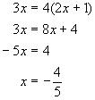
REF: 060612a

2 ANS: 3
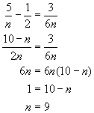
REF: 010825a

3 ANS: 3
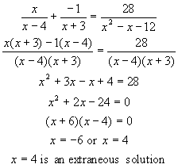
REF: 060212b

4 ANS: 3
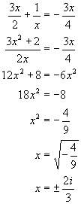
REF: 080818b

5 ANS:
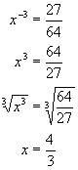
REF: 080423b

6 ANS:
2, . 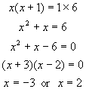
REF: 010131a

7 ANS:
1, . 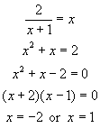
REF: 080722b

8 ANS:
. 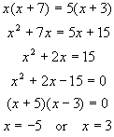
REF: 080439a

9 ANS:
. 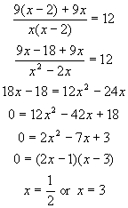
REF: 080529b

10 ANS:
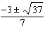. 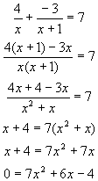. 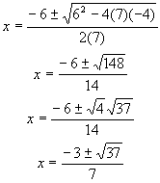
REF: 060429b

11 ANS:
0.4 and
REF: 011034b

12 ANS:
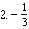
REF: 090403al

13 ANS:
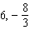
REF: 039111al

14 ANS:
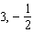
REF: 030502al

15 ANS:
8. 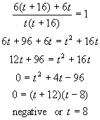
REF: 080125b

16 ANS:
. 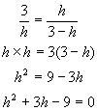. 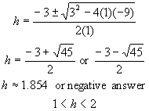
REF: 010224b

17 ANS:
3.5. 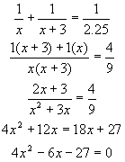. 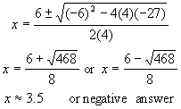
REF: 080234b

