1 Which equation could be used to solve 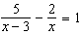?
1)
2)
3)
4)

2 Which value of x is the solution of 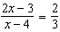?
1)
2)
3)
4) | 4

3 Which value of x is a solution of 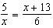?
1)
2)
3)
4)

4 What is the solution of the equation 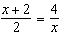?
1) | 1 and
2) | 2 and
3) | and 8
4) | and 4

5 What is the solution of the equation 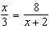?
1)
2)
3)
4)

6 What is the solution set of 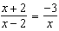?
1)
2)
3)
4)

7 What is the solution of 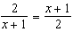?
1) | and
2) | and 3
3) | 1 and
4) | 1 and 3

8 Which value of x is the solution of 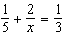?
1)
2)
3)
4) | 15

9 What is the solution of the equation 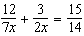?
1) | 1
2) | 5
3) | 3
4) | 14

10 What is the value of x in the equation 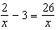?
1)
2)
3)
4) | 8

11 What is the solution set of 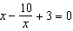?
1)
2)
3)
4)

12 What is the solution set of the equation 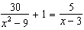?
1)
2)
3)
4)

13 Solve algebraically for all values of x that satisfy the equation: 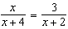

14 Solve for x: 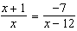

15 Solve algebraically for x: 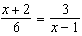

16 Solve algebraically for all values of x: 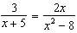

17 Solve algebraically for the exact values of x: 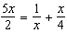

18 Solve algebraically for x: 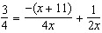

19 Solve for x: 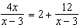

20 Solve algebraically for x: 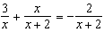

21 Solve algebraically: 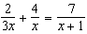
[Only an algebraic solution can receive full credit.]

22 Solve algebraically for x: 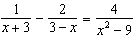

23 Solve the equation below algebraically, and express the result in simplest radical form:
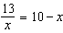
1 ANS: 3
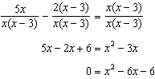

REF: 011522a2

2 ANS: 2
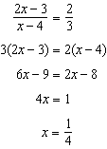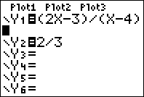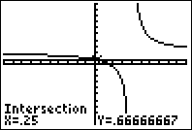

REF: 081012ia

3 ANS: 4
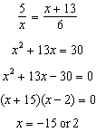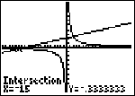

REF: 060826ia

4 ANS: 2
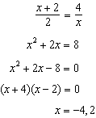

REF: 061317ia

5 ANS: 2
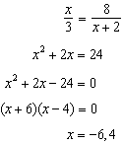

REF: 081429ia

6 ANS: 4
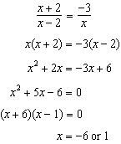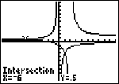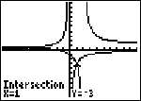

REF: 011028ia

7 ANS: 3
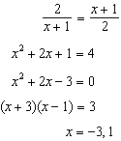

REF: 081226ia

8 ANS: 4
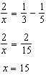

REF: 061507ia

9 ANS: 3
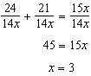

REF: 081416ia

10 ANS: 1
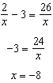

REF: 010918ia

11 ANS: 1
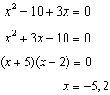

REF: 061616a2

12 ANS: 2
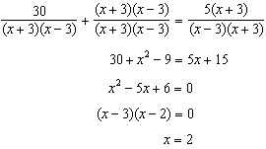 3 is an extraneous root.

REF: 061417a2

13 ANS:
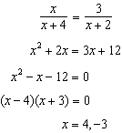

REF: 061636ia

14 ANS:
. 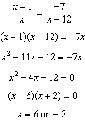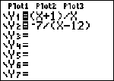 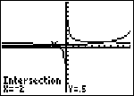

REF: fall0739ia

15 ANS:
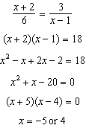

REF: 011136ia

16 ANS:
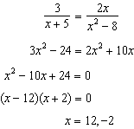

REF: 011438ia

17 ANS:
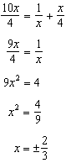

REF: 081534a2

18 ANS:
. 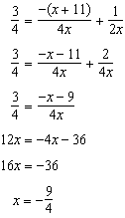

REF: 061137ia

19 ANS:
no solution. 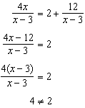

REF: fall0930a2

20 ANS:
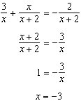

REF: 061537a2

21 ANS:
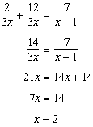

REF: 061337ia

22 ANS:
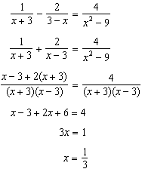

REF: 081036a2

23 ANS:
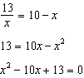. 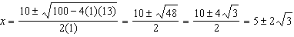

REF: 061336a2

