1 The focal length, F, of a camera’s lens is related to the distance of the object from the lens, J, and the distance to the image area in the camera, W, by the formula below.

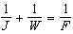

When this equation is solved for J in terms of F and W, J equals
1) |  | 3) | 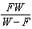
2) | 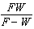 | 4) | 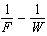

2 What is the solution set of the equation 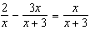?
1) |  | 3)
2) |  | 4) | 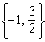

3 What is the solution set of the equation 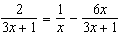?
1) | 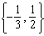 | 3)
2) | 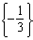 | 4) | 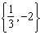

4 What is the solution set of the equation 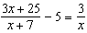?
1) | 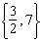 | 3) | 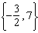
2) | 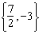 | 4) | 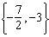

5 What is the solution set of the equation 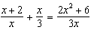?
1) |  | 3)
2) |  | 4)

6 What is the solution set of the equation 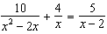?
1) |  | 3)
2) |  | 4)

7 The solution set of 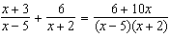 is
1) |  | 3)
2) |  | 4)

8 The solution of 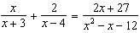 is
1) |  | 3) | 3
2) |  | 4) | 7

9 What is the solution, if any, of the equation 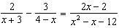?
1) |  | 3) | all real numbers
2) |  | 4) | no real solution

10 What is the solution set of the equation 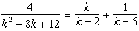?
1) |  | 3)
2) |  | 4)

11 To solve the equation 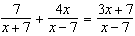, Joan's first step is to multiply both sides by the least common denominator. Which statement is true?
1) | is an extraneous solution. | 3) | 7 is an extraneous solution.
2) | 7 and are extraneous solutions. | 4) | There are no extraneous solutions.

12 To solve 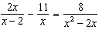, Ren multiplied both sides by the least common denominator. Which statement is true?
1) | 2 is an extraneous solution. | 3) | 0 and 2 are extraneous solutions.
2) | is an extraneous so1ution. | 4) | This equation does not contain any extraneous solutions.

13 The solutions to 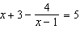 are
1) | 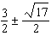 | 3) | 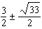
2) | 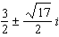 | 4) | 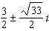

14 Solve for x: 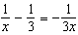

15 Solve algebraically for n: 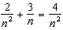

16 Solve for all values of p: 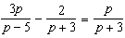

17 Solve algebraically for all values of x: 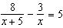

18 Algebraically solve for x: 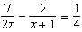

19 Algebraically solve for x: 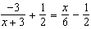

20 Solve for x algebraically: 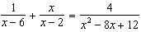

21 A formula for work problems involving two people is shown below.
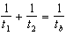
the time taken by the first person to complete the job
the time taken by the second person to complete the job
the time it takes for them working together to complete the job
Fred and Barney are carpenters who build the same model desk. It takes Fred eight hours to build the desk while it only takes Barney six hours. Write an equation that can be used to find the time it would take both carpenters working together to build a desk. Determine, to the nearest tenth of an hour, how long it would take Fred and Barney working together to build a desk.

22 Sarah is fighting a sinus infection. Her doctor prescribed a nasal spray and an antibiotic to fight the infection. The active ingredients, in milligrams, remaining in the bloodstream from the nasal spray, , and the antibiotic, , are modeled in the functions below, where t is the time in hours since the medications were taken.
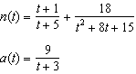
Determine which drug is made with a greater initial amount of active ingredient. Justify your answer. Sarah's doctor told her to take both drugs at the same time. Determine algebraically the number of hours after taking the medications when both medications will have the same amount of active ingredient remaining in her bloodstream.
1 ANS: 3
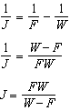

REF: 081617aii

2 ANS: 4
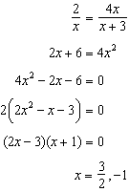

REF: 061809aii

3 ANS: 3
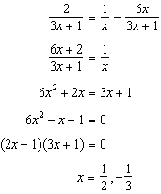 is extraneous.

REF: 011915aii

4 ANS: 4
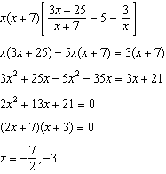

REF: fall1501aii

5 ANS: 3
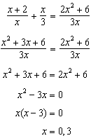 0 is extraneous.

REF: 012309aii

6 ANS: 4
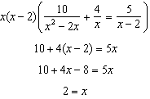 2 is extraneous.

REF: 081915aii

7 ANS: 1
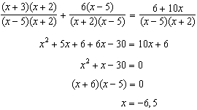 5 is extraneous.

REF: 062319aii

8 ANS: 4
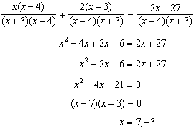 is extraneous.

REF: 082405AII

9 ANS: 1
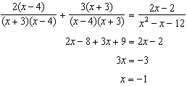

REF: 011717aii

10 ANS: 3
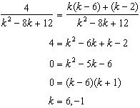 is extraneous

REF: 082218aii

11 ANS: 3
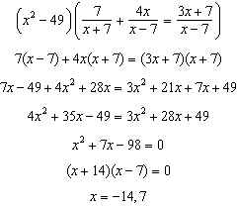

REF: 012422aii

12 ANS: 1
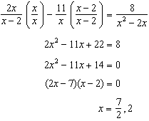

REF: 061719aii

13 ANS: 1
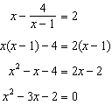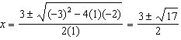

REF: 011812aii

14 ANS:
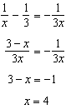

REF: 061625aii

15 ANS:
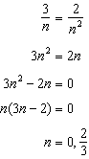 0 is an extraneous solution.

REF: 062227aii

16 ANS:
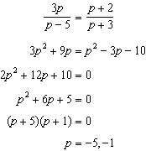

REF: 081733aii

17 ANS:
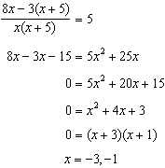

REF: 062430aii

18 ANS:
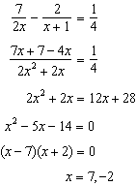

REF: 061926aii

19 ANS:
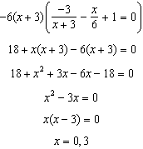

REF: 081829aii

20 ANS:
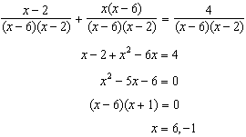. 6 is extraneous.

REF: 082334aii

21 ANS:
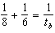; 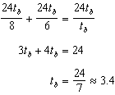

REF: 011827aii

22 ANS:
antibiotic 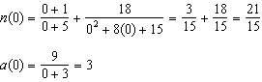 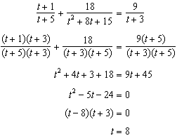

REF: 012037aii

