1 Solve:

2 Solve:

3 Solve:

4 Solve:

5 Solve:

6 Solve:

7 Solve:

8 Solve:

9 Solve:

10 Solve:

11 Solve: 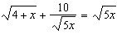

12 Solve: 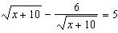

13 Solve: 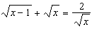

14 Solve: 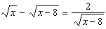

15 Solve: 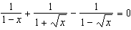

16 Solve: 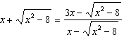
1 ANS:
12 and 3
REF: 090407al

2 ANS:
7
REF: 039410al

3 ANS:
12
REF: 019511al

4 ANS:
0 and 4
REF: 039913al

5 ANS:
8
REF: 099409al

6 ANS:
5
REF: 019609al

7 ANS:
3
REF: 099809al

8 ANS:
7
REF: 099905al

9 ANS:
7
REF: 010510al

10 ANS:
8
REF: 090509al

11 ANS:
1 and 5
REF: 030509al

12 ANS:
26
REF: 060504al

13 ANS:
REF: 060013al

14 ANS:
9
REF: 069711al

15 ANS:
REF: 039911al

16 ANS: 3
REF: 010608al

