1 If , which expression is equivalent to x?
1)
2)
3)
4)

2 If , what is the value of x?
1) | 11
2) | 18
3) | 45
4) | 53

3 What is the value of x in the equation ?
1) | 46
2) | 12
3) | 3
4) | 6

4 If then x is equal to
1) | 1
2) | 2
3) | 5
4) | 4

5 What is the solution of the equation ?
1) | 42
2) | 39
3) | 3
4) | 6

6 The solution set of the equation is
1)
2)
3)
4)

7 What is the solution set of the equation ?
1)
2)
3)
4)

8 What is the solution set of ?
1)
2)
3)
4)

9 The solution set of the equation is
1)
2)
3)
4)

10 The solution set of the equation is
1)
2)
3)
4)

11 The solution set of is
1)
2)
3)
4)

12 What is the solution set for the equation ?
1)
2)
3)
4)

13 What is the solution set of the equation ?
1)
2)
3)
4)

14 What is the solution set of the equation ?
1)
2)
3)
4)

15 What is the value of x in the equation ?
1) | 1
2) | 7
3)
4) | 4

16 Solve algebraically for x:

17 Solve algebraically for x:

18 Solve algebraically for x:

19 Solve algebraically:

20 Solve for all values of q that satisfy the equation .

21 Solve algebraically for x:

22 Solve for x:

23 Solve for x: 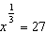

24 The number of dogs, D, housed at a county animal shelter is modeled by the function , where M is the number of months the shelter has been open. How many months will it take for 74 dogs to be housed at the shelter?

25 A wrecking ball suspended from a chain is a type of pendulum. The relationship between the rate of speed of the ball, R, the mass of the ball, m, the length of the chain, L, and the force, F, is 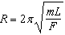. Determine the force, F, to the nearest hundredth, when , , and .

26 The period of a pendulum (T), in seconds, is the length of time it takes for the pendulum to make one complete swing back and forth. The formula 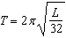 gives the period T for a pendulum of length L in feet. If you want to build a grandfather clock with a pendulum that swings back and forth once every 3 seconds, how long, to the nearest tenth of a foot, would you make the pendulum?

27 The lateral surface area of a right circular cone, s, is represented by the equation , where r is the radius of the circular base and h is the height of the cone. If the lateral surface area of a large funnel is 236.64 square centimeters and its radius is 4.75 centimeters, find its height, to the nearest hundredth of a centimeter.

28 Meteorologists can determine how long a storm lasts by using the function 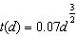, where d is the diameter of the storm, in miles, and t is the time, in hours. If the storm lasts 4.75 hours, find its diameter, to the nearest tenth of a mile.

1 ANS: 2 REF: 010703b

2 ANS: 4 REF: 011001b

3 ANS: 4
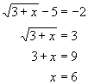

REF: 010802b

4 ANS: 3
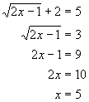. 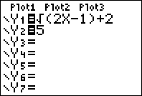. 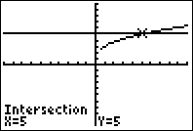

REF: 010607b

5 ANS: 1
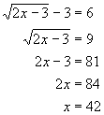

REF: 080602b

6 ANS: 3
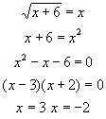. x = -2 is an extraneous solution.

REF: 080104b

7 ANS: 3
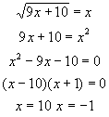. x = -1 is an extraneous solution.

REF: 010305b

8 ANS: 3
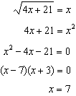. is an extraneous solution.

REF: 061018b

9 ANS: 1 REF: 061018a2

10 ANS: 2
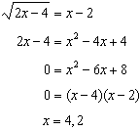

REF: 061406a2

11 ANS: 3
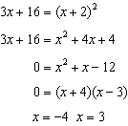. is an extraneous solution.

REF: 061121a2

12 ANS: 1
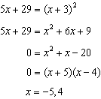. shows an extraneous solution.

REF: 061213a2

13 ANS: 4
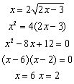

REF: 060214b

14 ANS: 4
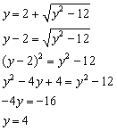

REF: 060915b

15 ANS: 2
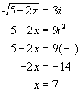

REF: 080302b

16 ANS:
7. 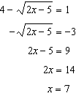

REF: 011229a2

17 ANS:
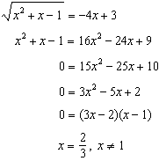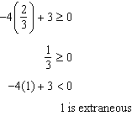

REF: 011339a2

18 ANS:
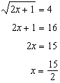

REF: 011628a2

19 ANS:
4. 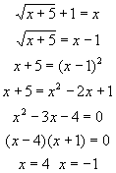. x = -1 is an extraneous solution. 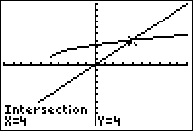

REF: 010427b

20 ANS:
. 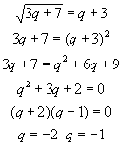

REF: 060528b

21 ANS:
5. 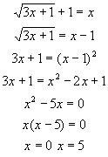. x = 0 is an extraneous solution. 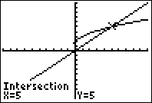

REF: 060629b

22 ANS:
. 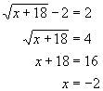
REF: 010921b

23 ANS:
REF: 061023b

24 ANS:
18. 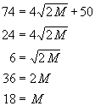.
REF: 080821b

25 ANS:
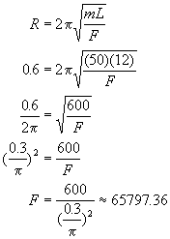
REF: 010323b

26 ANS:
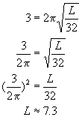
REF: fall9923b

27 ANS:
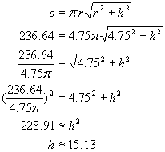
REF: 080528b

28 ANS:
16.6. 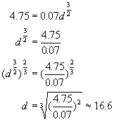
REF: 080325b

