1 The solution set for the equation is
1) |  | 3)
2) |  | 4)

2 What is the solution set of ?
1) |  | 3)
2) |  | 4)

3 The solution set for the equation is
1) |  | 3)
2) |  | 4)

4 What is the solution set for x in the equation below?
1) |  | 3)
2) |  | 4)

5 The solution set of the equation is
1) |  | 3)
2) |  | 4)

6 The solution set for the equation is
1) |  | 3)
2) |  | 4)

7 The solution set for the equation is
1) |  | 3)
2) |  | 4)

8 The value(s) of x that satisfy are
1) |  | 3)
2) |  | 4)

9 The solution set for the equation is
1) |  | 3)
2) |  | 4)

10 Determine the solution of algebraically.

11 Solve algebraically for all values of x:

12 Solve algebraically for all values of x:

13 Solve algebraically for all values of x:

14 Solve the equation algebraically.

15 Solve algebraically for all values of x:

16 Algebraically solve for x:

17 Solve the given equation algebraically for all values of x.

18 Solve the equation algebraically, and justify the solution set.

19 The speed of a tidal wave, s, in hundreds of miles per hour, can be modeled by the equation , where t represents the time from its origin in hours. Algebraically determine the time when . How much faster was the tidal wave traveling after 1 hour than 3 hours, to the nearest mile per hour? Justify your answer.

20 A Foucault pendulum can be used to demonstrate that the Earth rotates. The time, t, in seconds, that it takes for one swing or period of the pendulum can be modeled by the equation 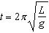 where L is the length of the pendulum in meters and g is a constant of 9.81 m/s². The first Foucault pendulum was constructed in 1851 and has a pendulum length of 67 m. Determine, to the nearest tenth of a second, the time it takes this pendulum to complete one swing. Another Foucault pendulum at the United Nations building takes 9.6 seconds to complete one swing. Determine, to the nearest tenth of a meter, the length of this pendulum.

21 The Beaufort Wind Scale was devised by British Rear Admiral Sir Francis Beaufort, in 1805 based upon observations of the effects of the wind. Beaufort numbers, B, are determined by the equation , where s is the speed of the wind in mph, and B is rounded to the nearest integer from 0 to 12.

Beaufort Wind Scale
Beaufort Number | Force of Wind
0 | Calm
1 | Light air
2 | Light breeze
3 | Gentle breeze
4 | Moderate breeze
5 | Fresh breeze
6 | Steady breeze
7 | Moderate gale
8 | Fresh gale
9 | Strong gale
10 | Whole gale
11 | Storm
12 | Hurricane

Using the table above, classify the force of wind at a speed of 30 mph. Justify your answer. In 1946, the scale was extended to accommodate strong hurricanes. A strong hurricane received a B value of exactly 15. Algebraically determine the value of s, to the nearest mph. Any B values that round to 10 receive a Beaufort number of 10. Using technology, find an approximate range of wind speeds, to the nearest mph, associated with a Beaufort number of 10.
1 ANS: 3
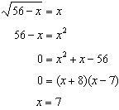 is extraneous.

REF: 061605aii

2 ANS: 2
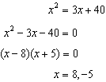. is an extraneous solution.

REF: 012010aii

3 ANS: 3
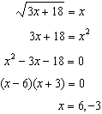 is extraneous.

REF: 082315aii

4 ANS: 3
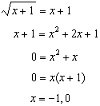

REF: 011802aii

5 ANS: 2
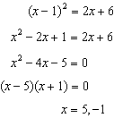 is extraneous.

REF: 082411aii

6 ANS: 2
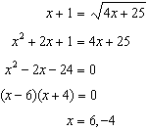

REF: 062408aii

7 ANS: 2
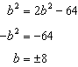 is extraneous.

REF: 061919aii

8 ANS: 3
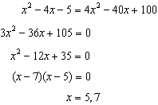

REF: 081807aii

9 ANS: 2
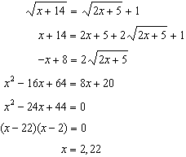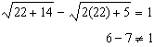

REF: 081704aii

10 ANS:
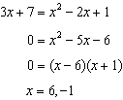 is extraneous.

REF: 062326aii

11 ANS:
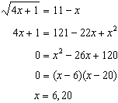 20 is extraneous.

REF: 082227aii

12 ANS:
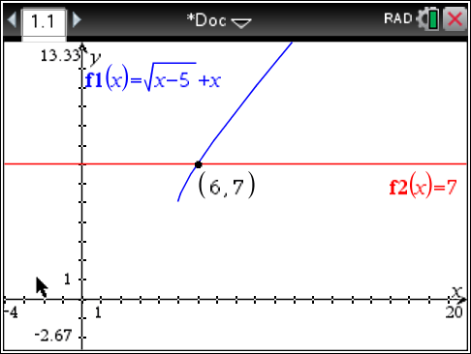 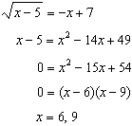 is extraneous.

REF: spr1508aii

13 ANS:
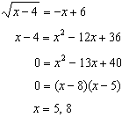 is extraneous.

REF: 061730aii

14 ANS:
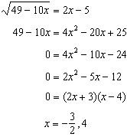 is extraneous.

REF: 012333aii

15 ANS:
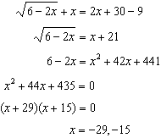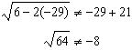, so is extraneous.

REF: 061833aii

16 ANS:
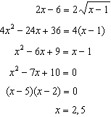 2 is extraneous.

REF: 012434aii

17 ANS:
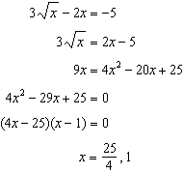1 is extraneous.

REF: 011936aii

18 ANS:
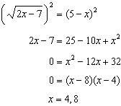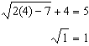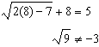

REF: 081635aii

19 ANS:
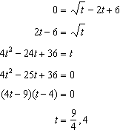 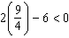, so is extraneous. 327 mph

REF: 011737aii

20 ANS:
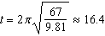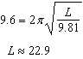

REF: 062234aii

21 ANS:
, which is a steady breeze. 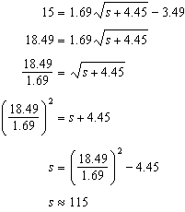 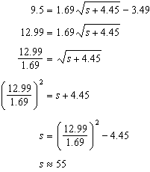 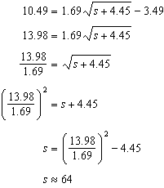 55-64

REF: 081937aii

