1 The operation element @ is determined by the following table:

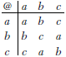

What is the identity element of this operation?
1) | a, only
2) | b, only
3) | c
4) | a and b

2 What is the identity element for in the accompanying table?

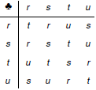
1) | r
2) | s
3) | t
4) | u

3 An addition table for a subset of real numbers is shown below. Which number is the identity element? Explain your answer.

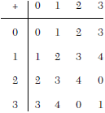

4 The operation ∗ for the set is defined in the accompanying table. What is the inverse element of r under the operation ∗?

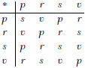
1) | p
2) | r
3) | s
4) | v

5 In the addition table for a subset of real numbers shown below, which number is the inverse of 3? Explain your answer.

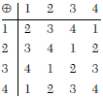

1 ANS: 1
The identity element is a, because any element @ a equals the original element.

REF: 080112a

2 ANS: 2
The identity element is s because any element s equals the original element.

REF: 080514a

3 ANS:
The identity element is 0, because any element + 0 equals the original element.

REF: 060224a

4 ANS: 4
The identity element is s because any elements equals the original element. Then review the table to solve: . The inverse of r is v because .

REF: 080010a

5 ANS:
The identity element is 4 because any element 4 equals the original element. Then review the table to solve: . The inverse of 3 is 1, because .

REF: 080222a

