1 If the product of x and is , then x is equivalent to
1) | m
2)
3)
4)

2 If , then x equals
1) | 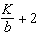
2) | 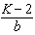
3) | 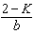
4) | 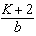

3 If , then a equals
1) | 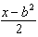
2) | 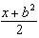
3) | 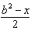
4)

4 If , p equals
1)
2)
3)
4)

5 In the equation , t is equivalent to
1) | 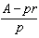
2) | 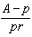
3) | 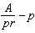
4) | 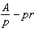

6 If , then m is equal to
1) | 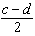
2) | 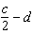
3) | 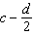
4)

7 Sean knows the length of the base, b, and the area, A, of a triangular window in his bedroom. Which formula could he use to find the height, h, of this window?
1)
2) | 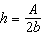
3)
4) | 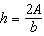

8 The formula for the volume of a right circular cylinder is . The value of h can be expressed as
1)
2)
3)
4)

9 The formula for potential energy is , where P is potential energy, m is mass, g is gravity, and h is height. Which expression can be used to represent g?
1)
2)
3) | 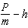
4)

10 If , then x equals
1) | a
2)
3)
4)

11 If , then x is equal to
1) | y
2)
3) | 0
4) | 8

12 If , then x is equivalent to
1)
2)
3)
4)

13 If , then x is equivalent to
1) | 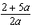
2) | 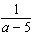
3) | 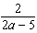
4)

14 If 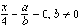, then x is equal to
1)
2)
3)
4)

15 The equation is equivalent to
1) | 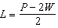
2) | 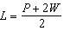
3) | 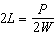
4)

16 Which equation is equivalent to ?
1) | 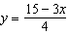
2) | 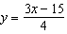
3)
4)

17 Solve:

18 In physics class, Esther learned that force due to gravity can be determined by using the formula 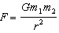. Solve for r in terms of F, G, , and .

19 Shoe sizes and foot length are related by the formula , where S represents the shoe size and F represents the length of the foot, in inches.
a Solve the formula for F.
b To the nearest tenth of an inch, how long is the foot of a person who wears a size shoe?

20 The slant height, , of the conical water tank shown in the accompanying diagram is 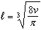. Solve for v, in terms of and .

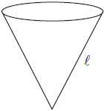

21 The volume of Earth can be calculated by using the formula 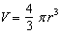. Solve for r in terms of V.
1 ANS: 2
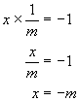

REF: 060729a

2 ANS: 4
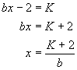

REF: 010116a

3 ANS: 2
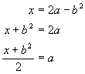

REF: 060219a

4 ANS: 1
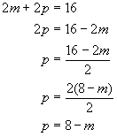

REF: 080218a

5 ANS: 2
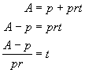

REF: 010620a

6 ANS: 1
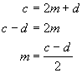

REF: 060719a

7 ANS: 4
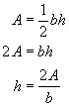

REF: 010517a

8 ANS: 2
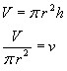

REF: 060617a

9 ANS: 4
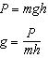

REF: 010710a

10 ANS: 4
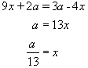

REF: 010011a

11 ANS: 3
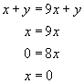

REF: 060310a

12 ANS: 4
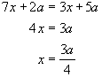

REF: 060513a

13 ANS: 3
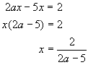

REF: 010421a

14 ANS: 4
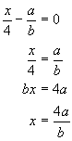

REF: 080530a

15 ANS: 1
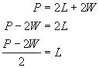

REF: 010310a

16 ANS: 1
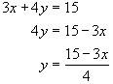

REF: 080722a

17 ANS:
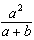

REF: 039008al

18 ANS:
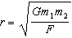. 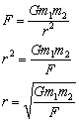

REF: 080924b

19 ANS:
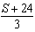, 11.5. 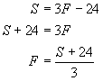. 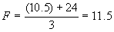

REF: 069922a

20 ANS:
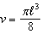. 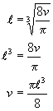

REF: 080725b

21 ANS:
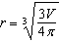. 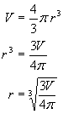

REF: 010926b

