1 If , which expression represents x?
1) | 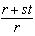
2) | 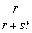
3) | 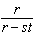
4) | 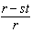

2 If , then x equals
1)
2)
3) | 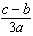
4) | 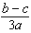

3 If , what is x in terms of a and b?
1) | 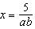
2) | 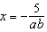
3)
4)

4 If the formula for the perimeter of a rectangle is , then w can be expressed as
1) | 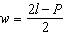
2) | 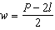
3) | 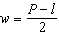
4) | 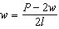

5 If , then w, in terms of x and y, is equal to
1)
2) | 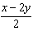
3)
4) | 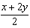

6 The members of the senior class are planning a dance. They use the equation to determine the total receipts. What is n expressed in terms of r and p?
1)
2)
3) | 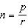
4) | 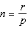

7 Given 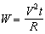, which expression can be used to represent t in terms of W, R, and V?
1)
2)
3) | 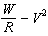
4)

8 The formula for the volume of a pyramid is 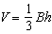. What is h expressed in terms of B and V?
1) | 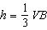
2) | 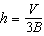
3) | 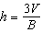
4)

9 A formula used for calculating velocity is 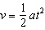. What is a expressed in terms of v and t?
1) | 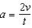
2) | 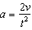
3) | 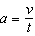
4) | 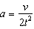

10 If 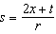, then x equals
1) | 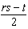
2) | 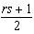
3)
4)

11 If 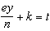, what is y in terms of e, n, k, and t?
1) | 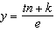
2) | 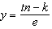
3) | 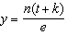
4) | 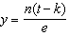

12 If , the value of a in terms of b and r can be expressed as
1) | 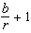
2) | 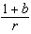
3) | 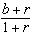
4) | 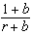

13 If , the value of m in terms of a, k, and x can be expressed as
1) | 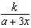
2) | 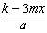
3) | 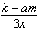
4) | 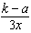

14 If , what is x expressed in terms of a and b?
1)
2)
3) | 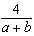
4) | 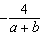

15 If , what is x expressed in terms of y and z?
1)
2) | 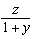
3) | 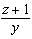
4) | 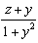

16 Solve for c in terms of a and b:

1 ANS: 1
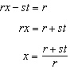
REF: 061316ia

2 ANS: 3
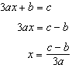
REF: 080808ia

3 ANS: 1
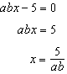
REF: 011425ia

4 ANS: 2
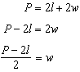
REF: 010911ia

5 ANS: 2
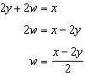
REF: 081330ia

6 ANS: 4 REF: 011016ia

7 ANS: 1 REF: 061623ia

8 ANS: 3 REF: 081230ia

9 ANS: 2 REF: 061023ia

10 ANS: 1
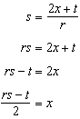
REF: 011228ia

11 ANS: 4
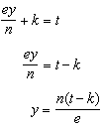
REF: 011125ia

12 ANS: 3
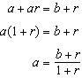
REF: 060913ia

13 ANS: 1
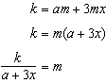
REF: 061215ia

14 ANS: 3
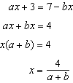
REF: 081426ia

15 ANS: 4
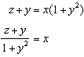
REF: 061524ia

16 ANS:
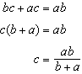
REF: 081131ia

