1 During summer vacation, Ben decides to sell hot dogs and pretzels on a food cart in Manhattan. It costs Ben $0.50 for each hot dog and $0.40 for each pretzel. He has only $100 to spend each day on hot dogs and pretzels. He wants to sell at least 200 items each day. If h is the number of hot dogs and p is the number of pretzels, which inequality would be part of a system of inequalities used to determine the total number of hot dogs and pretzels Ben can sell?
1)
2)
3)
4)

2 A tour bus can seat, at most, 48 passengers. An adult ticket costs $18 and a child ticket costs $12. The bus company must collect at least $650 to make a profit. If a represents the number of adult tickets sold and c represents the number of child tickets sold, which system of inequalities models this situation if they make a profit?
1) | 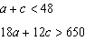
2) | 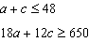
3) | 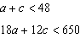
4) | 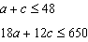

3 Jordan works for a landscape company during his summer vacation. He is paid $12 per hour for mowing lawns and $14 per hour for planting gardens. He can work a maximum of 40 hours per week, and would like to earn at least $250 this week. If m represents the number of hours mowing lawns and g represents the number of hours planting gardens, which system of inequalities could be used to represent the given conditions?
1) | 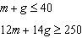
2) | 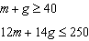
3) | 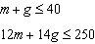
4) | 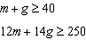

4 Gretchen has $50 that she can spend at the fair. Ride tickets cost $1.25 each and game tickets cost $2 each. She wants to go on a minimum of 10 rides and play at least 12 games. Which system of inequalities represents this situation when r is the number of ride tickets purchased and g is the number of game tickets purchased?
1) | 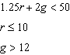
2) | 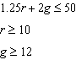
3) | 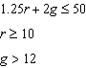
4) | 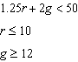

5 A high school drama club is putting on their annual theater production. There is a maximum of 800 tickets for the show. The costs of the tickets are $6 before the day of the show and $9 on the day of the show. To meet the expenses of the show, the club must sell at least $5,000 worth of tickets.
a) Write a system of inequalities that represent this situation.
b) The club sells 440 tickets before the day of the show. Is it possible to sell enough additional tickets on the day of the show to at least meet the expenses of the show? Justify your answer.

6 A drama club is selling tickets to the spring musical. The auditorium holds 200 people. Tickets cost $12 at the door and $8.50 if purchased in advance. The drama club has a goal of selling at least $1000 worth of tickets to Saturday's show. Write a system of inequalities that can be used to model this scenario. If 50 tickets are sold in advance, what is the minimum number of tickets that must be sold at the door so that the club meets its goal? Justify your answer.

7 The drama club is running a lemonade stand to raise money for its new production. A local grocery store donated cans of lemonade and bottles of water. Cans of lemonade sell for $2 each and bottles of water sell for $1.50 each. The club needs to raise at least $500 to cover the cost of renting costumes. The students can accept a maximum of 360 cans and bottles. Write a system of inequalities that can be used to represent this situation. The club sells 144 cans of lemonade. What is the least number of bottles of water that must be sold to cover the cost of renting costumes? Justify your answer.

8 A system of inequalities is graphed on the set of axes below.

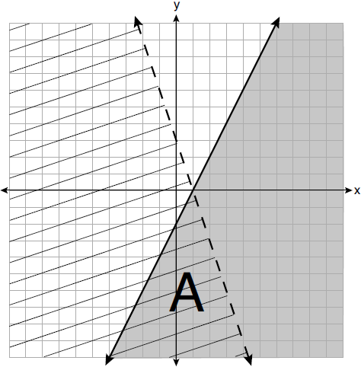

State the system of inequalities represented by the graph. State what region A represents. State what the entire gray region represents.

9 An on-line electronics store must sell at least $2500 worth of printers and computers per day. Each printer costs $50 and each computer costs $500. The store can ship a maximum of 15 items per day. On the set of axes below, graph a system of inequalities that models these constraints.

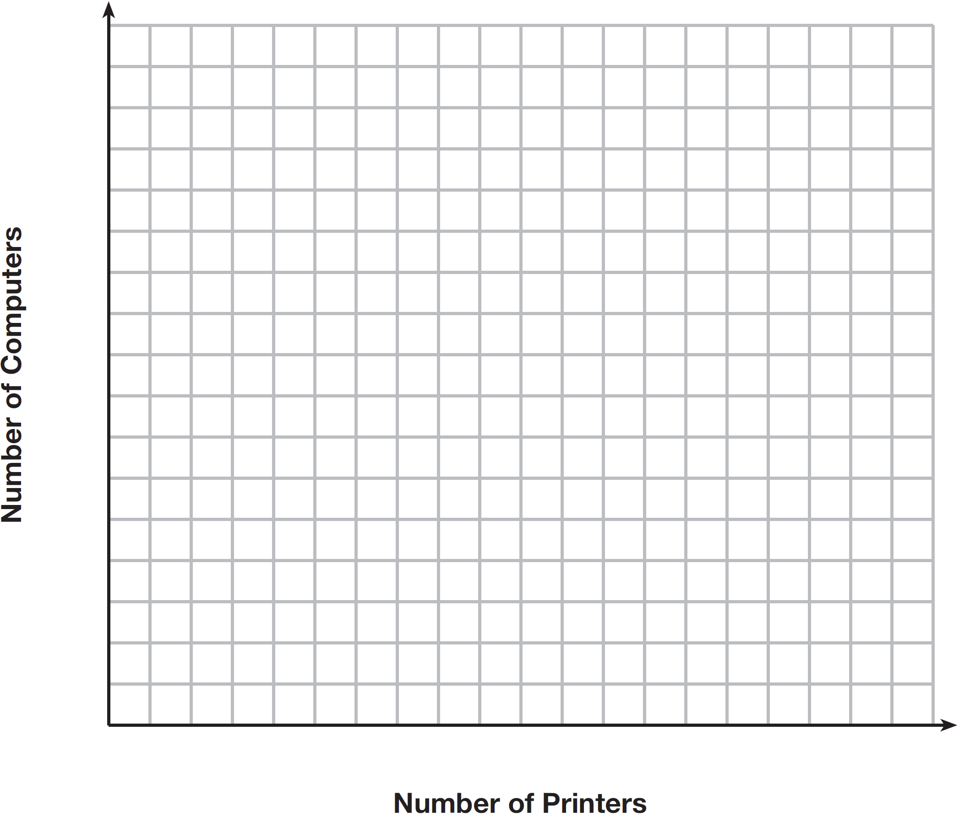

Determine a combination of printers and computers that would allow the electronics store to meet all of the constraints. Explain how you obtained your answer.

10 Edith babysits for x hours a week after school at a job that pays $4 an hour. She has accepted a job that pays $8 an hour as a library assistant working y hours a week. She will work both jobs. She is able to work no more than 15 hours a week, due to school commitments. Edith wants to earn at least $80 a week, working a combination of both jobs. Write a system of inequalities that can be used to represent the situation. Graph these inequalities on the set of axes below.

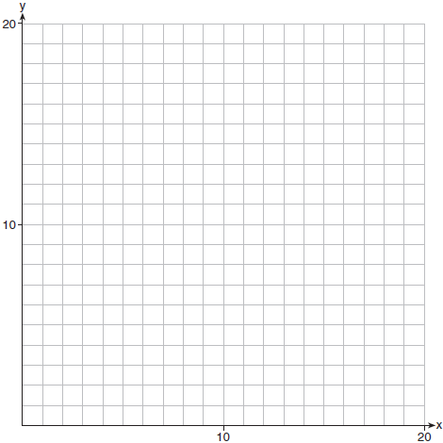

Determine and state one combination of hours that will allow Edith to earn at least $80 per week while working no more than 15 hours.
1 ANS: 2 REF: 012324ai

2 ANS: 2 REF: 062402ai

3 ANS: 1 REF: 061711ai

4 ANS: 2 REF: 081810ai

5 ANS:
a) 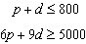b) 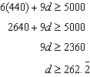 Since , it is possible.

REF: spr1306ai

6 ANS:
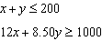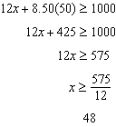

REF: 081635ai

7 ANS:
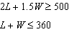 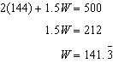 142 bottles of water must be sold to cover the cost of renting costumes.

REF: 011835ai

8 ANS:
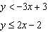 Region A represents the solution set of the system. The gray region represents the solution set of .

REF: 061936ai

9 ANS:
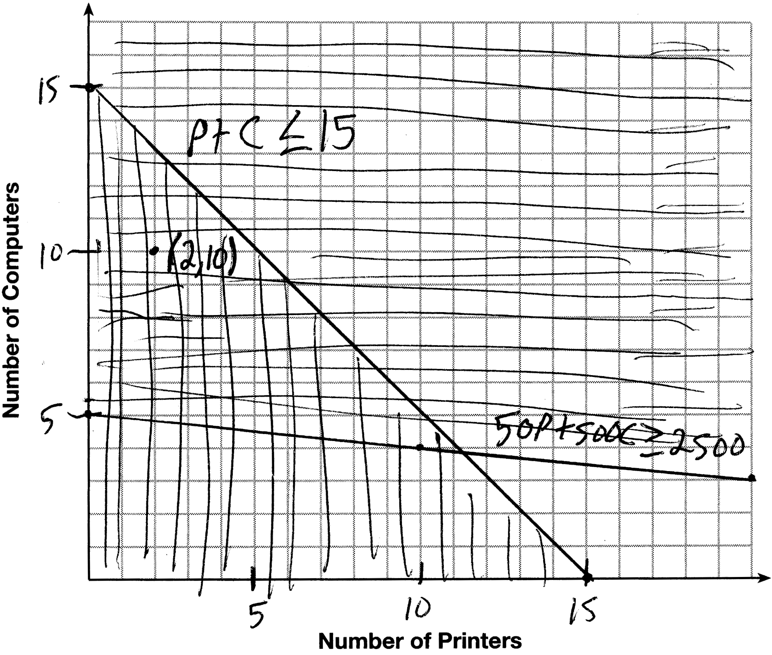 A combination of 2 printers and 10 computers meets all the constraints because is in the solution set of the graph.

REF: 061535ai

10 ANS:
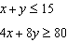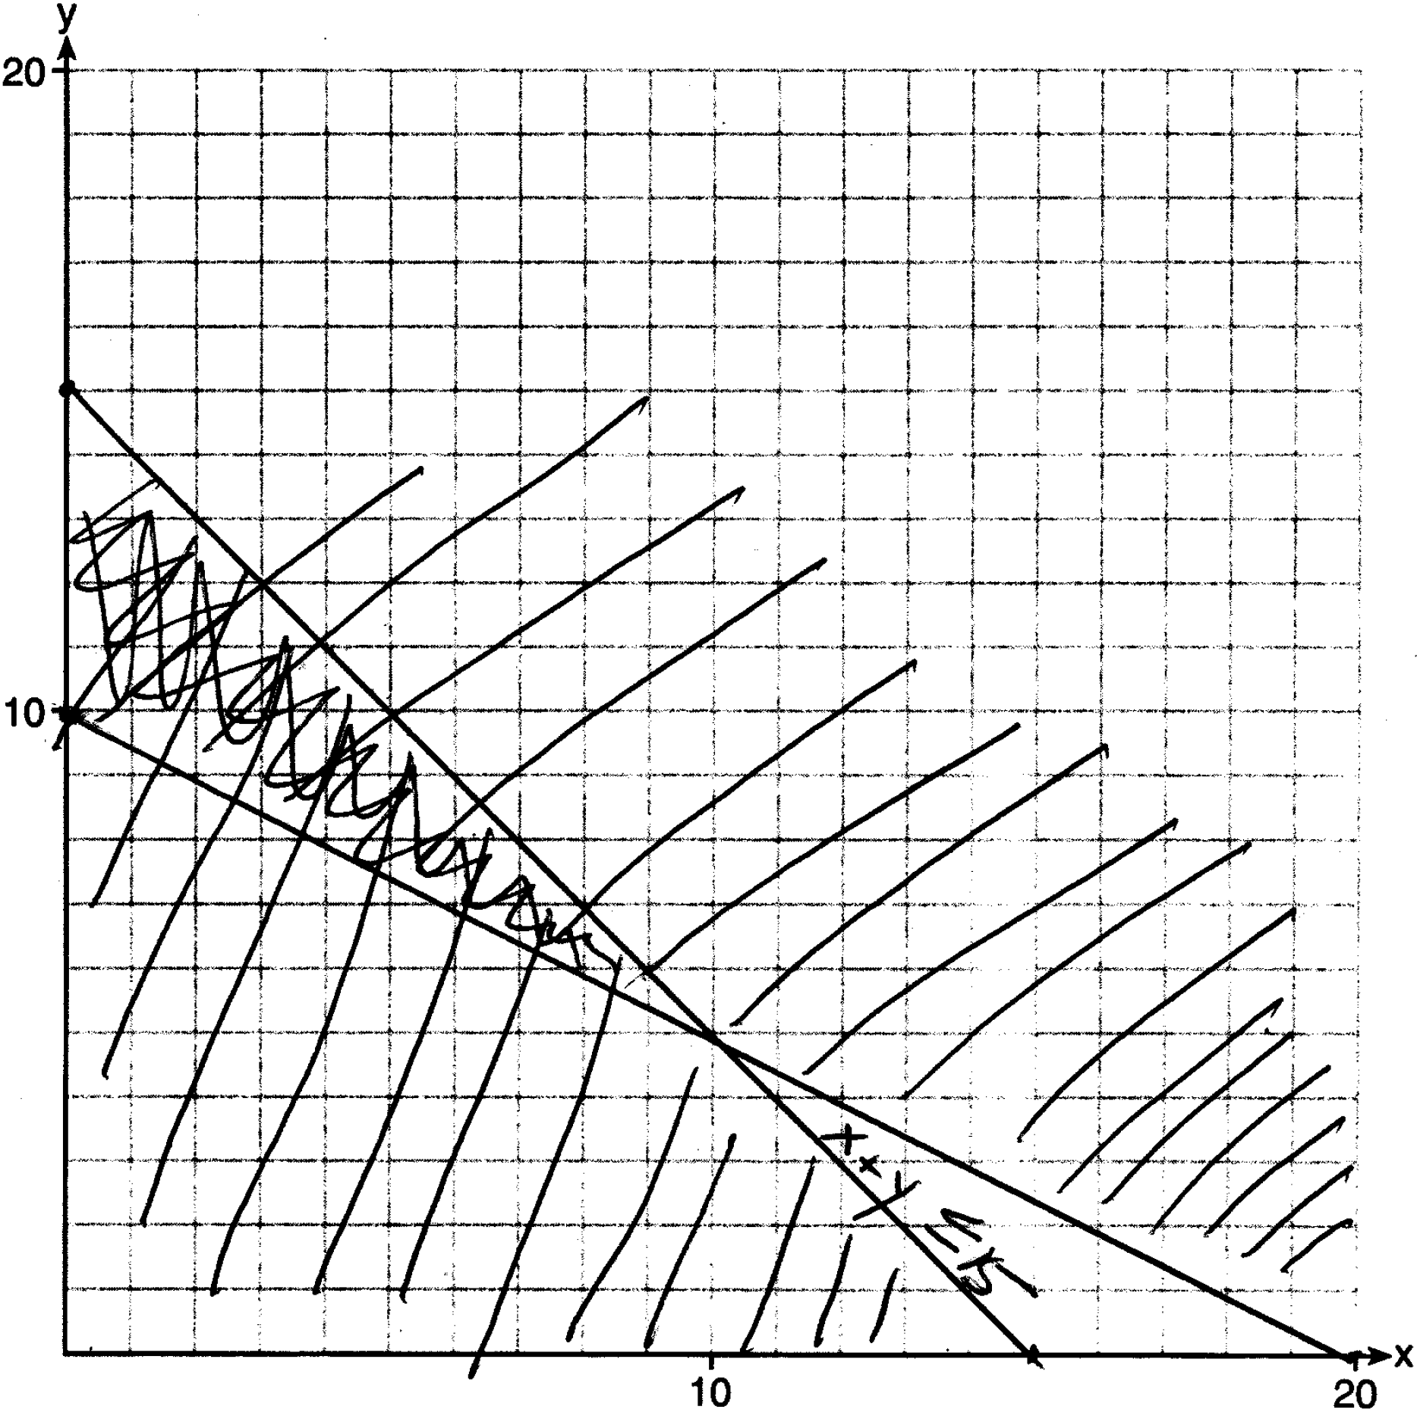 One hour at school and eleven hours at the library.

REF: 081437ai

