1 Jamie is 5 years older than her sister Amy. If the sum of their ages is 19, how old is Jamie?
1) | 5
2) | 7
3) | 12
4) | 14

2 Three times as many robins as cardinals visited a bird feeder. If a total of 20 robins and cardinals visited the feeder, how many were robins?
1) | 5
2) | 10
3) | 15
4) | 20

3 Sal keeps quarters, nickels, and dimes in his change jar. He has a total of 52 coins. He has three more quarters than dimes and five fewer nickels than dimes. How many dimes does Sal have?
1) | 13
2) | 18
3) | 20
4) | 21

4 At a concert, $720 was collected for hot dogs, hamburgers, and soft drinks. All three items sold for $1.00 each. Twice as many hot dogs were sold as hamburgers. Three times as many soft drinks were sold as hamburgers. The number of soft drinks sold was
1) | 120
2) | 240
3) | 360
4) | 480

5 A hotel charges $20 for the use of its dining room and $2.50 a plate for each dinner. An association gives a dinner and charges $3 a plate but invites four nonpaying guests. If each person has one plate, how many paying persons must attend for the association to collect the exact amount needed to pay the hotel?
1) | 60
2) | 44
3) | 40
4) | 20

6 Two numbers are in the ratio . If 6 is subtracted from their sum, the result is 50. What is the larger number?
1) | 55
2) | 45
3) | 40
4) | 35

7 The ratio of Tariq’s telephone bill to Pria’s telephone bill was . Tariq’s bill was $14 more than Pria’s bill. What was Tariq’s bill?
1) | $21
2) | $28
3) | $35
4) | $49

8 A cellular telephone company has two plans. Plan A charges $11 a month and $0.21 per minute. Plan B charges $20 a month and $0.10 per minute. After how much time, to the nearest minute, will the cost of plan A be equal to the cost of plan B?
1) | 1 hr 22 min
2) | 1 hr 36 min
3) | 81 hr 8 min
4) | 81 hr 48 min

9 Mary and Amy had a total of 20 yards of material from which to make costumes. Mary used three times more material to make her costume than Amy used, and 2 yards of material was not used. How many yards of materials did Amy use for her costumer?

10 A ribbon 56 centimeters long is cut into two pieces. One of the pieces is three times longer than the other. Find the lengths, in centimeters, of both pieces of ribbon.

11 Arielle has a collection of grasshoppers and crickets. She has 561 insects in all. The number of grasshoppers is twice the number of crickets. Find the number of each type of insect that she has.

12 Ramón rented a sprayer and a generator. On his first job, he used each piece of equipment for 6 hours at a total cost of $90. On his second job, he used the sprayer for 4 hours and the generator for 8 hours at a total cost of $100. What was the hourly cost of each piece of equipment?

13 Sharu has $2.35 in nickels and dimes. If he has a total of thirty-two coins, how many of each coin does he have?

14 Ben had twice as many nickels as dimes. Altogether, Ben had $4.20. How many nickels and how many dimes did Ben have?

15 Using only 32-cent and 20-cent stamps, Charlie put $3.36 postage on a package he sent to his sister. He used twice as many 32-cent stamps as 20-cent stamps. Determine how many of each type of stamp he used.

16 Juan has a cellular phone that costs $12.95 per month plus 25¢ per minute for each call. Tiffany has a cellular phone that costs $14.95 per month plus 15¢ per minute for each call. For what number of minutes do the two plans cost the same?

17 The ninth graders at a high school are raising money by selling T-shirts and baseball caps. The number of T-shirts sold was three times the number of caps. The profit they received for each T-shirt sold was $5.00, and the profit on each cap was $2.50. If the students made a total profit of $210, how many T-shirts and how many caps were sold?

18 Tanisha and Rachel had lunch at the mall. Tanisha ordered three slices of pizza and two colas. Rachel ordered two slices of pizza and three colas. Tanisha’s bill was $6.00, and Rachel’s bill was $5.25. What was the price of one slice of pizza? What was the price of one cola?

19 When Tony received his weekly allowance, he decided to purchase candy bars for all his friends. Tony bought three Milk Chocolate bars and four Creamy Nougat bars, which cost a total of $4.25 without tax. Then he realized this candy would not be enough for all his friends, so he returned to the store and bought an additional six Milk Chocolate bars and four Creamy Nougat bars, which cost a total of $6.50 without tax. How much did each type of candy bar cost?

20 Alexandra purchases two doughnuts and three cookies at a doughnut shop and is charged $3.30. Briana purchases five doughnuts and two cookies at the same shop for $4.95. All the doughnuts have the same price and all the cookies have the same price. Find the cost of one doughnut and find the cost of one cookie.

21 A group of 148 people is spending five days at a summer camp. The cook ordered 12 pounds of food for each adult and 9 pounds of food for each child. A total of 1,410 pounds of food was ordered. Write an equation or a system of equations that describes the above situation and define your variables. Find the total number of adults in the group and the total number of children in the group.

22 The owner of a movie theater was counting the money from 1 day’s ticket sales. He knew that a total of 150 tickets were sold. Adult tickets cost $7.50 each and children’s tickets cost $4.75 each. If the total receipts for the day were $891.25, how many of each kind of ticket were sold?

23 A total of 600 tickets were sold for a concert. Twice as many tickets were sold in advance than were sold at the door. If the tickets sold in advance cost $25 each and the tickets sold at the door cost $32 each, how much money was collected for the concert?

24 The tickets for a dance recital cost $5.00 for adults and $2.00 for children. If the total number of tickets sold was 295 and the total amount collected was $1,220, how many adult tickets were sold? [Only an algebraic solution can receive full credit.]

25 There were 100 more balcony tickets than main-floor tickets sold for a concert. The balcony tickets sold for $4 and the main-floor tickets sold for $12. The total amount of sales for both types of tickets was $3,056. Write an equation or a system of equations that describes the given situation. Define the variables. Find the number of balcony tickets that were sold.

26 The Excel Cable Company has a monthly fee of $32.00 and an additional charge of $8.00 for each premium channel. The Best Cable Company has a monthly fee of $26.00 and an additional charge of $10.00 for each premium channel. The Horton family is deciding which of these two cable companies to subscribe to. For what number of premium channels will the total monthly subscription fee for the Excel and Best Cable companies be the same? The Horton family decides to subscribe to 2 premium channels for a period of one year. Which cable company should they subscribe to in order to spend less money? How much money will the Hortons save in one year by using the less expensive company?

27 A total of 800 votes were cast in an election. The table below represents the votes that were received by the candidates. Candidate D got at least 30 votes more than Candidate E. What is the least number of votes that Candidate D could have received? Show how you arrived at your answer.

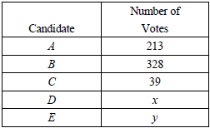

28 The cost of a long-distance telephone call is determined by a flat fee for the first 5 minutes and a fixed amount for each additional minute. If a 15-minute telephone call costs $3.25 and a 23-minute call costs $5.17, find the cost of a 30-minute call.

29 At the local video rental store, José rents two movies and three games for a total of $15.50. At the same time, Meg rents three movies and one game for a total of $12.05. How much money is needed to rent a combination of one game and one movie?
1 ANS: 3
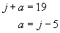. 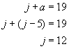

REF: 060201a

2 ANS: 3
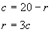. 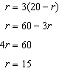

REF: 010104a

3 ANS: 2
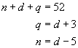. 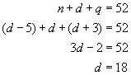

REF: 080606a

4 ANS: 3
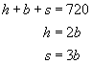. 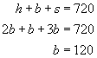. 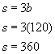

REF: 089916a

5 ANS: 1
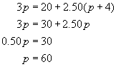

REF: 060117a

6 ANS: 3
. 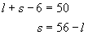. 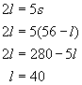

REF: 060004a

7 ANS: 4
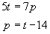. 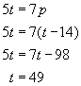

REF: 080412a

8 ANS: 1
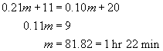

REF: 080114b

9 ANS:
4.5. 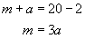. 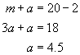

REF: 010022a

10 ANS:
14 and 42. 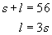. 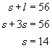. 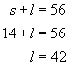

REF: 060531a

11 ANS:
374 grasshoppers and 187 crickets. 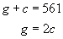. 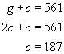. 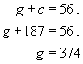

REF: 010327a

12 ANS:
$5 for sprayer and $10 for generator. 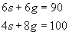. 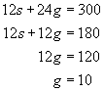. 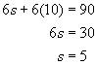

REF: 060133a

13 ANS:
17 nickels and 15 dimes. 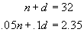. 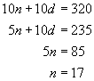. 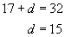

REF: 060638a

14 ANS:
42 nickels and 21 dimes. 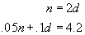. 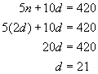. 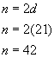

REF: 060123a

15 ANS:
Four 20-cent and eight 32-cent stamps. 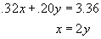. 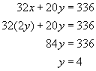. 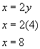

REF: 010436a

16 ANS:
20. 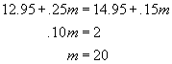

REF: 010130a

17 ANS:
36 T-shirts and 12 caps. 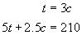. 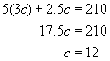. 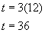

REF: 080132a

18 ANS:
$1.50 for pizza and $0.75 for cola. 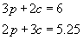. 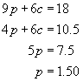. 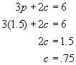

REF: 080233a

19 ANS:
Milk Chocolate, $0.75 and Creamy Nougat, $0.50. 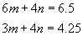. 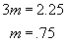. 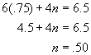

REF: 010232a

20 ANS:
doughnut = $0.75, cookie = $0.60. 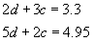. 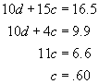.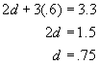

REF: 010332a

21 ANS:
a = adults c = children 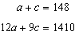, 26, 122. 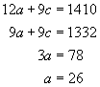. 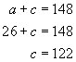

REF: 010033a

22 ANS:
65 adult and 85 children. 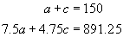. 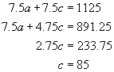. 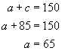

REF: 060031a

23 ANS:
$16,400. 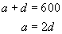. 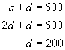. 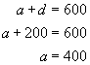. 200(32) + 400(25) = 16,400

REF: 010228a

24 ANS:
210. 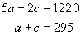. 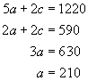

REF: 010539a

25 ANS:
b = balcony m = main-floor 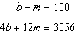, 266. 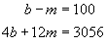. 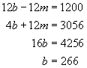

REF: 010134a

26 ANS:
3, Best; 24. Best, 26 + 10(2) = 46. Excel, 32 + 8(2) = 48. The Hortons should subscribe to Best. Since Best is $2/month cheaper, the Hortons will save $24 in one year.

REF: 010035a

27 ANS:
125. 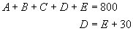. 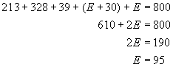. 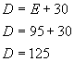

REF: spring9828a

28 ANS:
$6.85. 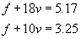. 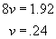. 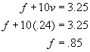.

REF: 060123b

29 ANS:
$6.15. 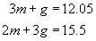. 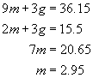. 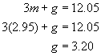.

REF: 010228b

