1 The local deli charges a fee for delivery. On Monday, they delivered two dozen bagels to an office at a total cost of $8. On Tuesday, three dozen bagels were delivered at a total cost of $11. Which system of equations could be used to find the cost of a dozen bagels, b, if the delivery fee is f?
1) | 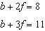
2) | 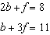
3) | 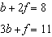
4) | 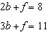

2 The sum of two numbers is 47, and their difference is 15. What is the larger number?
1) | 16
2) | 31
3) | 32
4) | 36

3 Michael is 25 years younger than his father. The sum of their ages is 53. What is Michael’s age?
1) | 14
2) | 25
3) | 28
4) | 39

4 The total score in a football game was 72 points. The winning team scored 12 points more than the losing team. How many points did the winning team score?
1) | 30
2) | 42
3) | 54
4) | 60

5 Pam is playing with red and black marbles. The number of red marbles she has is three more than twice the number of black marbles she has. She has 42 marbles in all. How many red marbles does Pam have?
1) | 13
2) | 15
3) | 29
4) | 33

6 Sam and Odel have been selling frozen pizzas for a class fundraiser. Sam has sold half as many pizzas as Odel. Together they have sold a total of 126 pizzas. How many pizzas did Sam sell?
1) | 21
2) | 42
3) | 63
4) | 84

7 Josh and Mae work at a concession stand. They each earn $8 per hour. Josh worked three hours more than Mae. If Josh and Mae earned a total of $120, how many hours did Josh work?
1) | 6
2) | 9
3) | 12
4) | 15

8 Ben has four more than twice as many CDs as Jake. If they have a total of 31 CDs, how many CDs does Jake have?
1) | 9
2) | 13
3) | 14
4) | 22

9 Jack bought 3 slices of cheese pizza and 4 slices of mushroom pizza for a total cost of $12.50. Grace bought 3 slices of cheese pizza and 2 slices of mushroom pizza for a total cost of $8.50. What is the cost of one slice of mushroom pizza?
1) | $1.50
2) | $2.00
3) | $3.00
4) | $3.50

10 Julia went to the movies and bought one jumbo popcorn and two chocolate chip cookies for $5.00. Marvin went to the same movie and bought one jumbo popcorn and four chocolate chip cookies for $6.00. How much does one chocolate chip cookie cost?
1) | $0.50
2) | $0.75
3) | $1.00
4) | $2.00

11 At Genesee High School, the sophomore class has 60 more students than the freshman class. The junior class has 50 fewer students than twice the students in the freshman class. The senior class is three times as large as the freshman class. If there are a total of 1,424 students at Genesee High School, how many students are in the freshman class?
1) | 202
2) | 205
3) | 235
4) | 236

12 A DVD costs twice as much as a music CD. Jack buys 2 DVDs and 2 CDs and spends $45. Determine how much one CD costs, in dollars. [Only an algebraic solution can receive full credit.]

13 The cost of three notebooks and four pencils is $8.50. The cost of five notebooks and eight pencils is $14.50. Determine the cost of one notebook and the cost of one pencil. [Only an algebraic solution can receive full credit.]

14 The difference between two numbers is 28. The larger number is 8 less than twice the smaller number. Find both numbers. [Only an algebraic solution can receive full credit.]

15 The cost of 3 markers and 2 pencils is $1.80. The cost of 4 markers and 6 pencils is $2.90. What is the cost of each item? Include appropriate units in your answer.

16 During its first week of business, a market sold a total of 108 apples and oranges. The second week, five times the number of apples and three times the number of oranges were sold. A total of 452 apples and oranges were sold during the second week. Determine how many apples and how many oranges were sold the first week. [Only an algebraic solution can receive full credit.]
1 ANS: 4 REF: 061504ia

2 ANS: 2
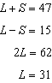

REF: 060912ia

3 ANS: 1
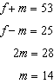

REF: 061126ia

4 ANS: 2
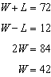

REF: 081227ia

5 ANS: 3
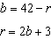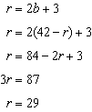

REF: 060812ia

6 ANS: 2
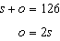. 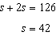

REF: 080811ia

7 ANS: 2
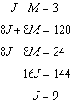

REF: 011115ia

8 ANS: 1
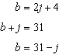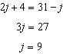

REF: 081119ia

9 ANS: 2
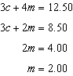

REF: 060806ia

10 ANS: 1
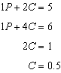

REF: 011003ia

11 ANS: 1
. 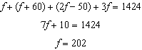

REF: 060917ia

12 ANS:
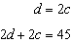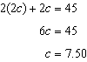

REF: 011534ia

13 ANS:
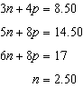. 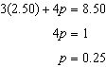

REF: 011335ia

14 ANS:
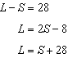. 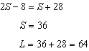

REF: 081335ia

15 ANS:
m = 50¢, p = 15¢. 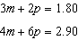. 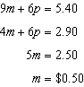. 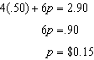

REF: 080837ia

16 ANS:
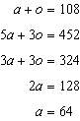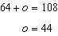

REF: 061437ia

