1 During the 2010 season, football player McGee’s earnings, m, were 0.005 million dollars more than those of his teammate Fitzpatrick’s earnings, f. The two players earned a total of 3.95 million dollars. Which system of equations could be used to determine the amount each player earned, in millions of dollars?
1) | 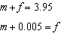
2) | 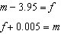
3) | 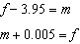
4) | 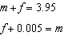

2 The Celluloid Cinema sold 150 tickets to a movie. Some of these were child tickets and the rest were adult tickets. A child ticket cost $7.75 and an adult ticket cost $10.25. If the cinema sold $1470 worth of tickets, which system of equations could be used to determine how many adult tickets, a, and how many child tickets, c, were sold?
1) | 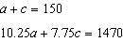
2) | 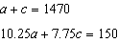
3) | 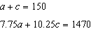
4) | 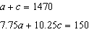

3 Alicia purchased H half-gallons of ice cream for $3.50 each and P packages of ice cream cones for $2.50 each. She purchased 14 items and spent $43. Which system of equations could be used to determine how many of each item Alicia purchased?
1) | 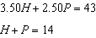
2) | 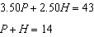
3) | 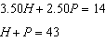
4) | 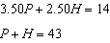

4 Lizzy has 30 coins that total $4.80. All of her coins are dimes, D, and quarters, Q. Which system of equations models this situation?
1) | 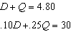
2) | 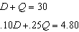
3) | 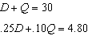
4) | 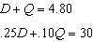

5 Mo's farm stand sold a total of 165 pounds of apples and peaches. She sold apples for $1.75 per pound and peaches for $2.50 per pound. If she made $337.50, how many pounds of peaches did she sell?
1) | 11
2) | 18
3) | 65
4) | 100

6 Last week, a candle store received $355.60 for selling 20 candles. Small candles sell for $10.98 and large candles sell for $27.98. How many large candles did the store sell?
1) | 6
2) | 8
3) | 10
4) | 12

7 A fence was installed around the edge of a rectangular garden. The length, l, of the fence was 5 feet less than 3 times its width, w. The amount of fencing used was 90 feet. Write a system of equations or write an equation using one variable that models this situation. Determine algebraically the dimensions, in feet, of the garden.

8 Jacob and Zachary go to the movie theater and purchase refreshments for their friends. Jacob spends a total of $18.25 on two bags of popcorn and three drinks. Zachary spends a total of $27.50 for four bags of popcorn and two drinks. Write a system of equations that can be used to find the price of one bag of popcorn and the price of one drink. Using these equations, determine and state the price of a bag of popcorn and the price of a drink, to the nearest cent.

9 Two friends went to a restaurant and ordered one plain pizza and two sodas. Their bill totaled $15.95. Later that day, five friends went to the same restaurant. They ordered three plain pizzas and each person had one soda. Their bill totaled $45.90. Write and solve a system of equations to determine the price of one plain pizza. [Only an algebraic solution can receive full credit.]

10 There are two parking garages in Beacon Falls. Garage A charges $7.00 to park for the first 2 hours, and each additional hour costs $3.00. Garage B charges $3.25 per hour to park. When a person parks for at least 2 hours, write equations to model the cost of parking for a total of x hours in Garage A and Garage B. Determine algebraically the number of hours when the cost of parking at both garages will be the same.

11 An animal shelter spends $2.35 per day to care for each cat and $5.50 per day to care for each dog. Pat noticed that the shelter spent $89.50 caring for cats and dogs on Wednesday. Write an equation to represent the possible numbers of cats and dogs that could have been at the shelter on Wednesday. Pat said that there might have been 8 cats and 14 dogs at the shelter on Wednesday. Are Pat’s numbers possible? Use your equation to justify your answer. Later, Pat found a record showing that there were a total of 22 cats and dogs at the shelter on Wednesday. How many cats were at the shelter on Wednesday?

12 Jen joined the Fan Favorite Movie Club at the local movie theater. At this theater, the cost of admission in May and June remains the same. In May, she saw 2 matinees and 3 regular-priced shows and spent $38.50. In June, she went to 6 matinees and one regular-priced show and spent $47.50. Write a system of equations to represent the cost, m, of a matinee ticket and the cost, r, of a regular-priced ticket. Jen said she spent $5.75 on each matinee and $9 on each regular show. Is Jen correct? Justify your answer. Use your system of equations to algebraically determine both the actual cost of each matinee ticket and the actual cost of each regular ticket.

13 For a class picnic, two teachers went to the same store to purchase drinks. One teacher purchased 18 juice boxes and 32 bottles of water, and spent $19.92. The other teacher purchased 14 juice boxes and 26 bottles of water, and spent $15.76. Write a system of equations to represent the costs of a juice box, j, and a bottle of water, w. Kara said that the juice boxes might have cost 52 cents each and that the bottles of water might have cost 33 cents each. Use your system of equations to justify that Kara's prices are not possible. Solve your system of equations to determine the actual cost, in dollars, of each juice box and each bottle of water.

14 At Bea's Pet Shop, the number of dogs, d, is initially five less than twice the number of cats, c. If she decides to add three more of each, the ratio of cats to dogs will be · Write an equation or system of equations that can be used to find the number of cats and dogs Bea has in her pet shop. Could Bea's Pet Shop initially have 15 cats and 20 dogs? Explain your reasoning. Determine algebraically the number of cats and the number of dogs Bea initially had in her pet shop.

15 Dylan has a bank that sorts coins as they are dropped into it. A panel on the front displays the total number of coins inside as well as the total value of these coins. The panel shows 90 coins with a value of $17.55 inside of the bank. If Dylan only collects dimes and quarters, write a system of equations in two variables or an equation in one variable that could be used to model this situation. Using your equation or system of equations, algebraically determine the number of quarters Dylan has in his bank. Dylan's mom told him that she would replace each one of his dimes with a quarter. If he uses all of his coins, determine if Dylan would then have enough money to buy a game priced at $20.98 if he must also pay an 8% sales tax. Justify your answer.

16 At the present time, Mrs. Bee's age is six years more than four times her son's age. Three years ago, she was seven times as old as her son was then. If b represents Mrs. Bee's age now and s represents her son's age now, write a system of equations that could be used to model this scenario. Use this system of equations to determine, algebraically, the ages of both Mrs. Bee and her son now. Determine how many years from now Mrs. Bee will be three times as old as her son will be then.

17 When visiting friends in a state that has no sales tax, two families went to a fast-food restaurant for lunch. The Browns bought 4 cheeseburgers and 3 medium fries for $16.53. The Greens bought 5 cheeseburgers and 4 medium fries for $21.11. Using c for the cost of a cheeseburger and f for the cost of medium fries, write a system of equations that models this situation. The Greens said that since their bill was $21.11, each cheeseburger must cost $2.49 and each order of medium fries must cost $2.87 each. Are they correct? Justify your answer. Using your equations, algebraically determine both the cost of one cheeseburger and the cost of one order of medium fries.

18 Allysa spent $35 to purchase 12 chickens. She bought two different types of chickens. Americana chickens cost $3.75 each and Delaware chickens cost $2.50 each. Write a system of equations that can be used to determine the number of Americana chickens, A, and the number of Delaware chickens, D, she purchased. Determine algebraically how many of each type of chicken Allysa purchased. Each Americana chicken lays 2 eggs per day and each Delaware chicken lays 1 egg per day. Allysa only sells eggs by the full dozen for $2.50. Determine how much money she expects to take in at the end of the first week with her 12 chickens.

19 At a local garden shop, the price of plants includes sales tax. The cost of 4 large plants and 8 medium plants is $40. The cost of 5 large plants and 2 medium plants is $28. If l is the cost of a large plant and m is the cost of a medium plant, write a system of equations that models this situation. Could the cost of one large plant be $5.50 and the cost of one medium plant be $2.25? Justify your answer. Determine algebraically both the cost of a large plant and the cost of a medium plant.

20 An ice cream shop sells small and large sundaes. One day, 30 small sundaes and 50 large sundaes were sold for $420. Another day, 15 small sundaes and 35 large sundaes were sold for $270. Sales tax is included in all prices. If x is the cost of a small sundae and y is the cost of a large sundae, write a system of equations to represent this situation. Peyton thinks that small sundaes cost $2.75 and large sundaes cost $6.75. Is Peyton correct? Justify your answer. Using your equations, determine algebraically the cost of one small sundae and the cost of one large sundae.

21 Courtney went to a coffee shop to purchase lattes and donuts for her friends. One day she spent a total of $15.50 on four lattes and two donuts. The next day she spent a total of $18.10 on three lattes and five donuts. All prices included tax. If x represents the cost of one latte and y represents the cost of one donut, write a system of equations that can be used to model this situation. Courtney thinks that one latte costs $2.75 and one donut costs $2.25. Is Courtney correct? Justify your answer. Use your equations to determine algebraically the exact cost of one latte and the exact cost of one donut.

22 At an amusement park, the cost for an adult admission is a, and for a child the cost is c. For a group of six that included two children, the cost was $325.94. For a group of five that included three children, the cost was $256.95. All ticket prices include tax. Write a system of equations, in terms of a and c, that models this situation. Use your system of equations to determine the exact cost of each type of ticket algebraically. Determine the cost for a group of four that includes three children.

23 Jim had a bag of coins. The number of nickels, n, and the number of quarters, q, totaled 28 coins. The combined value of the coins was $4. Write a system of equations that models this situation. Use your system of equations to algebraically determine both the number of quarters, q, and the number of nickels, n, that Jim had in the bag. Jim was given an additional $3.00 that was made up of equal numbers of nickels and quarters. How many of each coin was he given? Justify your answer.

24 Dana went shopping for plants to put in her garden. She bought three roses and two daisies for $31.88. Later that day, she went back and bought two roses and one daisy for $18.92. If r represents the cost of one rose and d represents the cost of one daisy, write a system of equations that models this situation. Use your system of equations to algebraically determine both the cost of one rose and the cost of one daisy. If Dana had waited until the plants were on sale, she would have paid $4.50 for each rose and $6.50 for each daisy. Determine the total amount of money she would have saved by buying all of her flowers during the sale.

25 The graph below models the cost of renting video games with a membership in Plan A and Plan B.

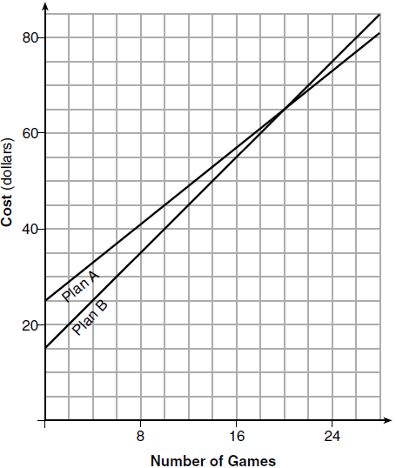

Explain why Plan B is the better choice for Dylan if he only has $50 to spend on video games, including a membership fee. Bobby wants to spend $65 on video games, including a membership fee. Which plan should he choose? Explain your answer.
1 ANS: 4 REF: 081419ai

2 ANS: 1 REF: 061605ai

3 ANS: 1 REF: 011803ai

4 ANS: 2 REF: 081809ai

5 ANS: 3
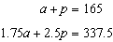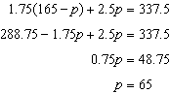

REF: 061506ai

6 ANS: 2
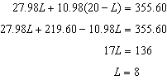

REF: 081510ai

7 ANS:
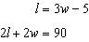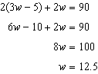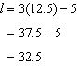

REF: 012335ai

8 ANS:
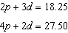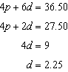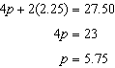

REF: 011533ai

9 ANS:
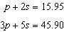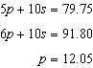

REF: 011734ai

10 ANS:
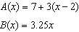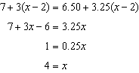

REF: 061834ai

11 ANS:
Pat’s numbers are not possible: 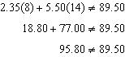 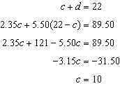

REF: 061436ai

12 ANS:
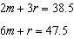 Jen is not correct because the prices are 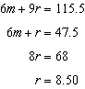 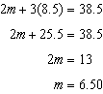

REF: 082435ai

13 ANS:
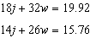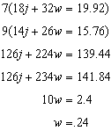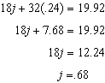

REF: 081637ai

14 ANS:
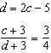; 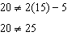 20 dogs is not five less than twice 15 cats 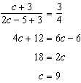

REF: 011837ai

15 ANS:
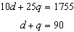, 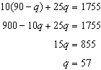, no, because

REF: 061837ai

16 ANS:
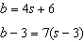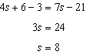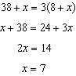

REF: 081837ai

17 ANS:
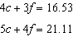 No, because . 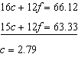 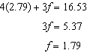

REF: 061937ai

18 ANS:
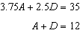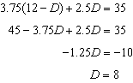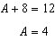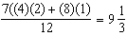

REF: 081937ai

19 ANS:
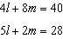 No, since 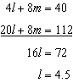 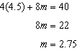

REF: 062137ai

20 ANS:
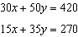 Peyton is wrong as . 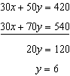 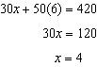

REF: 082237ai

21 ANS:
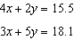 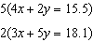 Courtney is incorrect because of the following calculations: 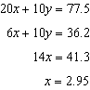 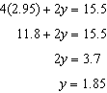

REF: 062435ai

22 ANS:
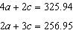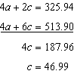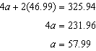

REF: 062237ai

23 ANS:
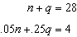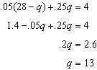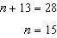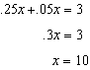

REF: 012437ai

24 ANS:
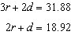; 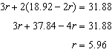; 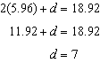; 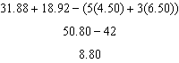

REF: 062337ai

25 ANS:
Plan A: , Plan B: . 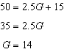 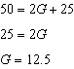 With Plan B, Dylan can rent 14 games, but with Plan A, Dylan can rent only 12. Bobby can choose either plan, as he could rent 20 games for $65 with both plans.

REF: 081728ai

