1 A car travels 110 miles in 2 hours. At the same rate of speed, how far will the car travel in h hours?
1) 2) 3) 4)

2 A rocket car on the Bonneville Salt Flats is traveling at a rate of 640 miles per hour. How much time would it take for the car to travel 384 miles at this rate?
1) 36 minutes 2) 245 minutes 3) 256 minutes 4) 1.7 hours

3 A truck travels 40 miles from point A to point B in exactly 1 hour. When the truck is halfway between point A and point B, a car starts from point A and travels at 50 miles per hour. How many miles has the car traveled when the truck reaches point B?
1) 25 2) 40 3) 50 4) 60

4 Andy drives 80 miles to get to the Thruway, drives 100 miles on the Thruway, and then drives an additional 75 miles after leaving the Thruway. If the entire trip took 5 hours and he made no stops, what was his average speed, in miles per hour?
1) 51 2) 65 3) 250 4) 255

5 If Jamar can run of a mile in 2 minutes 30 seconds, what is his rate in miles per minute?
1) 2) 3) 4)

6 On her first trip, Sari biked 24 miles in T hours. The following week Sari biked 32 miles in T hours. Determine the ratio of her average speed on her second trip to her average speed on her first trip.
1) 2) 3) 4)

7 On a trip, a student drove 40 miles per hour for 2 hours and then drove 30 miles per hour for 3 hours. What is the student’s average rate of speed, in miles per hour, for the whole trip?
1) 34 2) 35 3) 36 4) 37

8 A girl can ski down a hill five times as fast as she can climb up the same hill. If she can climb up the hill and ski down in a total of 9 minutes, how many minutes does it take her to climb up the hill?
1) 1.8 2) 4.5 3) 7.2 4) 7.5

9 A bicyclist leaves Bay Shore traveling at an average speed of 12 miles per hour. Three hours later, a car leaves Bay Shore, on the same route, traveling at an average speed of 30 miles per hour. How many hours after the car leaves Bay Shore will the car catch up to the cyclist?
1) 8 2) 2 3) 5 4) 4

10 Kimberly rides her bicycle from her home to school at an average rate of 12 miles per hour. If it takes her 20 minutes to get to school, how many miles is her home from her school?

11 Running at a constant speed, Andrea covers 15 miles in hours. At this speed, how many minutes will it take her to run 2 miles?

12 The figure below represents the distances traveled by car A and car B in 6 hours.

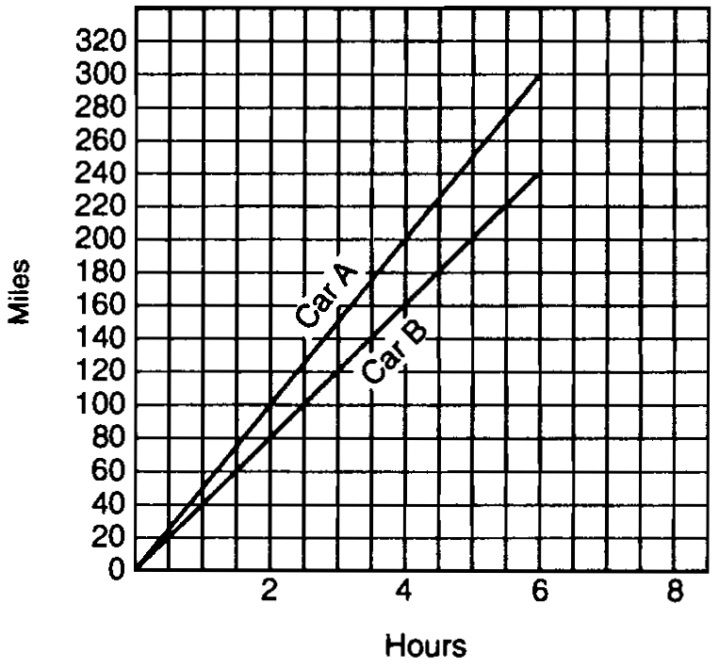

Which car is going faster and by how much? Explain how you arrived at your answer.

13 During a 45-minute lunch period, Albert (A) went running and Bill (B) walked for exercise. Their times and distances are shown in the accompanying graph. How much faster was Albert running than Bill was walking, in miles per hour?

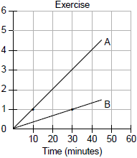

14 Bob and Latoya both drove to a baseball game at a college stadium. Bob lives 70 miles from the stadium and Latoya lives 60 miles from it, as shown in the accompanying diagram. Bob drove at a rate of 50 miles per hour, and Latoya drove at a rate of 40 miles per hour. If they both left home at the same time, who got to the stadium first?

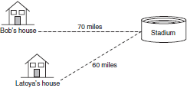

15 The trip from Manhattan to Montauk Point is 120 miles by train or by car. A train makes the trip in 2 hours, while a car makes the trip in hours. How much faster, in miles per hour, is the average speed of the train than the average speed of the car?

16 A truck traveling at a constant rate of 45 miles per hour leaves Albany. One hour later a car traveling at a constant rate of 60 miles per hour also leaves Albany traveling in the same direction on the same highway. How long will it take for the car to catch up to the truck, if both vehicles continue in the same direction on the highway?

17 Two trains leave the same station at the same time and travel in opposite directions. One train travels at 80 kilometers per hour and the other at 100 kilometers per hour. In how many hours will they be 900 kilometers apart?

18 It took a man 12 hours to make a certain journey. Had he traveled 1 mile an hour faster he would have required 2 hours less time. What was his rate an hour and how long was the journey?

19 A who travels 4 miles an hour, starts from a certain place two hours in advance of B who travels 5 miles an hour in the same direction. How many hours must B travel to overtake A?

1 ANS: 1 REF: 060101a

2 ANS: 1
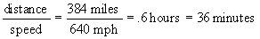

REF: 080415a

3 ANS: 1
Since the car starts at the halfway point of the truck’s hour-long journey, the car is traveling for half an hour.

REF: 060010a

4 ANS: 1
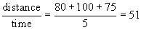

REF: 080805a

5 ANS: 2
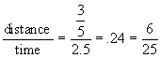

REF: 080119b

6 ANS: 3
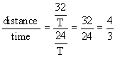

REF: 060116b

7 ANS: 1
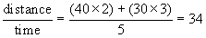

REF: 080111b

8 ANS: 4
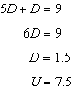

REF: 080019a

9 ANS: 2
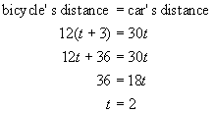

REF: 080518a

10 ANS:
4. 20 minutes is hour. 

REF: 060833a

11 ANS:
20. 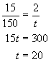

REF: 080632a

12 ANS:
Car A is going faster. After 6 hours, it has gone 60 miles farther than car B, so is traveling 10  mph faster.

REF: spring9827a

13 ANS:
4. 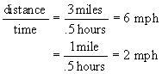

REF: 069926a

14 ANS:
Bob. 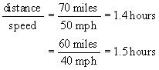

REF: 010433a

15 ANS:
12. 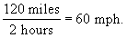 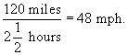

REF: 080736a

16 ANS:
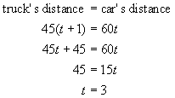

REF: 010027a

17 ANS:
Since the trains are traveling in opposite directions, you add the distances they have traveled to find their distance apart. 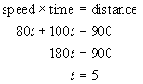

REF: 010125a

18 ANS:
5 and 60 miles

REF: 039512al

19 ANS:
8

REF: 090405al

