1 What is the speed, in meters per second, of a paper airplane that flies 24 meters in 6 seconds?
1) | 144
2) | 30
3) | 18
4) | 4

2 In a baseball game, the ball traveled 350.7 feet in 4.2 seconds. What was the average speed of the ball, in feet per second?
1) | 83.5
2) | 177.5
3) | 354.9
4) | 1,472.9

3 Steve ran a distance of 150 meters in minutes. What is his speed in meters per hour?
1) | 6
2) | 60
3) | 100
4) | 6,000

4 A hiker walked 12.8 miles from 9:00 a.m. to noon. He walked an additional 17.2 miles from 1:00 p.m. to 6:00 p.m. What is his average rate for the entire walk, in miles per hour?
1) | 3.75
2) | 3.86
3) | 4.27
4) | 7.71

5 It takes Tammy 45 minutes to ride her bike 5 miles. At this rate, how long will it take her to ride 8 miles?
1) | 0.89 hour
2) | 1.125 hours
3) | 48 minutes
4) | 72 minutes

6 It takes a snail 500 hours to travel 15 miles. At this rate, how many hours will it take the snail to travel 6 miles?
1) | 0.18
2) | 5.56
3) | 150
4) | 200

7 Jonathan drove to the airport to pick up his friend. A rainstorm forced him to drive at an average speed of 45 mph, reaching the airport in 3 hours. He drove back home at an average speed of 55 mph. How long, to the nearest tenth of an hour, did the trip home take him?
1) | 2.0 hours
2) | 2.5 hours
3) | 2.8 hours
4) | 3.7 hours

8 The distance traveled is equal to the rate of speed multiplied by the time traveled. If the distance is measured in feet and the time is measured in minutes, then the rate of speed is expressed in which units? Explain how you arrived at your answer.

9 In a game of ice hockey, the hockey puck took 0.8 second to travel 89 feet to the goal line. Determine the average speed of the puck in feet per second.

10 Jen traveled a distance of 170 miles in 2 hours and 45 minutes. Express her speed, in miles per hour, to the nearest tenth.

11 The distance from Earth to Mars is 136,000,000 miles. A spaceship travels at 31,000 miles per hour. Determine, to the nearest day, how long it will take the spaceship to reach Mars.

12 The chart below compares two runners.

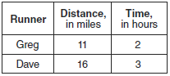

Based on the information in this chart, state which runner has the faster rate. Justify your answer.

13 A turtle and a rabbit are in a race to see who is first to reach a point 100 feet away. The turtle travels at a constant speed of 20 feet per minute for the entire 100 feet. The rabbit travels at a constant speed of 40 feet per minute for the first 50 feet, stops for 3 minutes, and then continues at a constant speed of 40 feet per minute for the last 50 feet. Determine which animal won the race and by how much time.

14 Loretta and her family are going on vacation. Their destination is 610 miles from their home. Loretta is going to share some of the driving with her dad. Her average speed while driving is 55 mph and her dad's average speed while driving is 65 mph. The plan is for Loretta to drive for the first 4 hours of the trip and her dad to drive for the remainder of the trip. Determine the number of hours it will take her family to reach their destination. After Loretta has been driving for 2 hours, she gets tired and asks her dad to take over. Determine, to the nearest tenth of an hour, how much time the family will save by having Loretta's dad drive for the remainder of the trip.

15 Hannah took a trip to visit her cousin. She drove 120 miles to reach her cousin’s house and the same distance back home. It took her 1.2 hours to get halfway to her cousin’s house. What was her average speed, in miles per hour, for the first 1.2 hours of the trip? Hannah’s average speed for the remainder of the trip to her cousin’s house was 40 miles per hour. How long, in hours, did it take her to drive the remaining distance? Traveling home along the same route, Hannah drove at an average rate of 55 miles per hour. After 2 hours her car broke down. How many miles was she from home?

16 An airplane leaves New York City and heads toward Los Angeles. As it climbs, the plane gradually increases its speed until it reaches cruising altitude, at which time it maintains a constant speed for several hours as long as it stays at cruising altitude. After flying for 32 minutes, the plane reaches cruising altitude and has flown 192 miles. After flying for a total of 92 minutes, the plane has flown a total of 762 miles. Determine the speed of the plane, at cruising altitude, in miles per minute. Write an equation to represent the number of miles the plane has flown, y, during x minutes at cruising altitude, only. Assuming that the plane maintains its speed at cruising altitude, determine the total number of miles the plane has flown 2 hours into the flight.

17 Aidan and his sister Ella are having a race. Aidan runs at a rate of 10 feet per second. Ella runs at a rate of 6 feet per second. Since Ella is younger, Aidan is letting her begin 30 feet ahead of the starting line. Let y represent the distance from the starting line and x represent the time elapsed, in seconds. Write an equation to model the distance Aidan traveled. Write an equation to model the distance Ella traveled. On the set of axes below, graph your equations.

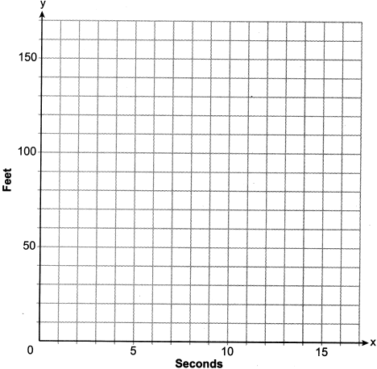

Exactly how many seconds does it take Aidan to catch up to Ella? Justify your answer.
1 ANS: 4
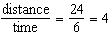

REF: 010902ia

2 ANS: 1
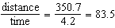

REF: 061201ia

3 ANS: 4
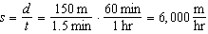

REF: 061025ia

4 ANS: 1
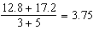

REF: 061117ia

5 ANS: 4
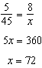

REF: 060901ia

6 ANS: 4
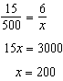

REF: 061403ia

7 ANS: 2
miles. 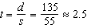 hours

REF: 011419ia

8 ANS:
The rate of speed is expressed in 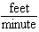 because 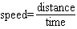.

REF: 011827ai

9 ANS:
111.25. 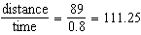
REF: 080831ia

10 ANS:
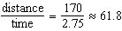
REF: 061531ia

11 ANS:
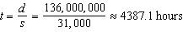. 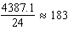
REF: 061333ia

12 ANS:
Greg’s rate of 5.5 is faster than Dave’s rate of 5.3. 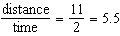. 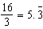
REF: 080936ia

13 ANS:
The turtle won by .5 minutes. Turtle: 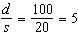. Rabbit: 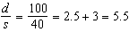
REF: 011236ia

14 ANS:
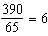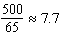
REF: 081733ai

15 ANS:
50, 1.5, 10. 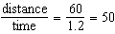. 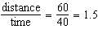. .
REF: fall0734ia

16 ANS:
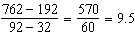
REF: 061635ai

17 ANS:
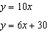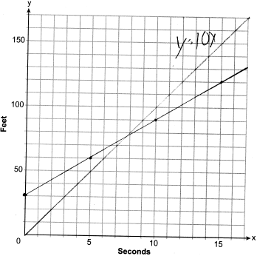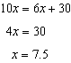
REF: 012337ai

