1 Which graph represents the equation ?
1) | 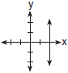
2) | 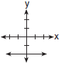
3) | 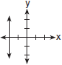
4) | 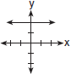

2 Which graph shows a line where each value of y is three more than half of x?
1) | 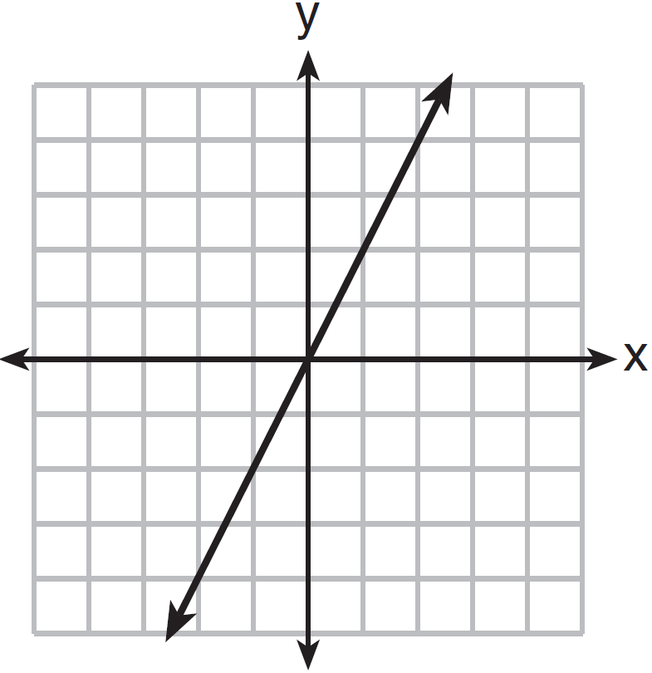
2) | 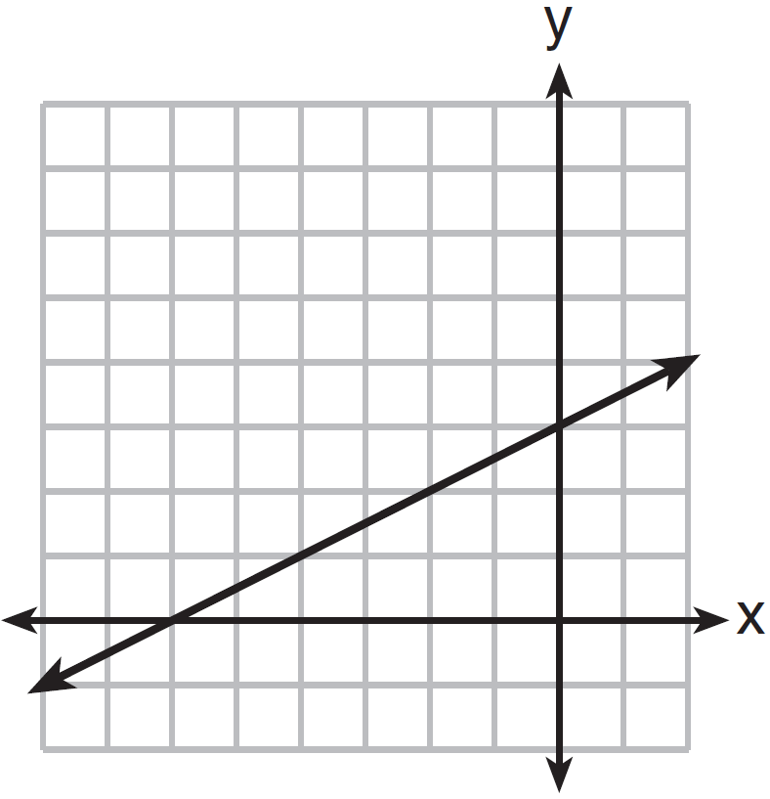
3) | 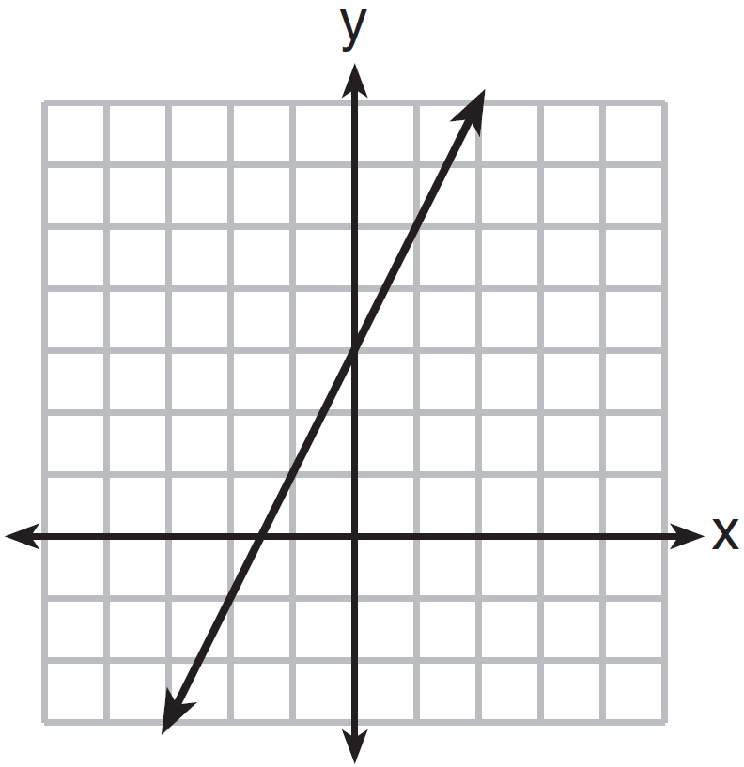
4) | 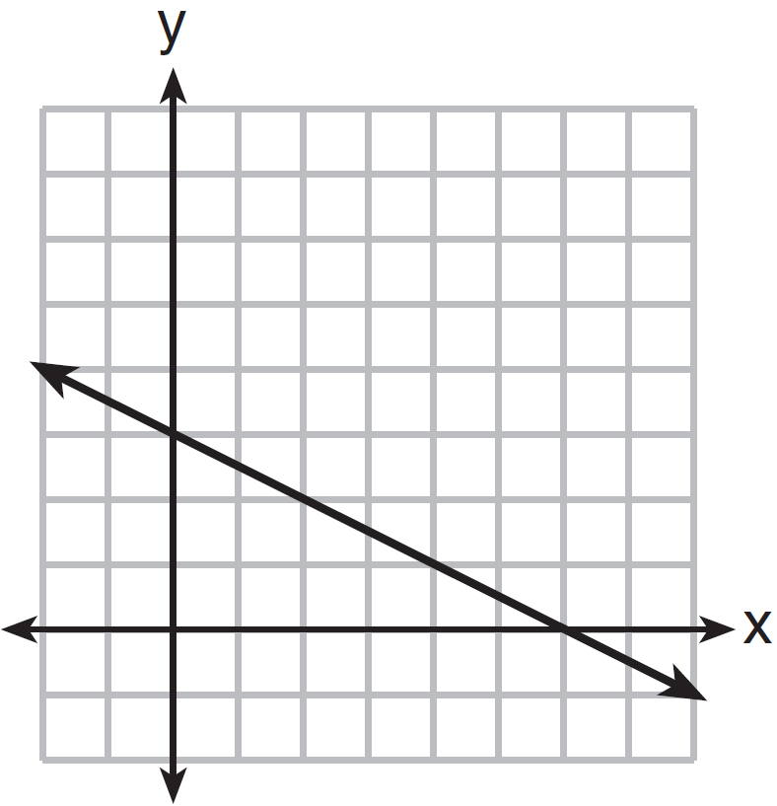

3 Super Painters charges $1.00 per square foot plus an additional fee of $25.00 to paint a living room. If x represents the area of the walls of Francesca's living room, in square feet, and y represents the cost, in dollars, which graph best represents the cost of painting her living room?
1) | 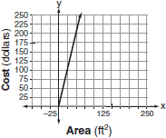
2) | 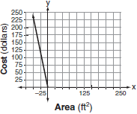
3) | 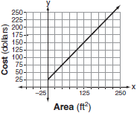
4) | 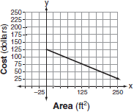

4 The gas tank in a car holds a total of 16 gallons of gas. The car travels 75 miles on 4 gallons of gas. If the gas tank is full at the beginning of a trip, which graph represents the rate of change in the amount of gas in the tank?
1) | 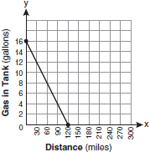
2) | 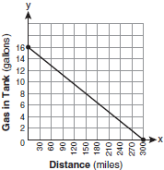
3) | 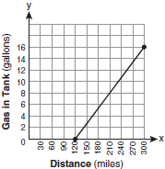
4) | 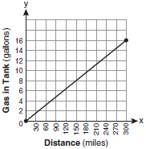

5 The graph below was created by an employee at a gas station.

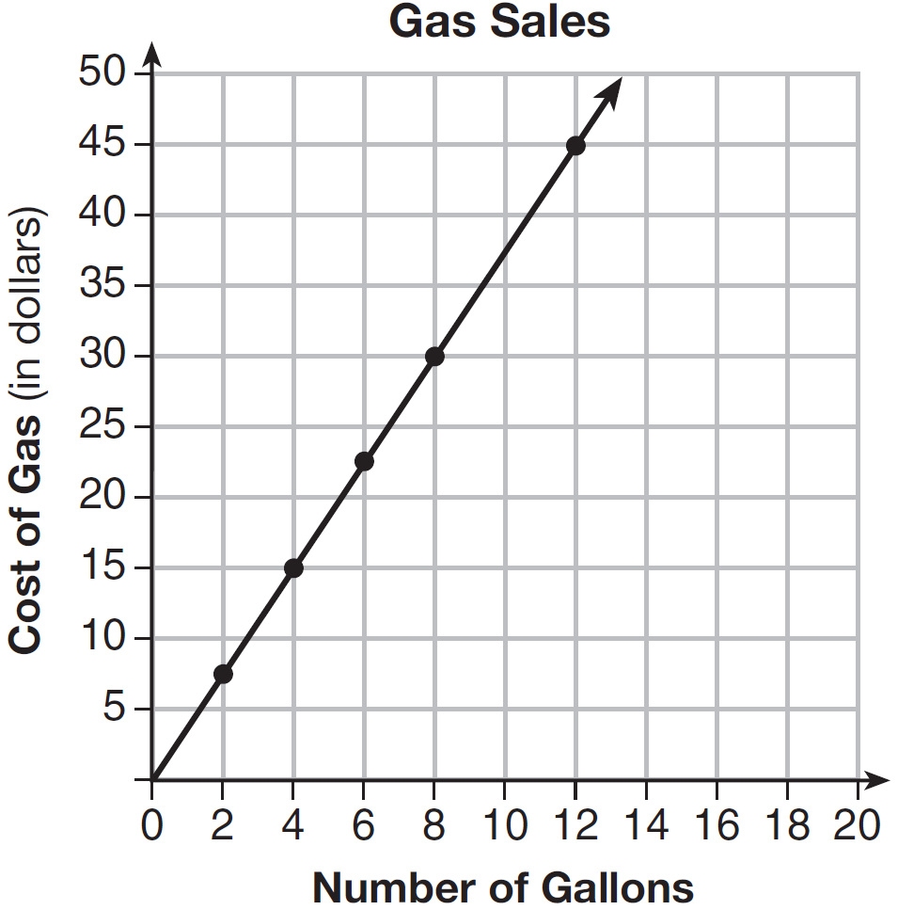

Which statement can be justified by using the graph?
1) | If 10 gallons of gas was purchased, $35 was paid.
2) | For every gallon of gas purchased, $3.75 was paid.
3) | For every 2 gallons of gas purchased, $5.00 was paid.
4) | If zero gallons of gas were purchased, zero miles were driven.

6 On the accompanying grid, draw the graph of the line whose slope is and whose y-intercept is .


7 Max purchased a box of green tea mints. The nutrition label on the box stated that a serving of three mints contains a total of 10 Calories. On the axes below, graph the function, C, where represents the number of Calories in x mints.
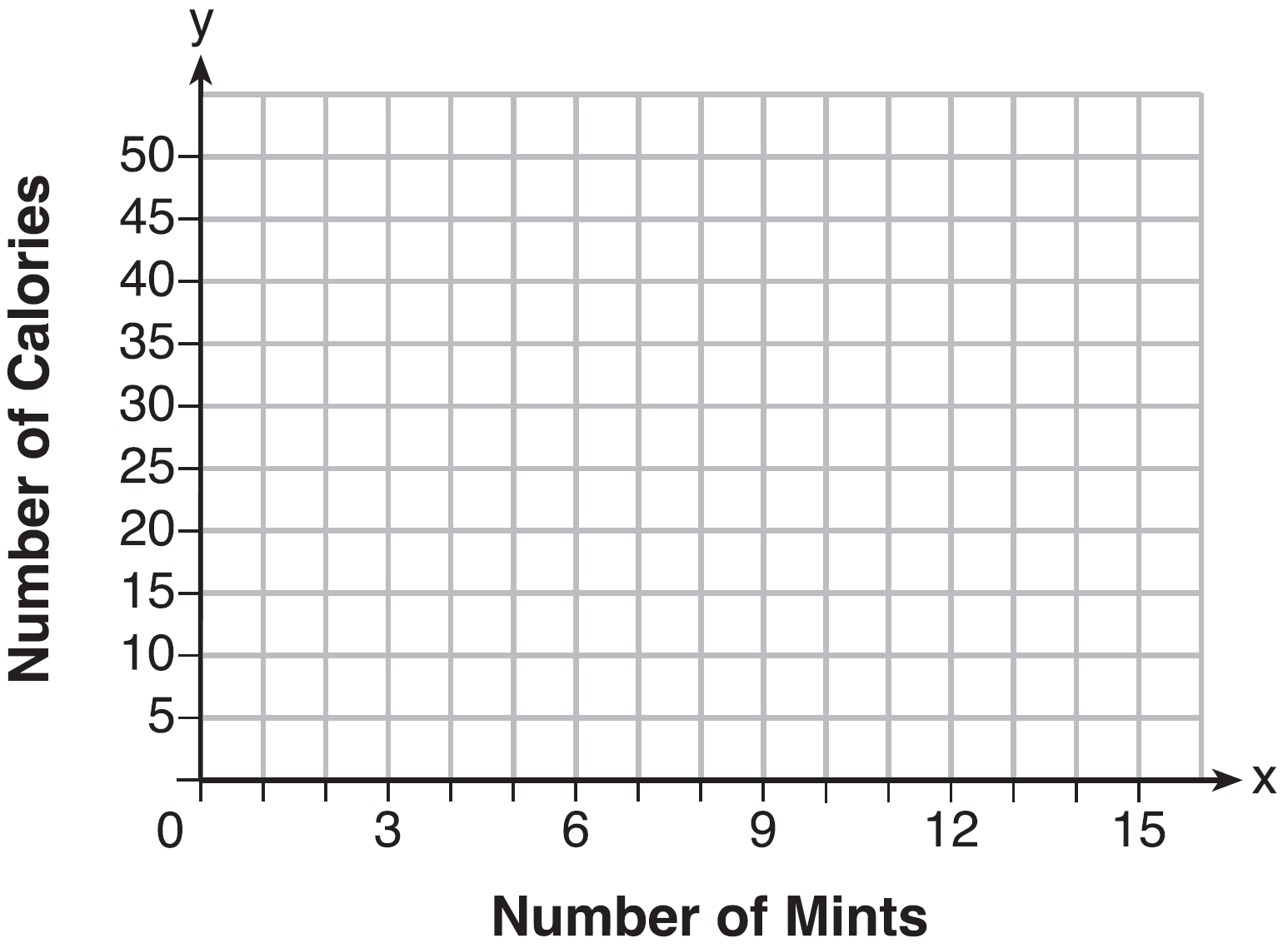
Write an equation that represents . A full box of mints contains 180 Calories. Use the equation to determine the total number of mints in the box.

8 The senior class is sponsoring a dance. The cost of a student disk jockey is $40, and tickets sell for $2 each. Write a linear equation and, on the accompanying grid, graph the equation to represent the relationship between the number of tickets sold and the profit from the dance. Then find how many tickets must be sold to break even.



9 Zeke and six of his friends are going to a baseball game. Their combined money totals $28.50. At the game, hot dogs cost $1.25 each, hamburgers cost $2.50 each, and sodas cost $0.50 each. Each person buys one soda. They spend all $28.50 on food and soda. Write an equation that can determine the number of hot dogs, x, and hamburgers, y, Zeke and his friends can buy. Graph your equation on the grid below.



Determine how many different combinations, including those combinations containing zero, of hot dogs and hamburgers Zeke and his friends can buy, spending all $28.50. Explain your answer.

1 ANS: 1 REF: 060523a

2 ANS: 2 REF: 081413ai

3 ANS: 3
This graph has a y-intercept of 25 and a slope of 1.

REF: 080703a

4 ANS: 2
If the car can travel 75 miles on 4 gallons, it can travel 300 miles on 16 gallons. 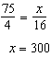.

REF: 080807ia

5 ANS: 2 REF: 011602ai

6 ANS:
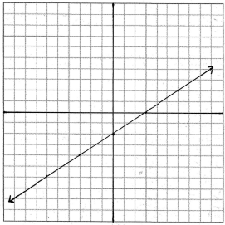

REF: 060834a

7 ANS:
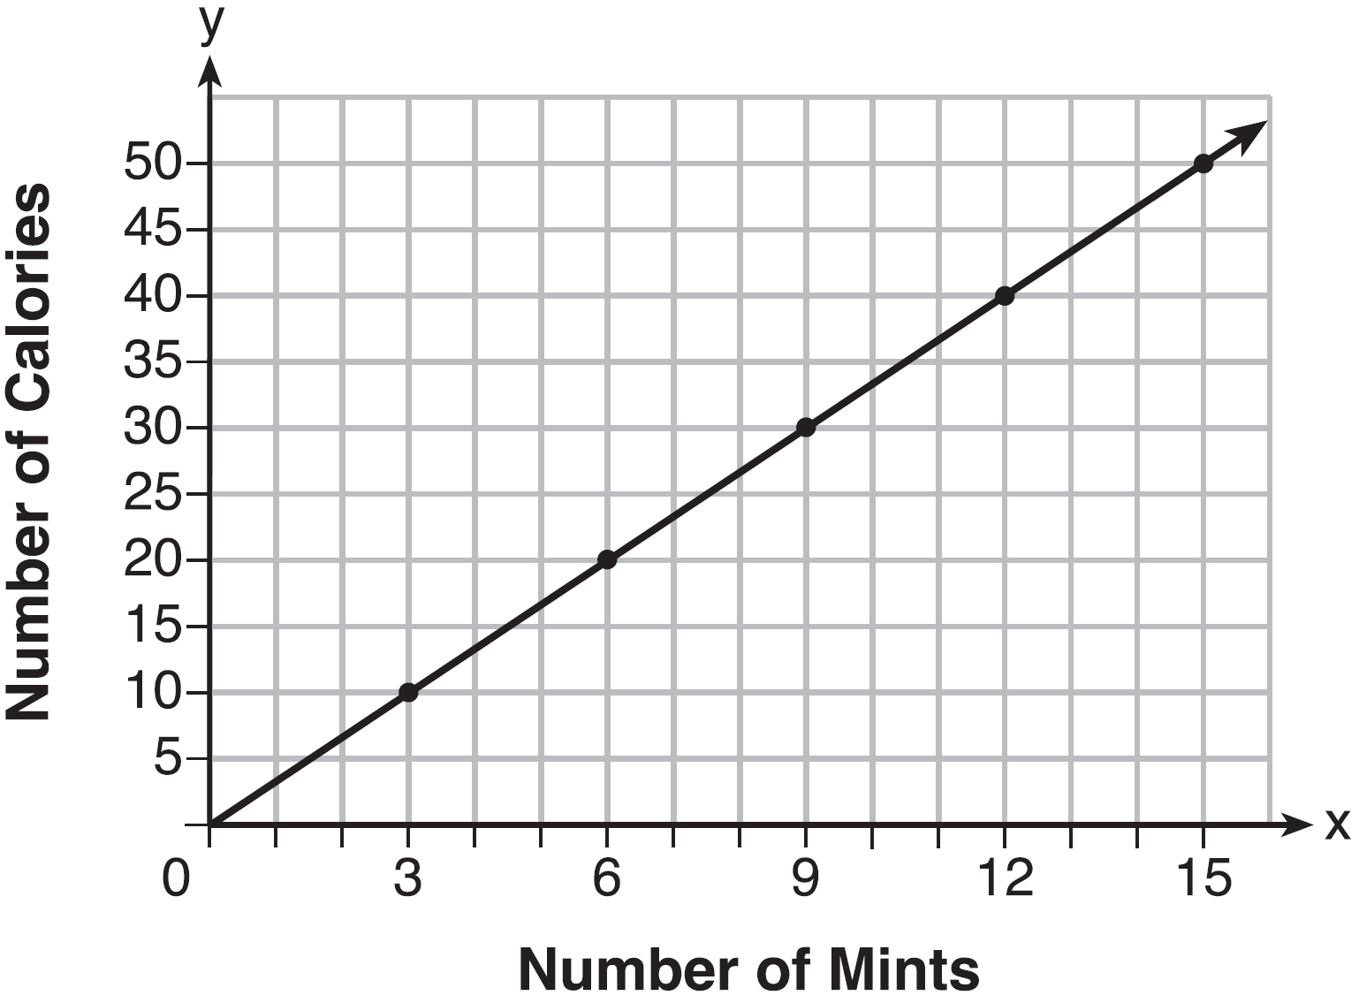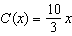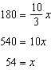

REF: fall1308ai

8 ANS:
. 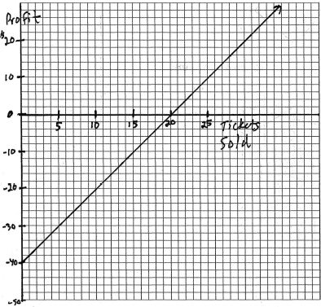. 20

REF: 060335a

9 ANS:
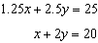 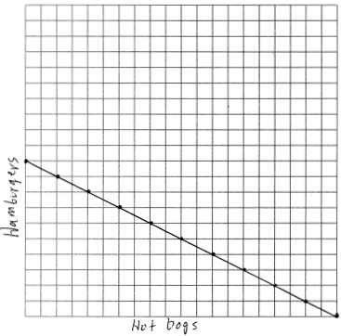 There are 11 combinations, as each dot represents a possible combination.

REF: 081737ai

