1 When Albert flips open his mathematics textbook, he notices that the product of the page numbers of the two facing pages that he sees is 156. Which equation could be used to find the page numbers that Albert is looking at?
1)
2)
3)
4)

2 Sam and Jeremy have ages that are consecutive odd integers. The product of their ages is 783. Which equation could be used to find Jeremy’s age, j, if he is the younger man?
1)
2)
3)
4)

3 Abigail's and Gina's ages are consecutive integers. Abigail is younger than Gina and Gina's age is represented by x. If the difference of the square of Gina's age and eight times Abigail's age is 17, which equation could be used to find Gina's age?
1)
2)
3)
4)

4 When 36 is subtracted from the square of a number, the result is five times the number. What is the positive solution?
1) | 9
2) | 6
3) | 3
4) | 4

5 The square of a positive number is 24 more than 5 times the number. What is the value of the number?
1) | 6
2) | 8
3) | 3
4) | 4

6 Byron is 3 years older than Doug. The product of their ages is 40. How old is Doug?
1) | 10
2) | 8
3) | 5
4) | 4

7 Noj is 5 years older than Jacob. The product of their ages is 84. How old is Noj?
1) | 6
2) | 7
3) | 12
4) | 14

8 Find two consecutive numbers whose product is 306.

9 Four times the square of a certain number increased by 6 times the number equals 108. Find the number.

10 Find three consecutive positive even integers such that the product of the second and third integers is twenty more than ten times the first integer. [Only an algebraic solution can receive full credit.]

11 Find three consecutive odd integers such that the product of the first and the second exceeds the third by 8.

12 Three brothers have ages that are consecutive even integers. The product of the first and third boys’ ages is 20 more than twice the second boy’s age. Find the age of each of the three boys.

13 Tamara has two sisters. One of the sisters is 7 years older than Tamara. The other sister is 3 years younger than Tamara. The product of Tamara’s sisters' ages is 24. How old is Tamara?

14 Julia is 4 years older than twice Kelly's age, x. The product of their ages is 96. Write an equation that models this situation. Determine Kelly's age algebraically. State the difference between Julia's and Kelly's ages, in years.
1 ANS: 4 REF: 080627a

2 ANS: 3 REF: 081409ai

3 ANS: 4 REF: 081723ai

4 ANS: 1
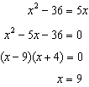

REF: 061020ia

5 ANS: 2
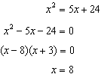

REF: 061518ia

6 ANS: 3
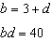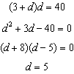

REF: 011208ia

7 ANS: 3
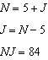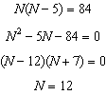

REF: 081304ia

8 ANS:
17 and 18

REF: 019917al

9 ANS:

REF: 099907al

10 ANS:
6, 8, 10. Three consecutive even integers are x, and . 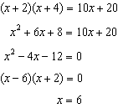

REF: 011039ia

11 ANS:
3, 5, 7. x = first odd integer, x + 2 = second odd integer, x + 4 = third odd integer. 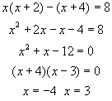

REF: 060131a

12 ANS:
4, 6, 8. x = youngest brother, x + 2 = middle brother, x + 4 = oldest brother. 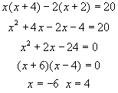

REF: 010326a

13 ANS:
5. x = Tamara’s age, x + 7 = Tamara’s older sister, x - 3 = Tamara’s younger sister. 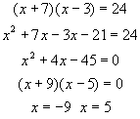

REF: 060636a

14 ANS:
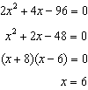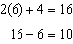

REF: 012435ai

