1 At the beginning of her mathematics class, Mrs. Reno gives a warm-up problem. She says, “I am thinking of a number such that 6 less than the product of 7 and this number is 85.” Which number is she thinking of?
1) | 11
2) | 13
3) | 84
4) | 637

2 If five times the measure of an angle is decreased by 30°, the result is the same as when two times the measure of the angle is increased by 18°. What is the measure of the angle?
1)
2)
3) | 16°
4) | 4°

3 Robin spent $17 at an amusement park for admission and rides. If she paid $5 for admission, and rides cost $3 each, what is the total number of rides that she went on?
1) | 12
2) | 2
3) | 9
4) | 4

4 Mario paid $44.25 in taxi fare from the hotel to the airport. The cab charged $2.25 for the first mile plus $3.50 for each additional mile. How many miles was it from the hotel to the airport?
1) | 10
2) | 11
3) | 12
4) | 13

5 If one-half of a number is 8 less than two-thirds of the number, what is the number?
1) | 24
2) | 32
3) | 48
4) | 54

6 A boy got 50% of the questions on a test correct. If he had 10 questions correct out of the first 12, and of the remaining questions correct, how many questions were on the test?
1) | 16
2) | 24
3) | 26
4) | 28

7 Laura goes shopping. She spends one-fourth of her money on a pair of shorts, and one-third of her remaining money on a belt. If Laura has $42 left after these two purchases, how much money did she have when she started shopping?
1) | $84
2) | $126
3) | $144
4) | $504

8 A total of $450 is divided into equal shares. If Kate receives four shares, Kevin receives three shares, and Anna receives the remaining two shares, how much money did Kevin receive?
1) | $100
2) | $150
3) | $200
4) | $250

9 In his will, a man leaves one-half of his money to his wife, one-half of what is then left to his older child, and one-half of what is then left to his younger child. His two cousins divide the remainder equally, each receiving $2,000. What was the total amount of money in the man’s will?
1) | $40,000
2) | $32,000
3) | $24,000
4) | $16,000

10 During a recent winter, the ratio of deer to foxes was 7 to 3 in one county of New York State. If there were 210 foxes in the county, what was the number of deer in the county?
1) | 90
2) | 147
3) | 280
4) | 490

11 Sterling silver is made of an alloy of silver and copper in the ratio of . If the mass of a sterling silver ingot is 600 grams, how much silver does it contain?
1) | 48.65 g
2) | 200 g
3) | 450 g
4) | 555 g

12 There are 357 seniors in Harris High School. The ratio of boys to girls is . How many boys are in the senior class?
1) | 210
2) | 147
3) | 117
4) | 107

13 Every month, Omar buys pizzas to serve at a party for his friends. In May, he bought three more than twice the number of pizzas he bought in April. If Omar bought 15 pizzas in May, how many pizzas did he buy in April?

14 The sum of the ages of the three Romano brothers is 63. If their ages can be represented as consecutive integers, what is the age of the middle brother?

15 Sara’s telephone service costs $21 per month plus $0.25 for each local call, and long-distance calls are extra. Last month, Sara’s bill was $36.64, and it included $6.14 in long-distance charges. How many local calls did she make?

16 In a town election, candidates A and B were running for mayor. There were 30,500 people eligible to vote, and of them actually voted. Candidate B received of the votes cast. How many people voted for candidate B? What percent of the votes cast, to the nearest tenth of a percent, did candidate A receive?

17 There are 28 students in a mathematics class. If of the students are called to the guidance office, of the remaining students are called to the nurse, and, finally, of those left go to the library, how many students remain in the classroom?

18 After an ice storm, the following headlines were reported in the Glacier County Times:
Monday: Ice Storm Devastates County — 8 out of every 10 homes lose electrical power
Tuesday: Restoration Begins — Power restored to of affected homes
Wednesday: More Freezing Rain — Power lost by 20% of homes that had power on Tuesday
Based on these headlines, what fractional portion of homes in Glacier County had electrical power on Wednesday?

19 The profits in a business are to be shared by the three partners in the ratio of 3 to 2 to 5. The profit for the year was $176,500. Determine the number of dollars each partner is to receive.

20 At the Phoenix Surfboard Company, $306,000 in profits was made last year. This profit was shared by the four partners in the ratio . How much more money did the partner with the largest share make than one of the partners with the smallest share?
1 ANS: 2
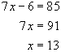
REF: 060409a

2 ANS: 3
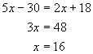
REF: 010909a

3 ANS: 4
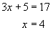
REF: 010801a

4 ANS: 4
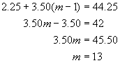
REF: 010726a

5 ANS: 3
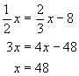
REF: 060111a

6 ANS: 4
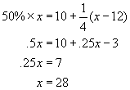
REF: 060116a

7 ANS: 1
If x represents the amount of money Laura had when she started shopping, she has left after she buys the shorts. 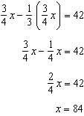
REF: spring9816a

8 ANS: 2
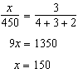
REF: 069913a

9 ANS: 2
wife 50.00%  older child 25.00%  younger child 12.50%  cousin #1 6.25%  cousin #2 6.25% | 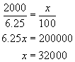
REF: 080114a

10 ANS: 4
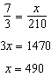
REF: 069915a

11 ANS: 4
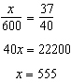
REF: 010014a

12 ANS: 2
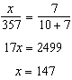
REF: 010210a

13 ANS:
6. 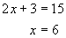
REF: 010733a

14 ANS:
21. Let x = youngest brother, x + 1 = middle brother, x + 2 = oldest brother. 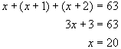. The age of the middle brother is , or 21.
REF: 080024a

15 ANS:
38. 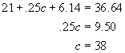
REF: 069925a

16 ANS:
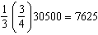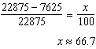
REF: 060328a

17 ANS:
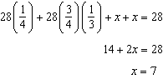
REF: 080228a

18 ANS:
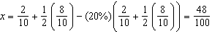
REF: 080029a

19 ANS:
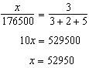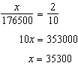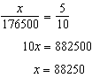
REF: 089931a

20 ANS: 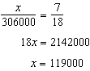 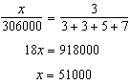 $119000-51000=$68,000
REF: 010331a

