1 The width of a rectangle is 3 less than twice the length, x. If the area of the rectangle is 43 square feet, which equation can be used to find the length, in feet?
1)
2)
3)
4)

2 The length of a rectangular window is 5 feet more than its width, w. The area of the window is 36 square feet. Which equation could be used to find the dimensions of the window?
1)
2)
3)
4)

3 A farmer has a rectangular field that measures 100 feet by 150 feet. He plans to increase the area of the field by 20%. He will do this by increasing the length and width by the same amount, x. Which equation represents the area of the new field?
1)
2)
3)
4)

4 What is the length of one side of the square whose perimeter has the same numerical value as its area?
1) | 5
2) | 6
3) | 3
4) | 4

5 A rectangle has an area of 24 square units. The width is 5 units less than the length. What is the length, in units, of the rectangle?
1) | 6
2) | 8
3) | 3
4) | 19

6 The length of a rectangle is 3 inches more than its width. The area of the rectangle is 40 square inches. What is the length, in inches, of the rectangle?
1) | 5
2) | 8
3) | 8.5
4) | 11.5

7 A contractor needs 54 square feet of brick to construct a rectangular walkway. The length of the walkway is 15 feet more than the width. Write an equation that could be used to determine the dimensions of the walkway. Solve this equation to find the length and width, in feet, of the walkway.

8 The area of the rectangular playground enclosure at South School is 500 square meters. The length of the playground is 5 meters longer than the width. Find the dimensions of the playground, in meters. [Only an algebraic solution will be accepted.]

9 Jack is building a rectangular dog pen that he wishes to enclose. The width of the pen is 2 yards less than the length. If the area of the dog pen is 15 square yards, how many yards of fencing would he need to completely enclose the pen?

10 Javon’s homework is to determine the dimensions of his rectangular backyard. He knows that the length is 10 feet more than the width, and the total area is 144 square feet. Write an equation that Javon could use to solve this problem. Then find the dimensions, in feet, of his backyard.

11 A rectangular park is three blocks longer than it is wide. The area of the park is 40 square blocks. If w represents the width, write an equation in terms of w for the area of the park. Find the length and the width of the park.

12 A rectangular piece of cardboard is to be formed into an uncovered box. The piece of cardboard is 2 centimeters longer than it is wide. A square that measures 3 centimeters on a side is cut from each corner. When the sides are turned up to form the box, its volume is 765 cubic centimeters. Find the dimensions, in centimeters, of the original piece of cardboard.

13 A homeowner wants to increase the size of a rectangular deck that now measures 14 feet by 22 feet. The building code allows for a deck to have a maximum area of 800 square feet. If the length and width are increased by the same number of feet, find the maximum number of whole feet each dimension can be increased and not exceed the building code. [Only an algebraic solution can receive full credit.]

14 A homeowner wants to increase the size of a rectangular deck that now measures 15 feet by 20 feet, but building code laws state that a homeowner cannot have a deck larger than 900 square feet. If the length and the width are to be increased by the same amount, find, to the nearest tenth, the maximum number of feet that the length of the deck may be increased in size legally.

15 Matt's rectangular patio measures 9 feet by 12 feet. He wants to increase the patio’s dimensions so its area will be twice the area it is now. He plans to increase both the length and the width by the same amount, x. Find x, to the nearest hundredth of a foot.

16 A rectangular patio measuring 6 meters by 8 meters is to be increased in size to an area measuring 150 square meters. If both the width and the length are to be increased by the same amount, what is the number of meters, to the nearest tenth, that the dimensions will be increased?

17 As shown in the accompanying diagram, the hypotenuse of the right triangle is 6 meters long. One leg is 1 meter longer than the other. Find the lengths of both legs of the triangle, to the nearest hundredth of a meter.

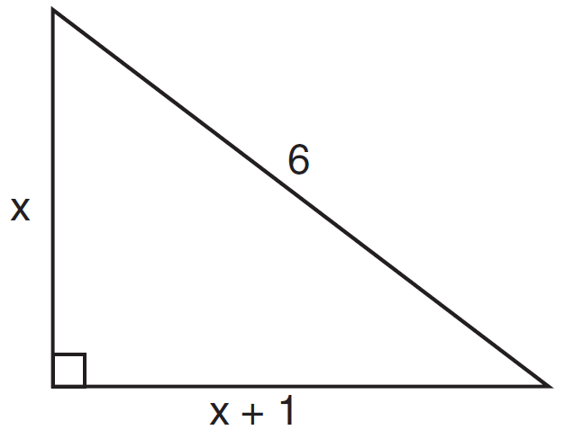

18 A small, open-top packing box, similar to a shoebox without a lid, is three times as long as it is wide, and half as high as it is long. Each square inch of the bottom of the box costs $0.008 to produce, while each square inch of any side costs $0.003 to produce. Write a function for the cost of the box described above. Using this function, determine the dimensions of a box that would cost $0.69 to produce.
1 ANS: 4 REF: 081011ia

2 ANS: 4
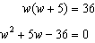

REF: fall0726ia

3 ANS: 3

REF: 060425a

4 ANS: 4
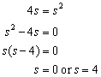

REF: 060608a

5 ANS: 2
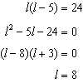

REF: 080817ia

6 ANS: 2
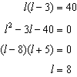

REF: 081116ia

7 ANS:
, 3, 18. 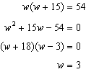

REF: 060837ia

8 ANS:
. 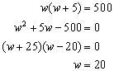

REF: 060035a

9 ANS:
16. 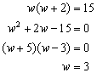. If w=3, then l=5.

REF: 080035a

10 ANS:
. 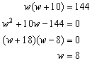

REF: 010233a

11 ANS:
, , . 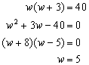

REF: 080232a

12 ANS:
. 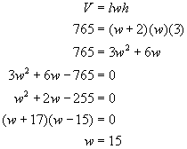If the width of the box is 15, adding the widths of the cutout squares means the width of the original sheet of cardboard is 21 (15 + 3 + 3). The length is 2 more, or 23.

REF: 080431b

13 ANS:
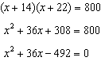 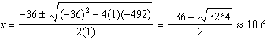 10 feet increase.

REF: 011539a2

14 ANS:
12.6. 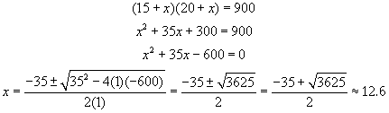

REF: 060128b

15 ANS:
4.27. The patio’s current area is 108 (9 x 12). After increasing the dimensions, the area will be 216. 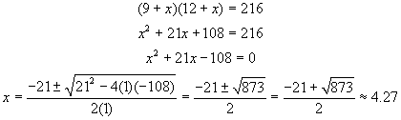

REF: 010729b

16 ANS:
5.3. 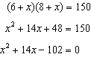. 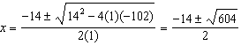. 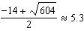

REF: 080727b

17 ANS:
3.71 and 4.71. 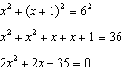. 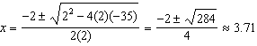

REF: 061030b

18 ANS:
, 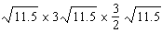. The area of the bottom is where w is the width in inches. If each square inch of the bottom costs $0.008 to produce, the cost of the bottom may be expressed as The area of the two smaller sides is 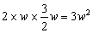 and the area of the two larger sides is 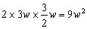 for a total area of If each square inch of a side of the box costs $0.003 to produce, the cost of the bottom may be expressed as Adding the cost of the bottom and sides equals A function for the cost of the box is A box that would cost $0.69 to produce would have the following dimensions 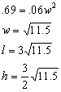

REF: 080130b

