1 The length of a rectangular patio is 7 feet more than its width, w. The area of a patio, , can be represented by the function
1)
2)
3)
4)

2 The length of a rectangular flat-screen television is six inches less than twice its width, x. If the area of the television screen is 1100 square inches, which equation can be used to determine the width, in inches?
1)
2)
3)
4)

3 Joe has a rectangular patio that measures 10 feet by 12 feet. He wants to increase the area by 50% and plans to increase each dimension by equal lengths, x. Which equation could be used to determine x?
1)
2)
3)
4)

4 The length of the shortest side of a right triangle is 8 inches. The lengths of the other two sides are represented by consecutive odd integers. Which equation could be used to find the lengths of the other sides of the triangle?
1)
2)
3)
4)

5 A movie theater's popcorn box is a rectangular prism with a base that measures 6 inches by 4 inches and has a height of 8 inches. To create a larger box, both the length and the width will be increased by x inches. The height will remain the same. Which function represents the volume, , of the larger box?
1)
2)
3)
4)

6 A landscaper is creating a rectangular flower bed such that the width is half of the length. The area of the flower bed is 34 square feet. Write and solve an equation to determine the width of the flower bed, to the nearest tenth of a foot.

7 A rectangular garden measuring 12 meters by 16 meters is to have a walkway installed around it with a width of x meters, as shown in the diagram below. Together, the walkway and the garden have an area of 396 square meters.

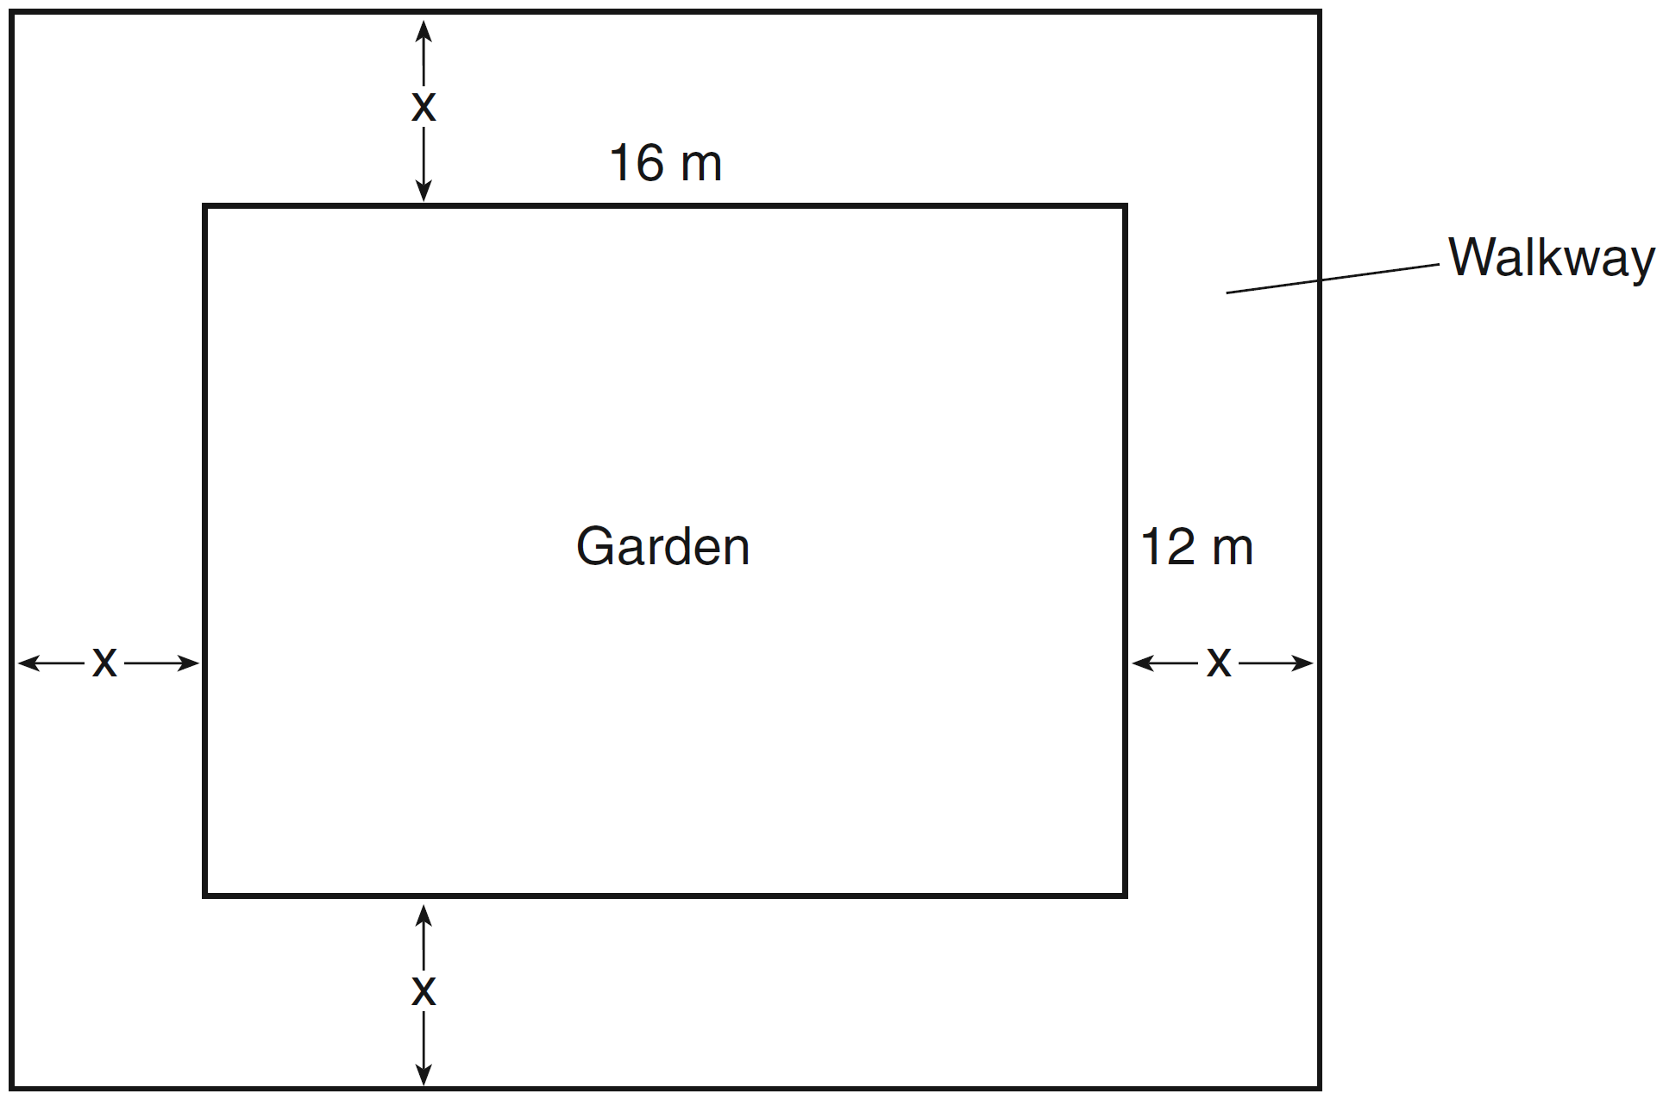

Write an equation that can be used to find x, the width of the walkway. Describe how your equation models the situation. Determine and state the width of the walkway, in meters.

8 A contractor has 48 meters of fencing that he is going to use as the perimeter of a rectangular garden. The length of one side of the garden is represented by x, and the area of the garden is 108 square meters. Determine, algebraically, the dimensions of the garden in meters.

9 A school is building a rectangular soccer field that has an area of 6000 square yards. The soccer field must be 40 yards longer than its width. Determine algebraically the dimensions of the soccer field, in yards.

10 The length of a rectangular sign is 6 inches more than half its width. The area of this sign is 432 square inches. Write an equation in one variable that could be used to find the number of inches in the dimensions of this sign. Solve this equation algebraically to determine the dimensions of this sign, in inches.

11 New Clarendon Park is undergoing renovations to its gardens. One garden that was originally a square is being adjusted so that one side is doubled in length, while the other side is decreased by three meters. The new rectangular garden will have an area that is 25% more than the original square garden. Write an equation that could be used to determine the length of a side of the original square garden. Explain how your equation models the situation. Determine the area, in square meters, of the new rectangular garden.

12 A rectangular picture measures 6 inches by 8 inches. Simon wants to build a wooden frame for the picture so that the framed picture takes up a maximum area of 100 square inches on his wall. The pieces of wood that he uses to build the frame all have the same width. Write an equation or inequality that could be used to determine the maximum width of the pieces of wood for the frame Simon could create. Explain how your equation or inequality models the situation. Solve the equation or inequality to determine the maximum width of the pieces of wood used for the frame to the nearest tenth of an inch.
1 ANS: 2

REF: 081920ai

2 ANS: 1 REF: 082306ai

3 ANS: 2 REF: 011611ai

4 ANS: 4 REF: spr1304ai

5 ANS: 2 REF: 062312ai

6 ANS:
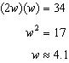

REF: 061532ai

7 ANS:
. The length, , and the width, , are multiplied and set equal to the area. 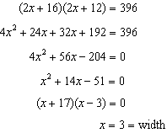

REF: 061434ai

8 ANS:
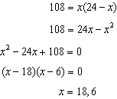

REF: 011636ai

9 ANS:
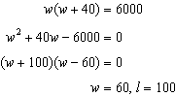

REF: 081436ai

10 ANS:
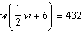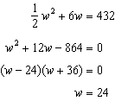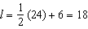

REF: 012036ai

11 ANS:
Because the original garden is a square, represents the original area, represents the side decreased by 3 meters, represents the doubled side, and represents the new garden with an area 25% larger. 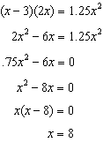

REF: 011537ai

12 ANS:
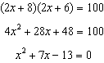 The frame has two parts added to each side, so must be added to the length and width. Multiply length and width to find area and set equal to 100. 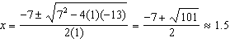

REF: 081537ai

