1 In the equation , y represents the number of snowboarders in millions and x represents the number of years since 1988. Find the year in which the number of snowboarders will be 10 million for the first time. (Only an algebraic solution will be accepted.)

2 Growth of a certain strain of bacteria is modeled by the equation , where:
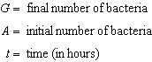
In approximately how many hours will 4 bacteria first increase to 2,500 bacteria? Round your answer to the nearest hour.

3 The number of houses in Central Village, New York, grows every year according to the function , where H represents the number of houses, and t represents the number of years since January 1995. A civil engineering firm has suggested that a new, larger well must be built by the village to supply its water when the number of houses exceeds 1,000. During which year will this first happen?

4 Currently, the population of the metropolitan Waterville area is 62,700 and is increasing at an annual rate of 3.25%. This situation can be modeled by the equation , where represents the total population and t represents the number of years from now. Find the population of the Waterville area, to the nearest hundred, seven years from now. Determine how many years, to the nearest tenth, it will take for the original population to reach 100,000. [Only an algebraic solution can receive full credit.]

5 Carla wants to start a college fund for her daughter Lila. She puts $63,000 into an account that grows at a rate of 2.55% per year, compounded monthly. Write a function, , that represents the amount ofmoney in the account t years after the account is opened, given that no more money is deposited into or withdrawn from the account. Calculate algebraically the number of years it will take for the account to reach $100,000, to the nearest hundredth of a year.

6 Seth’s parents gave him $5000 to invest for his 16th birthday. He is considering two investment options. Option A will pay him 4.5% interest compounded annually. Option B will pay him 4.6% compounded quarterly. Write a function of option A and option B that calculates the value of each account after n years. Seth plans to use the money after he graduates from college in 6 years. Determine how much more money option B will earn than option A to the nearest cent. Algebraically determine, to the nearest tenth of a year, how long it would take for option B to double Seth’s initial investment.

7 The Manford family started savings accounts for their twins, Abby and Brett, on the day they were born. They invested $8000 in an account for each child. Abby’s account pays 4.2% annual interest compounded quarterly. Brett’s account pays 3.9% annual interest compounded continuously. Write a function, , for Abby’s account and a function, , for Brett’s account that calculates the value of each account after t years. Determine who will have more money in their account when the twins turn 18 years old, and find the difference in the amounts in the accounts to the nearest cent. Algebraically determine, to the nearest tenth of a year, how long it takes for Brett’s account to triple in value.

8 Taylor wants to open an investment account with the $1200 she received for her birthday. She has narrowed her choices down to two banks. America's Bank offers 6.4% annual interest compounded quarterly. Barnyard Bank offers 6.35% annual interest compounded continuously. Write functions for and to represent the value of her investment with America's Bank and Barnyard Bank as a function of time, t, in years. Taylor would like to invest the $1200 into one bank for ten years making no additional deposits and no withdrawals. With which bank will Taylor earn the most money? Justify your answer. Taylor chooses to invest her money in Barnyard Bank. Algebraically determine how long, to the nearest tenth of a year, it will take her initial investment to triple assuming she makes no deposits or withdrawals.

9 Monthly mortgage payments can be found using the formula below:

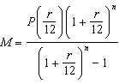

M = monthly payment
P = amount borrowed
r = annual interest rate
n = number of monthly payments

The Banks family would like to borrow $120,000 to purchase a home. They qualified for an annual interest rate of 4.8%. Algebraically determine the fewest number of whole years the Banks family would need to include in the mortgage agreement in order to have a monthly payment of no more than $720.

10 Kristen invests $5,000 in a bank. The bank pays 6% interest compounded monthly. To the nearest tenth of a year, how long must she leave the money in the bank for it to double? (Use the formula 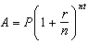, where A is the amount accrued, P is the principal, r is the interest rate, , and t is the length of time, in years.) [The use of the grid is optional.]



11 An amount of P dollars is deposited in an account paying an annual interest rate r (as a decimal) compounded n times per year. After t years, the amount of money in the account, in dollars, is given by the equation . Rachel deposited $1,000 at 2.8% annual interest, compounded monthly. In how many years, to the nearest tenth of a year, will she have $2,500 in the account? [The use of the grid is optional.]

12 Since January 1980, the population of the city of Brownville has grown according to the mathematical model , where x is the number of years since January 1980. Explain what the numbers 720,500 and 1.022 represent in this model. If this trend continues, use this model to predict the year during which the population of Brownville will reach 1,548,800. [The use of the grid is optional.]

13 After an oven is turned on, its temperature, T, is represented by the equation , where m represents the number of minutes after the oven is turned on and T represents the temperature of the oven, in degrees Fahrenheit. How many minutes does it take for the oven's temperature to reach 300°F? Round your answer to the nearest minute. [The use of the grid is optional.]

14 Tony is evaluating his retirement savings. He currently has $318,000 in his account, which earns an interest rate of 7% compounded annually. He wants to determine how much he will have in the account in the future, even if he makes no additional contributions to the account. Write a function, , to represent the amount of money that will be in his account in t years. Graph where on the set of axes below.

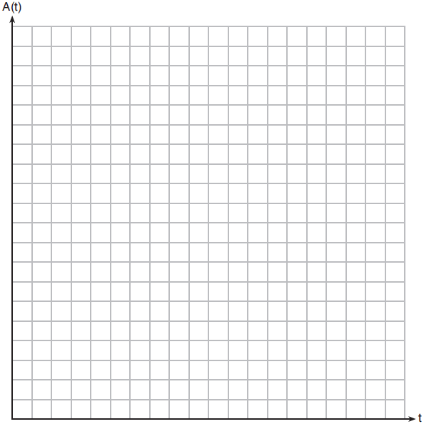

Tony's goal is to save $1,000,000. Determine algebraically, to the nearest year, how many years it will take for him to achieve his goal. Explain how your graph of confirms your answer.
1 ANS:
2004. 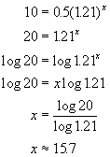. 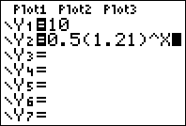. 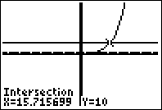

REF: fall9930b

2 ANS:
11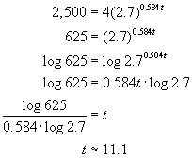 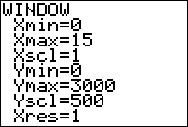 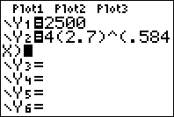 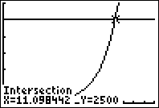

REF: 060224b

3 ANS:
2011. 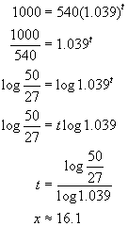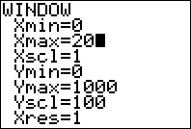 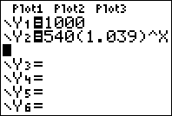 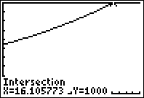

REF: 010828b

4 ANS:
78,400, 14.6

REF: 011031b

5 ANS:
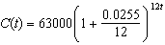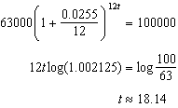

REF: 061835aii

6 ANS:
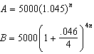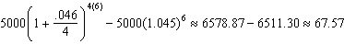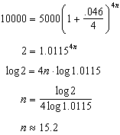

REF: 081637aii

7 ANS:
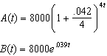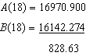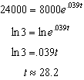

REF: 082337aii

8 ANS:
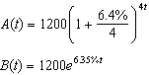 Barnyard because 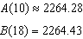 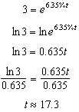

REF: 082437aii

9 ANS:
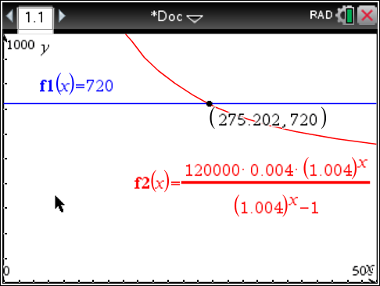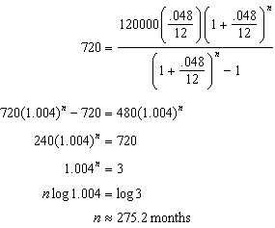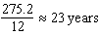

REF: spr1509aii

10 ANS:
11.6. 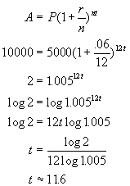. 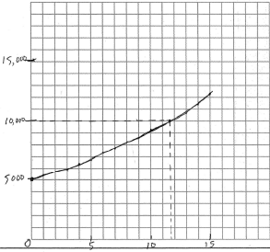. 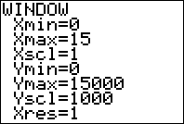. 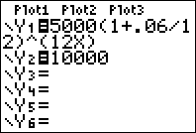. 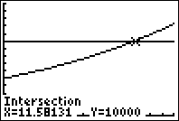

REF: 080832b

11 ANS:
32.8. 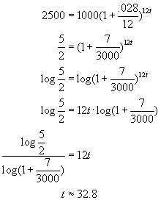. 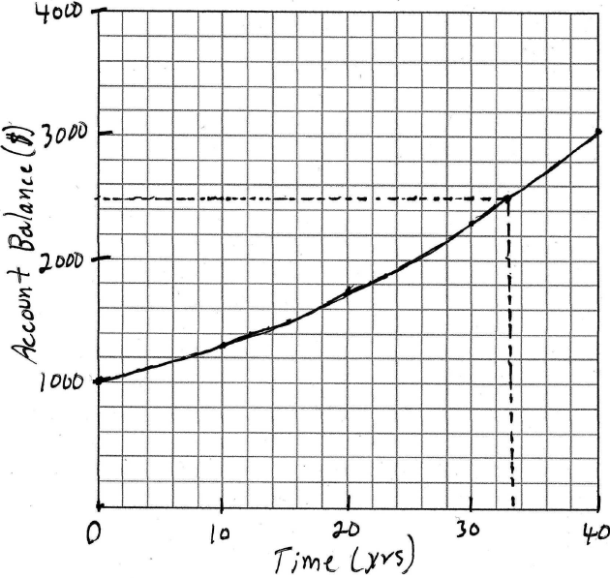. 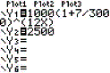. 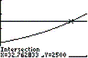

REF: 080428b

12 ANS:
720,500 is the population in 1980, 1.022 represents a growth rate of 2.2%, 2015. 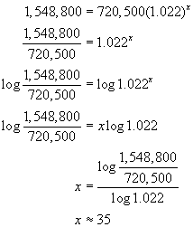. 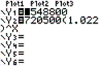. 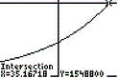. 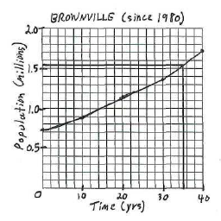

REF: 010728b

13 ANS:
11. 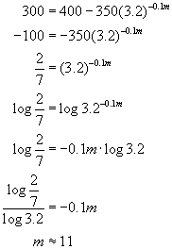. 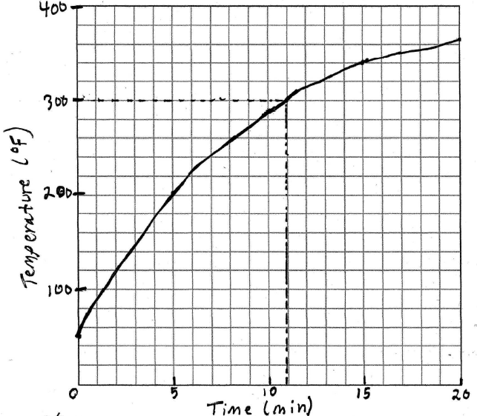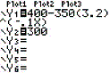. 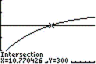.

REF: 080632b

14 ANS:
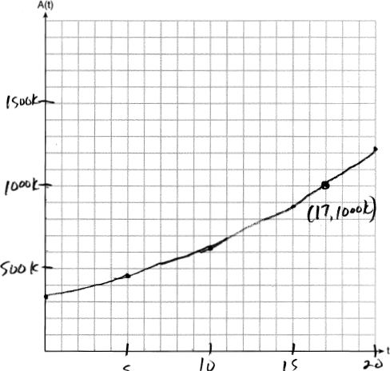 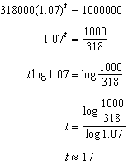 The graph of nearly intersects the point .

REF: 011937aii

