1 What is the value of x in the equation ?
1) 1 2) 3) 4)

2 What is the value of x in the equation ?
1) 2) 3) 4)

3 Solve for x:

4 Solve algebraically for x:

5 Solve algebraically for x:

6 Solve for x:

7 Solve for x:

8 Solve for x:

9 If , what is the value of x?

10 Solve algebraically for all values of x: 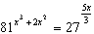

1 ANS: 4
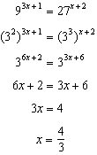.
REF: 081008a2

2 ANS: 4
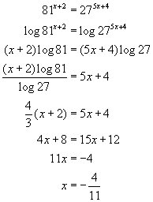. 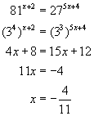. 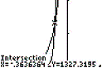. 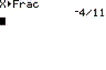
REF: 060303b

3 ANS:
REF: 068515siii

4 ANS:
. 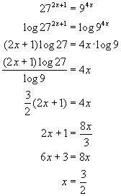. 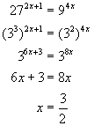. 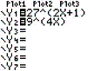. 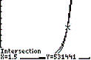
REF: 060422b

5 ANS:
4. 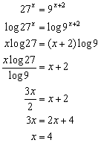. 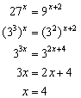. 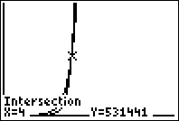. 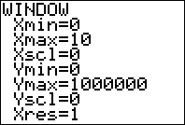

REF: 080922b

6 ANS:
2

REF: 069012siii

7 ANS:
8

REF: 019508siii

8 ANS:
3

REF: 060005siii

9 ANS:
2

REF: 080106siii

10 ANS:
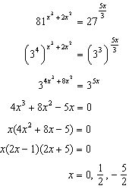

REF: 061239a2

