1 The solution set of the equation is
1)
2)
3)
4)

2 Determine the value of x and y if and .
1)
2)
3)
4)

3 What is the value of x in the equation ?
1) | 1
2)
3) | 3
4) | 0

4 Solve for x:

5 Solve for m:

6 Solve the equation for all values of x. [Only an algebraic solution will be accepted.]

7 Solve for y:

8 Solve for x:

9 Solve algebraically for x:

10 Solve for x:

11 Solve for x:

12 Solve for x: 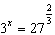

13 Solve algebraically for x:

14 If , find the positive value of x.

15 If , find the positive value of x.

1 ANS: 3 REF: 010222siii

2 ANS: 3
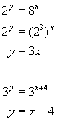. 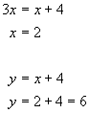

REF: 080118b

3 ANS: 3 REF: 089819siii

4 ANS:

REF: 088902siii

5 ANS:
2. 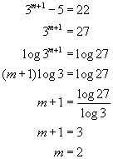. 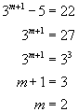. 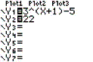. 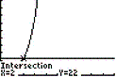

REF: 060522b

6 ANS:

REF: 019541siii

7 ANS:
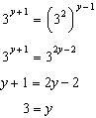

REF: 019706siii

8 ANS:
1

REF: 010004siii

9 ANS:
. 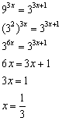

REF: 060923b

10 ANS:
2

REF: 068801siii

11 ANS:
2

REF: 089014siii

12 ANS:
2

REF: 019604siii

13 ANS:
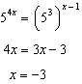

REF: 061528a2

14 ANS:
1

REF: 089702siii

15 ANS:
2

REF: 069412siii

